New CAMS System Setup

# **Introduction**

CAMS has essentially 7 phases:

1. Pre-capture (LaunchCapture\_KILL.bat terminates remaining rogue processes)
2. Capture to Working directories
3. Post-capture processing
4. Migrating to SubmissionFiles
5. Creating upload zip files and moving them into the Queue directory
6. Uploading
7. Archiving

# **Computer**

* Intel i5 or i7 with minimum of 8 GB RAM (16 GB or higher is better). Configure the BIOS so that the computer automatically reboots upon restoration of power after a power outage. Note: i5 for laptops is only a 2-core cpu and it doesn’t have the horsepower for a full 16 camera system. i5 for desktops has 4-cores, but it doesn’t do hyperthreading (to virtual 8 cpus). i5 for desktops has the horsepower for a 16 camera system. The i7 for laptops and desktops has 4 cores and hyperthreads to 8 virtual cpus. However, since you can’t install a PCIe board in a laptop, it won’t work for an 8 or 16 camera system.
* The Windows installation **MUST INCLUDE ENGLISH**. The **default CAMS user account must be an English language account using the en-US locale**. It’s OK to have other accounts configured to different languages, keyboards, regions, numbering and date formatting, however, the user account that CAMS runs under must be an en-US user. This has been a requirement that we discovered in 2019.
* The Sensoray boards are PCIe, therefore, you will need a system with enough PCIe buss slots to accommodate all your Sensoray boards.
* 1920 x 1080 Display is OK.
* Hard drive sized according to the **Storage** section below. See also, document on CAMS\_Storage\_Management.docx.
* UPS backup
* Internet connection with data plan that can accommodate the network traffic.

# **Cameras and other equipment**

* Cameras
* Weather proof housing (possibly with heaters)
* Power
* Cables
  + We have recently learned that using coax cables without ground-loop isolator baluns opens each camera up to numerous potential video problems. Below is an example of Before/After images of a security camera with such issues:  
    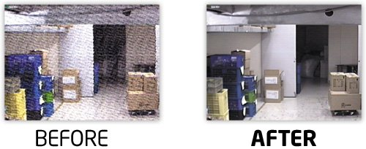  
    If your system is using COAX between the cameras and the computer, it is a good idea to install one of these at one end of each video cable if you have double-stars, ghosting, vertical or horizontal noise moving across the screen, etc.  
    These devices only need one device at one end. You can find them on Amazon for under $10 each.  
      
    If you are using ethernet cables for your video cables, you probably already have Cat5 or Cat6 cables with “video baluns” at each end. With this approach, you can run 4 camera feeds through a 4-port passive video balun with a passive video balun at each end. Using video baluns like this should avoid ground-loop interference problems the same as the ground loop isolator baluns. (I haven’t tried using both).  
    These devices can be found on Amazon for under $15 for each end.   
      
    For more before/after of noise, see this link:  
    [Noise Examples](https://www.google.com/search?q=bnc+ground+loop+isolator+video+before+and+after&rlz=1C1CHZL_enUS737US737&sxsrf=ALeKk02JrQhIdhZrHrzgNtlYzPxiA8IcCQ:1622567338840&tbm=isch&source=iu&ictx=1&fir=0_DT6HMR7IGeiM%252C34xtvAFRyi94TM%252C_&vet=1&usg=AI4_-kTplP5CZ6NfNI8wpLkUAYSqK0ZuKA&sa=X&ved=2ahUKEwjXzeuu9vbwAhUWQ80KHTtIDlQQ9QF6BAglEAE" \l "imgrc=0_DT6HMR7IGeiM&imgdii=H2ac74Cm8uzwwM)

# **Storage**

It has come to our attention that CAMS has real storage management implications and a multi-tier storage arrangement should be the standard.

* Windows drive (can be HD or SSD). There is no real reason for fast performance on the Windows drive, however, you don’t want it to run out of disk space.
* CAMS drive. This is where CAMS operates from. That includes Capture and post-capture processing (such as Validation, AutoCal, Detection, etc.)
* CAMS Archive. This is where files are migrated to for archival. Their original counterparts in the SubmissionFiles directory are deleted when: (a) they age to a specified age; (b) they have already been archived safely to the archive location. During the archive process, all of the FF files in the CapturedFiles directory are not archived… only the FF files in the ArchivedFiles and the ConfirmedFiles directories belong in the archive. Unless there is a noisy camera, the typical savings on this is about 90%.

Note: We “should” have a goal to keep ALL the FF files from CapturedFiles around long enough for us to be able to go back and do analysis days/weeks after an event. Since we don’t always know of these events immediately, or since we don’t always have time to process them right away, we want to be able to keep them long enough to be able to go back and investigate. Because of this, we have the “MaxDaysToKeep” setting in the **Cams2Global.ini** file. Remember that we always keep all the FF files in the ArchivedFiles and ConfirmedFiles dirs. But MaxDaysToKeep defines when to “cull” the FF files from the CapturedFiles dir.

The new Cams2 archiving scripts from Dave Samuels perform the archiving at around 3 pm the same day capture ends. That way, the MaxDaysToKeep can be set lower for disk space on the tier-1 storage.

(Steve’s LaunchCapture program does not employ this new algorithm in his archiving algorithm. Therefore, in order to override LaunchCapture’s archiving algorithm, we set MaxDaysToKeep variable in the **CamsGUI.ini** files to a large number, like **1000**. One of the reasons to disable Steve’s LaunchCapture archiving algorithm is because sometimes it would archive before it got a chance to process).

Perhaps a newer alternative version of the algorithm would “move” the CapturedFiles to the Tier-2 archive drive for safe-keeping until MaxDaysToKeep. Then cull the CapturedFiles from tier-2 at that time. That would be an algorithm that would better support SSD drives as tier-1 storage. It gets tricky though because most systems around the world use one drive for all storage tiers. Also, on a 20 camera system, it could take several hours to move that many files to another hard drive – especially to an external USB-2 hard drive (as opposed to a faster USB 3.0 hard drive). So, while it is tempting, and while we considered it, this would not be an acceptable approach and we have to reject the notion.

**Tier-1 Storage planning (CAMS Drive)**:

* A  1  camera station requires over 187 GB for 30 days of storage or 6.2 GB per camera per day.
* A 16 camera station requires over 3.0 TB for 30 days of storage.
* A 20 camera system requires over 3.8 TB for 30 days of storage.

**Tier-2 Storage planning (Cams Archive drive)**:

* A single camera station will require, on average, over 10 MB – 40 MB per camera per night for archival storage, depending on the conditions. On average, we are experiencing about 20 MB on some systems and 41 MB on others. It’s more if one or more of the cameras are “noisy”.
* A single camera station will require, on average, around 15 GB to store 365 days of archives, providing that the cameras don’t have excessive noise.
  + Example 1: Jim Wray’s 16 camera system is using 213 GB / yr of Tier-2 storage.
  + Example 2: Lick’s 20 camera system consumed 1.33 TB for 04/01/2018 through 09/24/2018 (6 months) for “archived\_SubmissionFiles” data. Lick has had some noisy cables, increasing the storage requirements for archiving. These noisy cameras were consuming an average of 365 MB of archive storage per camera per night.

# **CAMS Setup**

**IMPORTANT** - The Windows installation **MUST INCLUDE ENGLISH**. The **default CAMS user account** must be an **English** language account using the **en-US locale**. It’s OK to have other accounts configured to different languages, keyboards, regions, numbering and date formatting, however, the user account that CAMS runs under must be an en-US user. The reason for this is because the CAMS software is not internationalized, therefore, it can’t be properly localized. Providing support for installation and troubleshooting when the windows user account language is not English is impossible if we can’t understand the menus and message prompts in your local language. Also, on a related note, the **cams software requires english**, since the scripts are not internationalized. Part of the problem is because we interpret the results of running certain programs to fetch information. We can't possible foresee all the possible text. Also, some of the programs that we tickle return garbage characters, which are improperly interpreted. Therefore, we require that the CAMS user is en-US locale. No problem with adding other user accounts that are in your language for your convenience.

**FOCUS**

Try as best you can to focus the cameras on distant objects near infinity BEFORE installing the cameras outside in the field. During the daytime, you can use the tops of trees or radio towers a few miles away or more. You can also do this during the night focusing on lights in a distant city or the moon. You can also do this rough focusing through a window. Then test it – as much as possible before installing it in its final location. Testing means having the software installed and trying to capture. There are several camera boxes installed on rooftops, on top of poles, and other locations. The bottom line is that the cameras will be outside and the monitor to use for focusing and testing is usually too far away after final installation to perform these functions easily. You may not get it perfect, but at least it will be close enough to only require quick and minor tweaks.

1. **Configure the BIOS** so that it will automatically reboot when the power is interrupted.
   1. Test by pulling the plug on the computer while it is on, wait 15 seconds, then put the plug back in. It should boot up without issues.
   2. Configure Windows **Display Settings** to the “recommended” resolution. The default is 1024 x 768, but this is too small for CAMS. To adjust, do this:
      * Right-click on the desktop.
      * Select “**Display settings**”. The “Settings” dialog appears.
      * In the right-pane, for **Resolution**, select the resolution that shows “**Recommended**”. The resolution should change and the “Keep these display settings” dialog appears.
      * Click “**Keep Changes**”.
      * **Close** the Settings dialog.
   3. Disable Windows auto-snap:
      * Launch the **Settings** app.
      * Click **System**.
      * On the left, click **Multitasking**
      * On the right, under the “**Snap**” category, uncheck “**Arrange windows automatically by dragging them to the sides or corners of the screen**”.
      * **Close** the Settings app.
2. Since I use TotalCommander, TextPad, Chrome, and D4, download and install and configure each of those.
   1. Install and configure **Textpad**:
      * Search for and install **TextPad 64-bit English**.
      * Double-click the zip file and then double-click the “**setup.exe**” program to commence the installation.
      * Click **Next**.
      * **Accept** the terms…
      * Click **Next**.
      * Click **Next**.
      * For Destination Folder, click the **Change** button.
      * Change the drive letter from “C:\Program Files\TextPad 8\” to “**D:\Program Files\TextPad 8\**”, where “D:” is the CAMS drive.
      * Click **OK**.
      * Click **Next**.
      * Click **Install**.
      * Click **Yes**.
      * Check “**Launch the program**”.
      * Click **Finish**.
      * Uncheck “**Show tips on startup**”.
      * Click **Close**.
      * From the menu, select **Configure** > **Preferences**.
      * On the left, select **File**.
      * On the right, change **Number of recent files** and **recent workspaces** to **16**.
      * Click **OK**.
      * Click **OK**.
      * **Configure > Preferences**…
      * In the left pane, select **View**.
      * In the right pane, check **Line Numbers**.
      * Click **Apply**.
      * In the left pane, select **Keyboard**.
      * In the **Categories** list, select **Search**.
      * In the **Commands** list, select **SearchFind**.
      * In the “**Press new shortcut key**” box, press **Ctrl+F**.
      * Click the **Assign** button.
      * Click **OK**.
      * Close Textpad.
   2. Configure **TotalCommander** as follows:
      * When Installing, install with these settings:
        1. **English**
        2. **No** (no other languages)
        3. **<cams drive>\totalcmd**
        4. **Change ini file location**
        5. **Program directory** and **Set this location for all users**
        6. **All users**
      * Start **TotalCommander** and enter a number for the “nag” screen.
      * On the menu, select **Configuration** > **Options**. The Configuration dialog appears.
      * In the Navigation pane on the left, select **Layout**.
      * On the right, check the following boxes:
        1. **Show button bar**
        2. **Show Button bar 2**
        3. **Show drive buttons**
        4. **Show two drive button bars**
        5. **Flat icons**
        6. Leave the rest of the default checks.
      * In the left pane, select **Tabstops**.
      * On the right, in the “**Show file extensions**” box, select “**directly after filename**”.
      * In the left pane, select Edit/View.
      * For the Editor field, click the “>>” button.
      * Navigate to the TextPad installation directory (typically “**C:\Windows\Program Files\TextPad 8**”) and select the **TextPad.exe**
      * Click the **Open** button.
      * Click **OK**.
      * It will ask you to choose a **user interface style**. Just keep the default.
      * On the menu, select **Net** > **FTP Connect**. The Connect to ftp server dialog appears.
      * On the right, click the “**New connection**” button. The FTP: connection details dialog appears.  
        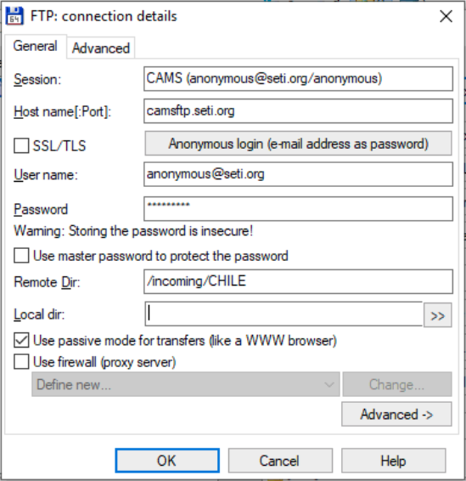
      * Configure as shown:  
        Session: **CAMS (anonymous@seti.org/anonymous)**  
        Host name: **camsftp.seti.org**  
        User name: [anonymous@seti.org](mailto:anonymous@seti.org)  
        password: **anonymous**  
        Remote dir: **/incoming/<network>**  
        Use passive mode: **checked**
      * Click **OK** to close the configuration dialog.
      * Click **Connect** to test the connection.
      * From the menu, select **Net** > **FTP Disconnect**.
      * On the menu, select **Configuration** > **Save Settings**.
      * **Close** Total Commander to save and exit.
   3. If you are using a sensoray card, install and configure that to the CAMS drive.
   4. Configure the Sensoray “**812 Demo**” program as follows:
      * Start the program from the desktop.
      * Windows Features dialog appears, asking you to Download and install .NET Framework.
      * Click “Download and install this feature”.
      * When it’s finished with .NET install, click Close.
      * Start the program from the desktop.
      * At the very bottom of the window, select “8 channels”.
      * For each sensoray card you have installed, do the following:
        1. From the menu, select **Devices** > **812 Device x**.
        2. From the menu, select **Tools Advanced Settings**. The Advanced Settings dialog appears.
        3. Select “NTSC Only” or “PAL Only” depending on your cameras. Failing to change it from the default setting of “Normal Operation” can yield undetermined results.
        4. Click **OK**.
        5. From the menu, select “**Save Settings**”. The Save As dialog appears.
        6. Save to “**d:\Cams2\_Board0\CAMS\sensoray812\_settings.s12**”.
        7. Click **Save**.
   5. Configure **Windows Explorer** display settings:
      * Start **Windows File Explorer**.
      * From the menu, select **View** > **Options** > **Change folder and search options**. The Folder Options dialog appears.
      * Select the **View** tab.
      * Add checks to the following checkboxes:
        1. **Always show icons, never thumbnails**
        2. **Always show menus**
        3. **Display full path in the title bar**
      * Uncheck:
        1. Hide empty drives
        2. Hide extensions for known file types.
      * Click **OK**.
      * **Close** Windows File Explorer.
   6. Dimension 4 setup:   
      Note: There is a set of configuration files you might be able to use to shortcut the configuration of D4. I will present those instructions first. In case you can’t use them for some reason, the alternative manual configuration steps follow.
      * **Download** Dimension 4.
      * Launch the **Dimension 4 setup**.
      * Click **Next**.
      * **Change the drive** in the folder field to the CAMS drive (e.g. change C: to D:).
      * Click **Next**.
      * Click **Next**.
      * Click “**I Agree**”.
      * Click **Next**.
      * Click **Yes**.
      * Click **Close**.
      * **Launch Dimension 4** for the first time.   
        This initializes the software with some files that are needed. So, this step must be performed before using the configuration files.
      * **Close** Dimension 4.
   7. Configuration of D4 using configuration files (recommended):
      * Download **Dimension4.**reg and **server.dat** files from the NASA server to your “…\**cams2\_queue\RunFolder**”:  
        **/incoming/cams2updates/Pending/Cams2\_queue\_RunFolder/**
      * Open D4 and then **close it** with the [X] close box or Terminate it using Task Manager.
      * From the windows search bar, enter “**services.msc**” and **right-click** and “**Run as administrator**”.
      * Locate the Dimension 4 service and **STOP** it.
      * Copy both files (Dimension4.reg and server.dat) from your cams2\_queue\RunFolder to “**C:\Program Files (x86)\D4**”.
      * Double-click **Dimension4.reg** and confirm/approve all the dialogs.
      * In the services.msc app, **start** the Dimension 4 service.
      * **Right-click** the **D4.exe** file and select “**Run as administrator**”. If Run as administrator isn’t available, then just select “Open”. It should NOT open and display D4 on the screen. Instead, it launches it in the background as it normally does upon bootup.
      * Locate **D4** in the bottom-right of the System Tray:  
        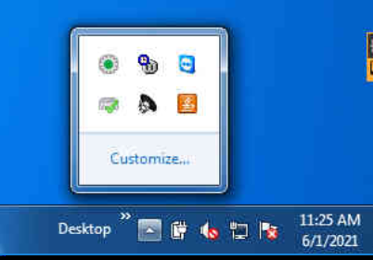

Left-click on this

* + - 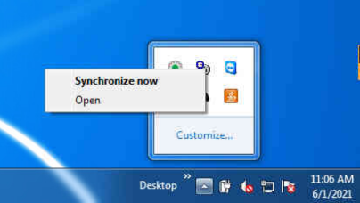**Right-click** on the icon, and select **Open**.  
      

Right-click on this and select Open

* + - The D4 configuration page opens and it should appear as shown. Pay attention to the **Synchronized** and **Current Status** fields at the bottom. It should show that it has recently synched. To test it, click **OK** and it should synch again.  
      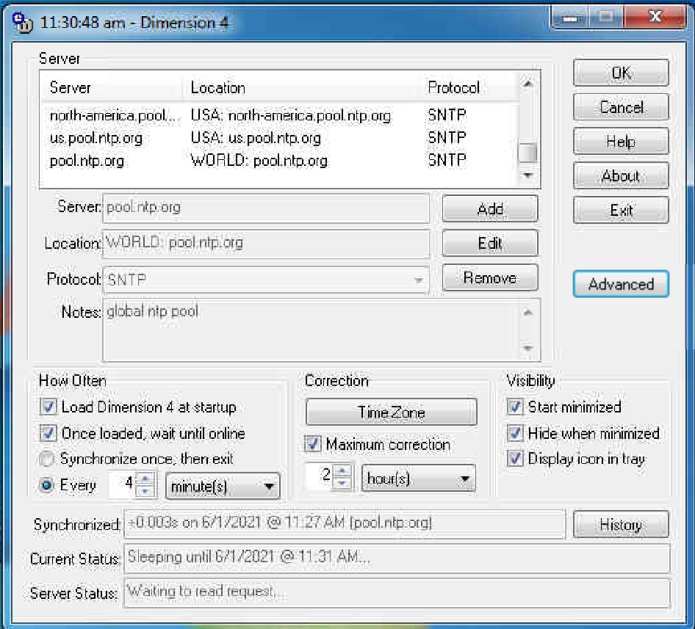  
      Notice that the server list only shows the pool servers now, but it should be set to the WORLD pool.ntp.org server, which should be the most reliable setting.
    - Minimize D4 (IMPORTANT: **NEVER CLOSE THE D4 WINDOW**. ONLY MINIMIZE IT. CLOSING IT WILL DISABLE IT UNTIL REBOOT)
    - **Close** the **services.msc** app.
  1. Configuration of D4 manually (skip this step if you used the previous automatic configuration steps):
     + In windows search, enter: “**dimension 4**”
     + Right-click on the Dimension 4 App and select: **Run as administrator**.
     + Click **Yes**.
     + Click **OK** to allow the D4 service to be installed.
     + For **How Often** box, change the interval to **4 minutes**.
     + For **Visibility**, check “**Hide when minimized**”.
     + In the **Server** group box, click the **Add** button to add the pool server.   
       There are several “pool” servers around the world to choose from. You can visit this URL for help (<https://support.ntp.org/bin/view/Servers/NTPPoolServers>). Also consider searching for the NTP pool server for your area.
       1. use “**north-america.pool.ntp.org**” for North America
       2. use “**europe.pool.ntp.org**” for Europe
       3. Use “**asia.pool.ntp.org**” for Asia
       4. Use “**oceania.pool.ntp.org**” for Australia, New Zealand, etc. (There are very few in this region)
       5. Use “**south-america.pool.ntp.org**” for South America.
       6. Use “**pool.ntp.org**” if you can’t find one more specific for your area.
     + Click **OK**. It should try to synch. When successful, the Synchronized field should show the correction and the Current Status field should show “Sleeping until…”
     + **Minimize D4**. (IMPORTANT: **NEVER CLOSE THE D4 WINDOW**. ONLY MINIMIZE IT. CLOSING IT WILL DISABLE IT UNTIL REBOOT).

1. On the CAMS computer, Register for and install DWService according to the instructions in the “**How to install DWService.net.pptx**” and create the shares as described in the document.
2. On the CAMS computer, Create the directory tree as follows:

**Do this once for the CAMS drive…**

<cams drive>\Cams2\_queue\Logs

<cams drive>\Cams2\_queue\RunFolder

<cams drive>\Cams2\_queue\RunFolder\en-US

<cams drive>\Cams2\_queue\Temp

<cams drive>\Cams2\_queue\Transmitted

<cams drive>\Cams2\_queue\Updates\ForTesting

<cams drive>\Cams2\_queue\Updates\Pending

<cams drive>\Cams2\_queue\Updates\Temp

<cams drive>\Cams2\_queue\Updates\Updates

<cams drive>\Cams2\_queue\Updates\Zips

<cams drive>\Cams2\_queue\Weather

**Do this once on the CAMS Archive drive…**

<cams archive drive>\cams\_Archive\archived\_SubmissionFiles

<cams archive drive>\cams\_Archive\archived\_Transmitted

<cams archive drive>\cams\_Archive\Cal

**Do this for each CAMS instance…**

<cams drive>\Cams2\_Board0\CAMS\ArchivedFiles

<cams drive>\Cams2\_Board0\CAMS\Cal

<cams drive>\Cams2\_Board0\CAMS\CapturedFiles

<cams drive>\Cams2\_Board0\CAMS\ConfirmedFiles

<cams drive>\Cams2\_Board0\CAMS\Logs

<cams drive>\Cams2\_Board0\CAMS\SubmissionFiles

<cams drive>\Cams2\_Board0\CAMS\Submitted

<cams drive>\Cams2\_Board0\CAMS\Temp

1. Download and unzip the files (or zip files) from the ftp server. It starts by downloading the main zip files. Then you unzip those zip files to their local directories. Then you update the files from another server folder. Then the final step, which is documented in step 6 and beyond, is to configure the configuration files. The location to download the zip files from is: “/incoming/cams2updates/Pending” from the following server dirs to the c:\Temp dir:
   1. **First step** is to download the files to C:\Temp
      * CAMS See (2019\_01\_26\_CAMS.zip)
      * Cams2\_queue\_RunFolder See (2019\_05\_23\_Cams2\_queue\_RunFolder.zip)
      * config\_files See (2018\_11\_05\_ConfigFiles.zip)
   2. **Second step** is to unzip the downloaded zip files to their destination directories. Note: If you have multiple cams instances (such as if you have more than one sensoray board) then you will unzip the CAMS zip file to the CAMS directory of each cams instance directory. For example (“d:\cams2\_Board0\CAMS” and “d:\cams2\_board1\CAMS”).
   3. **Third step** is to unzip the “<date>\_Cams2\_queue\_RunFolder.zip” file to the RunFolder under the queue directory tree. Example: “d:\cams2\_queue\RunFolder”.
   4. The **fourth step** is to unzip the “<date>\_ConfigFiles.zip” to the target directories. The “<date>\_ConfigFiles.zip” files archive has two subdirectories within it (CAMS and cams2\_queue). So, you will unzip the “cams2\_queue” files to the “D:\cams2\_queue\RunFolder” and unzip the “CAMS” directory to each of the CAMS instances.
   5. The **final** part of this step is download the updates from the server folders:
      * Download all the files from the “**/incoming/cams2updates/Pending/Cams2\_queue\_RunFolder**” server folder and overwrite all the files in the “d:\cams2\_queue\RunFolder” local directory. This will update most of the automation scripts.
      * Download all the files from the “**/incoming/cams2updates/Pending/CAMS**” server folder and overwrite all the files in each of the CAMS instances (e.g. “d:\cams2\_board0\CAMS”. This will update the CAMS software and the rest of the automation code.
2. If there are multiple Sensoray boards, there will be multiple CAMS instances. You will put instance 1 in “<cams drive>\cams2\_board0\CAMS” and instance 2 in “<cams drive>\cams2\_board1\CAMS”
   1. Sensoray board0’s config file “Sensoray812\_config.txt” should have a value for the second parameter “= 0”, where Board 1’s config file should have it set to “= 1”, and board 3 should have it set to “= 2”.
   2. If it’s not set this way, and they are all set to “= 0”, then the capture program will cause previous running capture instances to terminate.
3. Configure “**<cams drive>\cams2\_queue\RunFolder\cams2global.ini**” for:
   1. Only <n> boards
   2. Queue\_dir: <cams drive>\cams2\_queue
   3. CAMS.0=<cams drive>\cams2\_board0\CAMS
   4. Keep 10 days max (adjust to match your CAMS drive storage size)
   5. Upload to: /incoming/<seti folder for your network>
   6. ArchivePath\_base=<archive drive>\cams\_Archive
   7. Etc.
   8. From a “d:\cams2\_queue\RunFolder” command prompt, run **du** and **du64** as follows:
      * Enter:  
        **du d:\cams2\_queue**  
        The system will ask you about license agreement the first time this is run.
      * Click **I Agree**.
4. Configure each **camsgui.ini**
   1. **1st camera number**=<first camera number for the board>
   2. [CALIBRABRATION] section:   
      **detect\_flag=3**
   3. **Max days to keep**=**1000**        (This is how I disable Steve’s archiving routines, which aren’t compatible with my system)
   4. [FTP] section:  
      **IncludeExtraBinFiles=true  
      ftpupload=false**
5. Download all the cal files from PJ’s emails to temp dir and zip them into a zip. If there are no cal files available to start with, capture some FF files for a few minutes and manually calibrate using **FTP\_MeteorCal.exe**.
   1. Also, download all the files from **“/incoming/cams2updates/Cal**” to each “…\CAMS\Cal” directory.
6. Download the cal configuration zip files, such as camerasites.txt, etc from the ftp server
   1. Edit each **camerasites.txt** file with notepad or Textpad. Ensure that your editor is using a fixed-pitch font, such as Courier New, Lucida Console, Consolas, etc.
   2. Ensure that the camera numbers in the **camerasites.tx**t file are 6 digits and unique.
   3. Ensure that the lat/long/elev are correct and accurate.
   4. Ensure that the camera settings file name is correct for each camera. Be sure that the “Frame rate (Hz)” setting is correct.
   5. Ensure that the site name and abbreviation are correct for each camera.
   6. Ensure that there is one camerasites.txt file in each Cal directory of each CAMS instance. Once you have made one camerasites.txt file, for one CAMS instance, you can copy it to the rest.
   7. If the cameras have moved more than 30 meters, then you must create unique new camera numbers for each camera that moved more than 30 meters and put its new lat/long/elev in the CameraSites.txt file.
7. Download the files to **<cams drive>\cams2\_board0\CAMS\Cal**
8. Download and install the sensoray 812 board drivers and tested with the s812demo program.    
   Note: The s812demo program has the ability to adjust the brightness, etc of individual boards.  
   Note: without installing the sensoray drivers first, you get an error on channel 5 from **FTP\_Capture8AndDetect.exe**.
   1. Run the 812Demo program
   2. From Tools > All Channel Settings, select NTSC or PAL, whichever matches your video type.
   3. Click OK.
   4. At the bottom, select 8 channels.
   5. From Tools, select Start All.
   6. Check to see if there are some dark cameras or if some are too bright. Also watch for video interference patterns.
   7. For brighten or darken a camera, right-click on the camera and select settings.
   8. Select the Levels tab.
   9. For brightness, slide the slider a few points at a time until the video is usable, but not normal brightness. Too much brightness takes away the number of levels for detecting magnitude.
   10. Click OK.
   11. Do this for each camera that needs correction.
   12. Then from the File menu, select Save Settings to a Sensoray.s12 file in the CAMS directory.
   13. From Tools, select Stop All
   14. Exit the 812 Demo program.
9. Test **Camera8LiveViewer** (it might be named **Capture8LiveViewer**).
   1. New Steps:  
      Install the new VC\_redist.x64.exe  
      Install the new VC\_redist.x86.exe  
      Copy “s817dll\_2019\_03\_08.dll” to the CAMS dir and rename it to “s817dll.dll”.  
      Copy “mid812\_2019\_04\_02.dll” to the CAMS dir and rename it to “mid812.dll”.
   2. If you get errors relating to MSVCRT or VC\_RUNTIME dlls, you might need to download and install the vc\_redist.x86.exe and vc\_redist.x64.exe.
   3. Note: The viewer program is not compatible with v2.36 of the sensoray812\_config.txt file. To run it, you must provide: “Sensoray812\_v.200.txt”
10. Test **FTP\_Capture8AndDetect.exe**.
11. Set the “**open with…**” setting to use the   
    “<cams drive>\cams2\_board0\cams\**SPFF\_singlefileviewer.exe**” program so that when you double-click on an FF\*.bin file, it will open with the viewer.
12. ~~Download Dimension 4 and install.~~
13. ~~Configure D4:  
    There are several “pool” servers around the world to choose from. You can visit this URL for help. Also consider searching for the NTP pool server for your area.~~
    1. ~~use “~~**~~north-america.pool.ntp.org~~**~~” for North America~~
    2. ~~use “~~**~~europe.pool.ntp.org~~**~~” for Europe~~
    3. ~~Use “~~**~~asia.pool.ntp.org~~**~~” for Asia~~
    4. ~~Use “~~**~~oceania.pool.ntp.org~~**~~” for Australia, New Zealand, etc. (There are very few in this region)~~
    5. ~~Use “~~**~~south-america.pool.ntp.org~~**~~” for South America.~~
    6. ~~Use “~~**~~pool.ntp.org~~**~~” if you can’t find one more specific for your area.~~
14. From the command shell, run: **NET CONFIG WORK** to determine the logged in user.    
    [Write](mailto:setinz@gmail.com) down the “user name”:\_\_\_\_\_\_\_\_\_\_\_\_\_\_\_\_\_\_\_\_\_\_\_\_\_  
    computer name: \_\_\_\_\_\_\_\_\_\_\_\_\_\_\_\_\_\_\_\_\_\_\_\_\_\_\_\_\_\_\_\_\_  
    IMPORTANT: The CAMS user account must be an English en-US locale user account.
15. Run **copy\_cmd\_exe.bat** in order to ensure that all the cmd.exe clones exist properly and that their corresponding .mui files exist in the **en-US** dir.
    1. Be sure to run the command shell that you’re running this script with using an administrator level command shell.
16. **Import** each of the Cams2… scheduled tasks (I have a created scheduled tasks with names that start with “Cams2” so that they group together in the Scheduled Tasks program) and configure per steps a-c below. Test each task after you’re done configuring all of them.
    1. **But first, disable all the current scheduled tasks.**
       * The list of scheduled tasks is here. For each task, perform steps a-c:
17. Cams2 Archiving
18. CAMS2 GetStatus
19. Cams2 KILL Capture8
20. Cams2 KILL WerFault.exe
21. Cams2 LaunchCapture board0
22. Cams2 LaunchCapture board1
23. Cams2 LaunchCapture\_KILL
24. Cams2 UpdateScripts (default disabled)
25. Cams2 Upload\_Queue
26. Cams2\_Data\_Plan\_Reboot
27. Cams2\_Data\_Plan\_Reset
28. Cams2\_Reboot PC
29. Change **User** or Group to the user name you wrote down before
30. Edit all the fields in the **Action** tab to specify the drive of the computer as either “**<cams drive>**\cams2\_queue\RunFolder” or “**<cams drive>**\cams2\_board0\CAMS”
31. Run with **Highest Privileges**
32. Test the **Cams2 LaunchCapture board0** scheduled task. If it does not launch the 4 capture windows, press ALT+S.
    1. Waits until sun to drop… 08:50 UT because it’s summer there.
    2. In the CameraLiveView Console Window, press CTRL+P twice to end the capture session. IF it does not respond, hit CTRL+C.
    3. It seemed to successfully launch autocal, detect, and apply.
    4. Tests OK.
    5. Test any other boards also.
33. Test **LaunchCapture\_KILL** scheduled task:
    1. Launches OK
    2. Creates forecast file in the <cams drive>\cams2\_queue\Weather dir.
       * Note: If it fails to create the forecast file in the weather dir, it is typically because the camera numbers in the camerasites.txt file don’t have leading zeros.
       * Another cause for failure can be in Cams2Global.ini [CAMS2DIR]   
         bat\_CAMS2DIR.0 setting has the wrong drive.
       * Also check for the correct directory name. Such as cams\_board0 instead of cams2\_board0.
       * Another reason it fails to write to the Weather directory is due to some msxml3.dll error. We are still working to determine how to solve this issue.
34. Test **cams2 data plan reboot** scheduled task: (This one upgrades the BytesThisBillingCycle.txt file with new fields)
    1. First, you need to register the DU.exe and DU64.exe programs as follows:
       * First, from a command prompt, navigate to: <cams drive>\cams2\_queue\RunFolder
       * Then, run the following command:  
         du .  
         This will prompt you to agree to the license.
       * Click I Agree
       * Click OK
    2. Runs ok.
       * Troubleshooting: If you get “not enough memory to run this command…”, it’s possible you didn’t do step 19 (or there was a problem with it). Go back and ensure that all the cmd.exe copies are valid by running the command again as an administrator.
    3. <cams drive>\cams2\_queue\**BytesThisBillingCycle.txt** file is updated correctly. (automatically initialized)
    4. Data plan offset is correctly set to: 0,0,0
    5. Data plan month is correctly set to: 01
    6. Reboot date string is correctly set.
    7. Month “01=” is correctly set.
35. Test **cams2 data plan reset** scheduled task:
    1. Data plan month is correctly set to 01
    2. Data plan offset is correctly set to: network total, network inbound traffic, network outbound traffic (since boot)
    3. Data plan’s matching month “01=” is set to 0,0,0.
36. Set **defaults** and **properties** for the cmd shell **buffer** to have **300 chars wide** and **9999** lines long.
37. Configure the **cams2global.ini** [CAMS2ARCHIVE] settings to drive **<cams archive drive>**.
38. Test **cams2 Upload Queue** scheduled task:
    1. Runs ok
    2. Uploads .zip and .md5.txt files ok
    3. Correctly runs getstatus.bat
    4. Uploads getstatus report to **/incoming/status** OK.
39. **Disable Windows Updates** using the instructions in the “**DisableWindowsUpdates.txt**” file.
    1. There is also a “DisableWindowsUpdates.reg” file you can use to disable parts of windows updates via the registry:
40. If you don’t already have a password for the CAMS user, set one using the following:
    1. From the windows search, enter “cmd”.
    2. Right-click on the desktop app and select: “Run as administrator”. Answer any questions as necessary.
    3. From the command prompt, enter the following command:  
       **net user <user name> <password>**
41. Configure **Automatic Login** using the following steps:
    1. From the windows search, enter “**netplwiz**” (windows 8 and higher). For Windows 7 and before, Run > Control userpasswords2.
    2. Click on the one at the top of the list that appears. The User Accounts dialog appears.
    3. In the “Users for this computer” list, select the user account from step 18.
    4. Uncheck the checkbox for “Users must enter a user name and password to use this computer”.
    5. Click Apply. A dialog appears.
    6. Enter the password twice and click OK.
    7. Click OK.
    8. Test by rebooting the computer. It should automatically login.

If the netplwiz dialog doesn’t show a checkbox, you might be required to do this with the registry editor. See this article about how to do it.:  
<https://computerinfobits.com/windows-10-auto-login/>

Note: Some people worry about having the computer always being logged in this way. If you want it to be locked down so others can’t use it, set the screen saver to come on after a minute or so and require a password to awaken. Many of the scheduled tasks won’t work properly unless the computer is logged in.

1. Test **Cams2 GetStatus** scheduled task:  
   As the scheduled task ships right now, it’s possible that it is improperly configured to run under a command shell copy called “cmd\_getstatus.exe” when it should be “cmd\_getstatus.bat.exe”.
   1. Edit the scheduled task for “Cams2 GetStatus” and modified the Actions to use “cmd\_getstatus.bat.exe” instead.
   2. If it fails, it is sometimes because the du64.exe or du.exe program hasn’t been registered yet. Run it from a command line and click “Agree”.
2. Test **Cams2 Archiving** schedule task:
   1. It should copy files to the cams\_Archive dir. All three archive folders should have some files in them.
3. Update **System Properties**:
   1. Configure the system to have a fixed size paging file
      * Start **Windows File Explorer**.
      * Right-click on “**This PC**” and select **Properties**.
      * Select **Advanced** system settings.
      * Select the **Advanced** tab
      * For **Performance**, click **Settings**.
      * Select the **Advanced** tab.
      * For virtual memory, click **Change**.
      * **Uncheck** “**Automatically manage paging file size for all drives**”.   
        Note: The automatic setting is VERY bad. Without going into all the details of Windows virtual memory manager, suffice it to say that the “automatic” setting starts with a small paging file and allows it to dynamically grow as needed. There are two problems with Microsoft’s approach. (1) When it grows, it only grows by 8k at a time. (2) When it is reshuffling and growing the page file, it is a STOP THE WORLD event. That’s right, not a single thread gets any execution time while it is growing the pagefile. Therefore, let’s say that you are nearly out of memory and pagefile usage at its current level. Then you start a program that is, let’s say, 10 MB including the exe and RAM needed to execute. Windows would attempt to grow the pagefile 1,280 times! 8K at a time. Each of those 1280 events windows would completely stop. I’ve seen it go through this for 3 hours. Therefore, the most efficient pagefile is one that has a fixed size. Very often, we set the fixed size to be double the size of RAM (unless the amount of RAM is very large). For a CAMS computer, custom size of 8192 (that’s 8 GB) as initial size and 8192 for maximum is a good setting. Remember, this is in addition to the amount of physical RAM.
      * Select the **paging file drive**.  
        Note: You can split the workload of paging file across multiple drives. However, if you have an SSD, you’ll probably want a smaller paging file on that drive only. In that case, I’d select a 4 GB paging file instead of 8 GB and specify the SSD drive as the paging file drive.
      * Don’t forget to click the “**Set**” button. I dialog will appear reminding you that these changes won’t take effect until you reboot. When it reboots, it will rebuild the paging file to the new size.
      * Click **OK**.
      * Click **OK**.
      * Click **OK**. I dialog appears asking you to restart now or restart later. That’s up to you. I prefer to restart later and do it when I am done configuring everything else.
   2. Configure Windows to NOT animate windows and menus. This is to improve performance when operating remotely. You can google “windows 10 disable window animation” to locate articles for your operating system version. For Windows 10, follow these steps:
      * Press **Win+R** (or click the cursor in the search box).
      * Enter **sysdm.cpl**. The System Properties dialog appears.
      * Select the **Advanced** tab.
      * For **Performance**, click **Settings**…
      * Under the **Visual Effects** tab, *uncheck* the following:
        1. **Animate Controls and elements inside windows**
        2. **Animate windows when minimizing and maximizing**
        3. **Animations in the taskbar**
        4. **Fade or slide menus into view**
        5. **Fade or slide ToolTips into view**
        6. **Fade out menu items after clicking**
      * Click **OK**.
      * Click **OK**.

## Important note about Windows Files Explorer and Notepad:

**Important Note:** Various parts of the system will move files autonomously, when you don’t know it will do it. For that reason, it is extremely important to **never lock a file or directory**. How would you lock a file or directory? Using **Windows File Explorer** to navigate to directory will lock that directory. Yes, it is true, that, for example, if you use the Windows File Explorer to navigate to, such as “D:\Cams2\_Board0\CAMS\CapturedFiles”, will lock the entire directory. If one of our scripts or programs attempts to move the directory to SubmissionFiles, or if the archiving scripts attempts to cull files and move them to the Archive drive, the script or program will fail and break the script. The directory will remain in place and will not be moved. Likewise, opening a file in one of our directories with a program like **Notepad** will also lock the file. So, when AutoCAMS attempts to move a directory, all the files in the directory will be moved except the file you have locked AND the directory will still remain. This is why we install TotalCommander and TextPad on all the systems.   
To avoid this problem, use TotalCommander to navigate and copy and move files and use Textpad to open files for editing. Also, TotalCommander has a View tool to view the contents of files without opening them for edit. None of the tools lock the files.   
One of the things that has happened in the past is when I’ve used Windows Files Explorer to quickly navigate the file system, but then to lose the TeamViewer or DWService connection for a while. Later to find out that the system failed to move a directory because I couldn’t close the program before it attempted to do its work on it.

Therefore, **NEVER USE WINDOWS FILE EXPLORER OR NOTEPAD**.

## Additional Configuration Tweaks

This section will include miscellaneous configuration tweaks.

### **Exclude CAMS directories from anti-virus real-time scanning.**

Real-time virus scanning can mess up or interfere with CAMS in a few ways. The primary concern is “dropped frames”. During capture, when the files are being written, if real-time virus scanning must re-read each file, then there is the possibility that the I/O interrupts might cause dropped frames. Dropped capture frames cause meteors to appear to have much higher velocities than they have and the data reported is wrong. While a few dropped frames are inevitable on a Windows system (which cannot be configured as a “real-time” operating system), we need to take measures to avoid them.

The secondary concern is the time it takes to perform post-capture processing. We have seen that real-time virus scanning can slow these functions by as much as 4 times!

So, the idea is to add the three base CAMS directories to the exclusions for real-time scanning as well as the two WinSCP executables.

You can follow these instructions to disable real-time scanning for the following directories:

1. In the Search box, enter: **Windows Defender**.
2. Select **Windows Defender Security Center**
3. Under the “**Security at a glance**” section, click on “**Virus & threat protection**”.
4. Click **Virus & threat protection settings**
5. Scroll the window down until you see “**Exclusions**” in the right pane.
6. Click on “**Add or remove exclusions**”.
7. Click on “**Add an exclusion**”
8. For all CAMS exclusions except for the **WinSCP** exclusions, select “**Folder**”.
9. Navigate to and select the CAMS directory to exclude and click “**Select Folder**”.
10. Click **Yes**.
11. Repeat these steps for all the following:

* Cams2\_Board<n> (Folder)
* Cams\_Archive (Folder)
* Cams2\_queue (Folder)
* WinSCP.com (Process)
* WinSCP.exe (Process)

<https://wiki.nus.edu.sg/display/DA/Add+folder+exclusion+-+Windows+Defender+Security+Center>

We need to also exclude both the WinSCP.com and WinSCP.exe processes so that they are allowed to perform the upload/download functions.

### **Write-cache**

By default, Windows disables write-behind caching on all external storage devices, USB drives, such as USB2, USB3, eSATA, NAS, DAS, and external USB drives, and memory sticks, and floppy disks. This is because those storage devices could be unplugged at any moment without notice and without enough time to flush the write cache to the device. However, for CAMS, if such a device is actually being used for one of the CAMS storage devices (CAMS, cams\_Archive, cams2\_queue), and you will promise to make sure that you eject the drive or turn off or hibernate the system before unplugging the device, then you can re-enable the write-behind cache and improve the performance by as much as 10 times in some cases!

Here are directions shared by Andy Howell that he used to dramatically improve the performance of his USB 3.0 Drobo (DAS) storage device for use as the main CAMS and Archive drive.

I made a Windows software change two nights ago that reduced post-capture processing time from 4 hours to 1 hour. Here's how:

1. Open Device Manager;
2. Click on Disk Drives. Then right-click on the external hard drive where the CAMS files are located. Open "Properties" and then select the "Policies" tab;
3. The policies tab has two radio buttons: "Quick removal (default)", and "Better performance";
4. If this is currently set at "Quick removal (default)", change it to "Better performance".

What this does is to eliminate write caching.

More information - <https://tinyurl.com/y8zhkvap>

On my i7 computer, the change reduced post-capture processing time from 4 hours to 1 hour! It also reduced the number of dropped frames. Over the past two nights, there have been zero (0) dropped frames on all 8 cameras.

One drawback is that if there is a power outage while the drive is being used, there WILL BE lost data and possibly corrupt FF files. Since the computer and hard drive are both on a UPS, this should not be an issue. Also, since FTP\_ValidateFFfiles.exe fixes such corrupt files, it should be less of an issue.

## Configuring an internal hard drive

When you install a new larger hard drive into a system, it needs to be partitioned and formatted to NTFS. These steps summarize that procedure. It may be different for your system, but this is the general way of doing it:

1. Start Windows Explorer.
2. In the left pane, right-click on “This PC” and select “Manage”. The Computer Management window appears.
3. In the left pane, select Disk Management. After a few moments, the Initialize Disk dialog appears.
4. Select the uninitialized disk.
5. Select GPWT
6. Click OK.
7. In the bottom pane, right-click on the uninitialized disk (In this screenshot, it is Disk 1).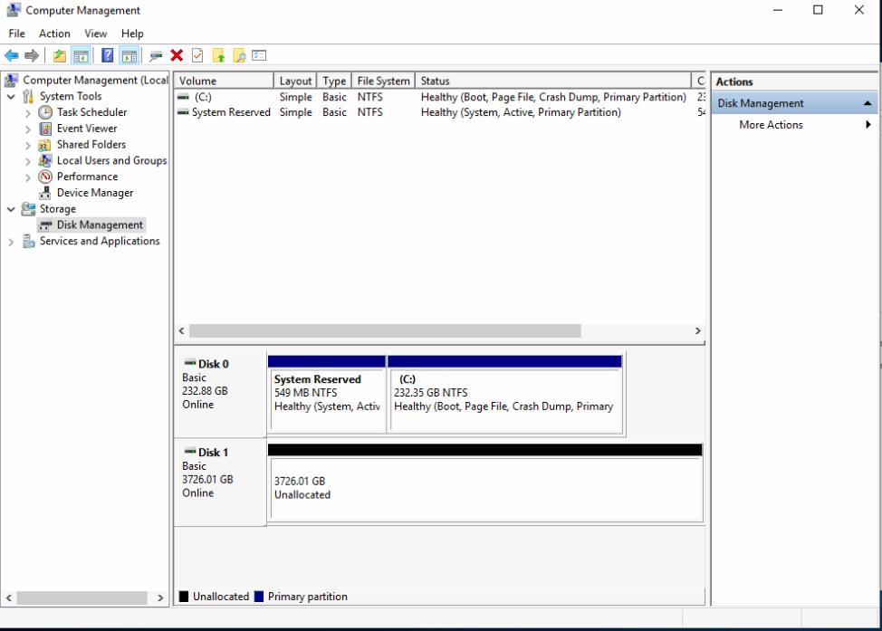
8. Select “New Simple Volume”. The “New Simple Volume Wizard” dialog appears.
9. Click Next.
10. Accept the default (initializing the entire drive as a single volume of the full size of the drive).
11. Click Next.
12. Accept the default and click Next.
13. For the “Format Partition” wizard page, Change the Volume Label to: “CAMS”.
14. Click Next.
15. Click Finish.
16. Close the Computer Management window.

## When Power is required (and Post-capture Phases)

There are several scheduled tasks that need to run - most of them each day - for full autonomous operation. All times are in local time.

1. At 5 pm each day, the system runs the LaunchCapture.exe program.  Since there is no practical way of automatically adjusting the LaunchCapture launch time, we run it at the earliest time of the day of the earliest capture time of the year.  (Winter Solstice nights are the longest, with the earliest time it is dark enough to capture around 4:30 - 5pm)  When LaunchCapture.exe starts, it checks the date and calculates the "actual" capture time (when it is dark enough based on sun angle) to start recording.  Then it puts itself into a sleep until the actual capture time.  At the actual capture time, it awakens, calculates again when capture should actually start in order to verify that its awakening wasn’t premature, then it calculates how long it should capture (duration - based on sun angle), and starts capturing.  Therefore, the PC should be on BEFORE 5pm each day (I'll explain the "before" part next.  Power to the cameras doesn't need to come on until dusk.  Many stations use a timer with a photocell to turn power on to the cameras.  This works ok for the cameras. However, the PC needs to be on much before that.
2. At 4 pm each day, the standard scripts reboot the PC.  We do this because experience has taught us that the PCs sometimes just get hung up in one way or another at times when we least expect it.  Sometimes, it's just the network interface.  Other times, it is a frozen application that has locked itself up.  Very seldom, but it does happen, some of my scripts get hung up.  Another cause is that sometimes applications pop up a modal dialog, which can lock the system up indefinitely (until someone logs in and closes all the dialog boxes).  When the network interface, or windows itself is locked up, we can't remote into it and solve the problems.  Rebooting the PC once per day helps to avoid these problems a lot.  With the daily reboot, we still have cases where someone actually has to go out and fix something (like the Meteor Crater station right now).  However, since we have started rebooting daily, aside from those rare cases where someone has to actually go out and fix something, we only have to wait until 4 pm the next day to be able to log in and work on the system. The reason we chose 4 pm is because sometimes when it boots, there are some required windows updates or other kinds of things that run and some of them can take some time. We need the station to be ready for the LaunchCapture\_KILL task, which is launched at 4:50 pm.  
     
   Therefore, the PC needs to have power at least a few minutes before 4 pm each day.  The time of this task can be adjusted, probably as late as 4:30pm, but probably not much later than that.
3. At 4:50 pm each day, we run **the LaunchCapture\_KILL** task.  This is a task that kills all CAMS related tasks in order to clear the way for the next day's new capture sessions.
4. At 3 pm, we run the **daily Archive routines**.  These are extremely important for a remote autonomous system because it's the script that keeps the hard drive from filling up.  The start time for this can be adjusted.  However, we need to ensure that this activity doesn't overlap with other post-capture processing from the morning.  Depending on how long it has been since this task ran, this task can take an hour or so to run.  It is designed to be resilient, in that, if it fails (let's say because the system is rebooted during archiving) it will re-archive the sessions that didn't finish the following day.
5. At the end of the night, let's say, around 6 am, the capturing stops and post-capture processing begins.  It's not always at the same time because capturing ends based on sun angle, which changes throughout the seasons.  Post-capture processing consists of **4 main phases**:
   1. **Validation** - We iterate through each FF file and check if it is corrupt. If it is corrupt, we rename it with the “.bad” extension instead of the normal “.bin” extension. This process takes a long time, since you might have 16 cameras on a 14 hour winter capture night. That would mean about 100,000 or more FF files that have to be checked. This phase is normally handled by the LaunchCapture instance.
   2. **AutoCal** - We iterate through all the captured files, ordered by camera, skipping a few minutes between samples, and compare the image of the night sky against a database of stars (magnitude 8.5 or brighter). Then we create CAL files in that are used to determine the exact locations of the center of the FOV of the camera for that night. These calibrations are later used during meteor detection to get very accurate sub-pixel coordinates for each frame of the event. This phase is normally handled by the LaunchCapture instance.
   3. **Detection** - (sometimes called "reprocessing" because of an old name. Also sometimes called "meteor scan".) Detection uses FTP\_DetectMultipleFF.exe and FTP\_DetectSingleFF.exe. It is a multi-threaded program that scans each FF file for streaks, given certain thresholds as specified in one of the config files. This phase is normally handled by the LaunchCapture instance.
   4. **Transmit** - This phase us launched by the Cams2 Upload\_Queue task. It's a special script that creates a zip file for each capture session, that hasn't already been transferred, into the queue dir. Once all the transfer zip files are created and placed into the queue, it iterates through each and attempts to upload. This script is designed to be resilient against all sorts of failures. Whatever the failure, it can pick up and finish next time from where it left off. It can even determine if an upload only partially succeeds. In which case it forces a retry.
6. All these phases can take some time.  If you have 16 cameras on a slow computer (maybe because the CPU is fast but the hard drive is slow), post-capture processing can take from 1-3 hours for a normal capture session... sometimes even more.  We need to leave the PC on long enough for the average night's capture sessions to finish post-capture processing.  Some computers are able to finish by 10 am while others take until 2 pm.  We have to determine this after running for a week or so.  Until we can determine the actual average, we need to leave the PC on all day to give it a chance to test and to gather information.
7. If any maintenance needs to be done on the system remotely, it will likely be done by us during California daylight hours 8 am until 8 pm let's say.