Module CAMS — Installation and Procedures

Goals
Install and run the single-camera CAMS system

Tasks | 1. | Set up the Camera
 | 2. | Clock Synchronization
 | 3. | Introduction to the AutoCams Menu System
 | 4. | Directory Structures
 | 5. | Download and configure the CAMS software
 | 6. | Calibrate FOV (Manual Calibration)
 | 7. | Manual Re-Calibration Sample Run
 | 8. | Understanding and Setting up the Twilight table
 | 9. | Setting up the Task Scheduler
 | 10. | Summary of the daily procedures
 | 11. | Capturing Video
 | 12. | Calibrating
 | 13. | Applying Calibration to Detect File
 | 14. | Reprocessing (MeteorScan)
 | 15. | Confirming (optional)
 | 16. | Collecting
 | 17. | Transmitting
 | 18. | DVD Archiving
 | 19. | Autonomous Mode Instructions
 | 20. | Calibration tricks
 | 21. | Coincidence
 | 22. | Manual Coincidence Preparation
 | 23. | Archiving for DVD with MakeArchiveDateZip.bat
 | 24. | "AutoCams.Params.ini" file settings
 | 25. | Multiple Cameras on One Computer
 | 26. | Focusing Tips and Tricks
 | 27. | AutoCams Utilities
© 2013 All rights reserved. |  | CAMS-1

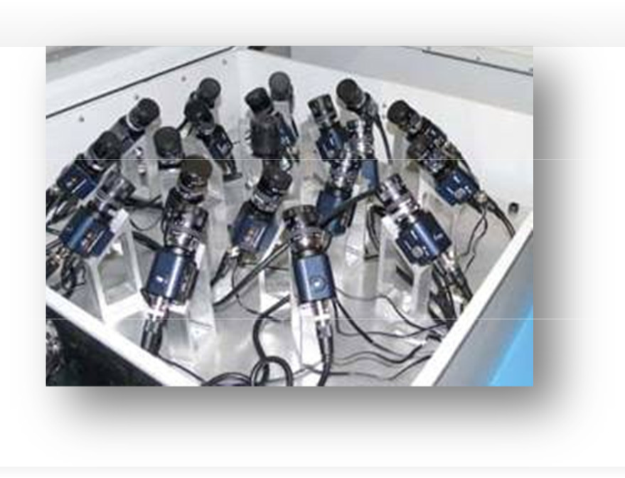Background
This document describes the amateur CAMS system that you can install at your home, school, or other location. CAMS is an acronym for "Cameras for All-sky Meteor Surveillance". The first three main all-sky CAMS array sites were set up in the Northern California network at Fremont Peak Observatory, Lick Observatory, and Sunnyvale. There is also a version that captures spectral data.
NASA/SETI is allowing amateurs to contribute to this science by setting up single- or multi-camera CAMS systems at their homes, schools, etc. and this will provide a level of redundancy against fog and other breakdowns as well as
providing improved accuracy in the data. You may be credited for discoveries and measurements made by your CAMS site. For additional information, see "http://cams.seti.org/easyCAMS.html". There is a user support group on Yahoo Groups that you can join by emailing:
"seticams-subscribe@yahoogroups.com". Once you subscribe, please enter your site information into the "CAMS Locator Table" Database and use the Database to find others in your local network.
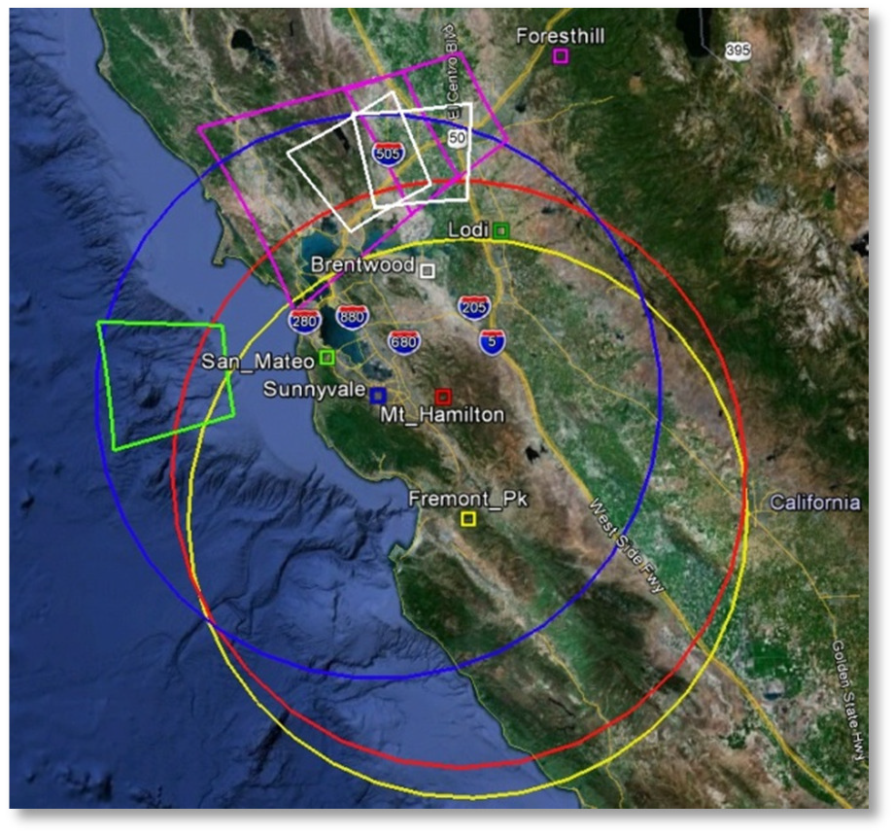The picture on the left shows the areas of coverage of the CAMS arrays in the San Francisco bay area and its single CAMS sites (circa 2012). The next picture shows the meteor tracks from the Mountain View, CA CAMS array on a single night in Dec 9, 2011, even with some cameras not functioning. You can see that Earth is under constant bombardment.

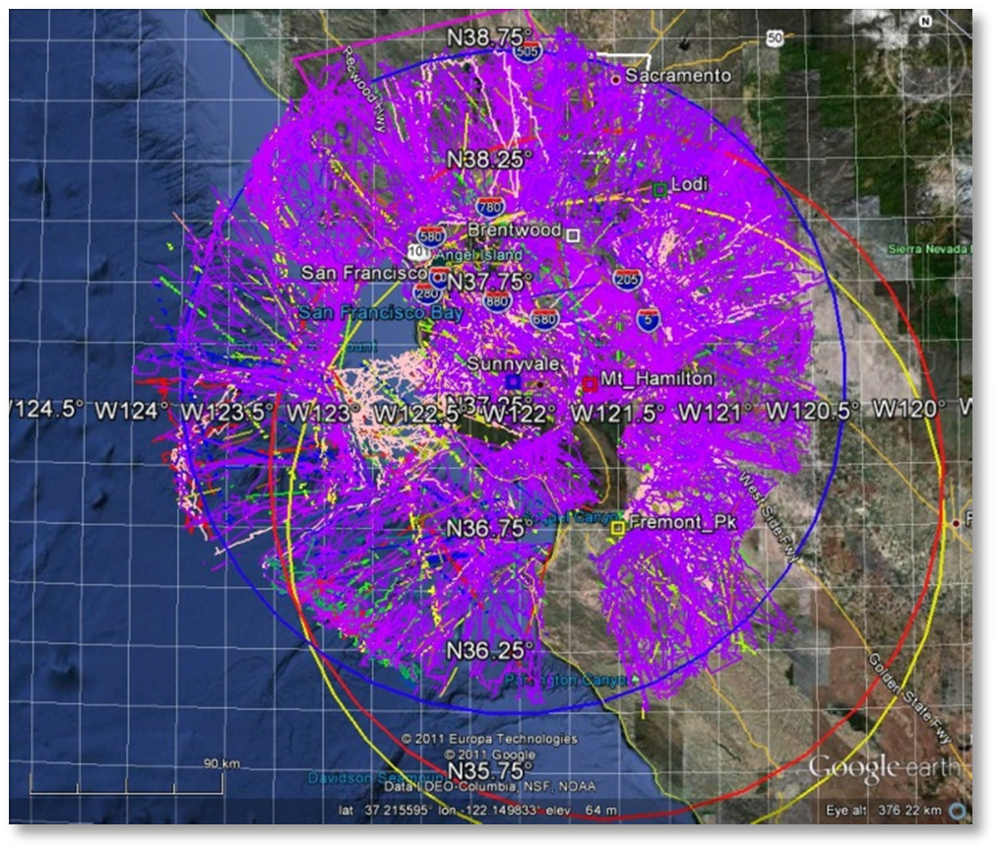

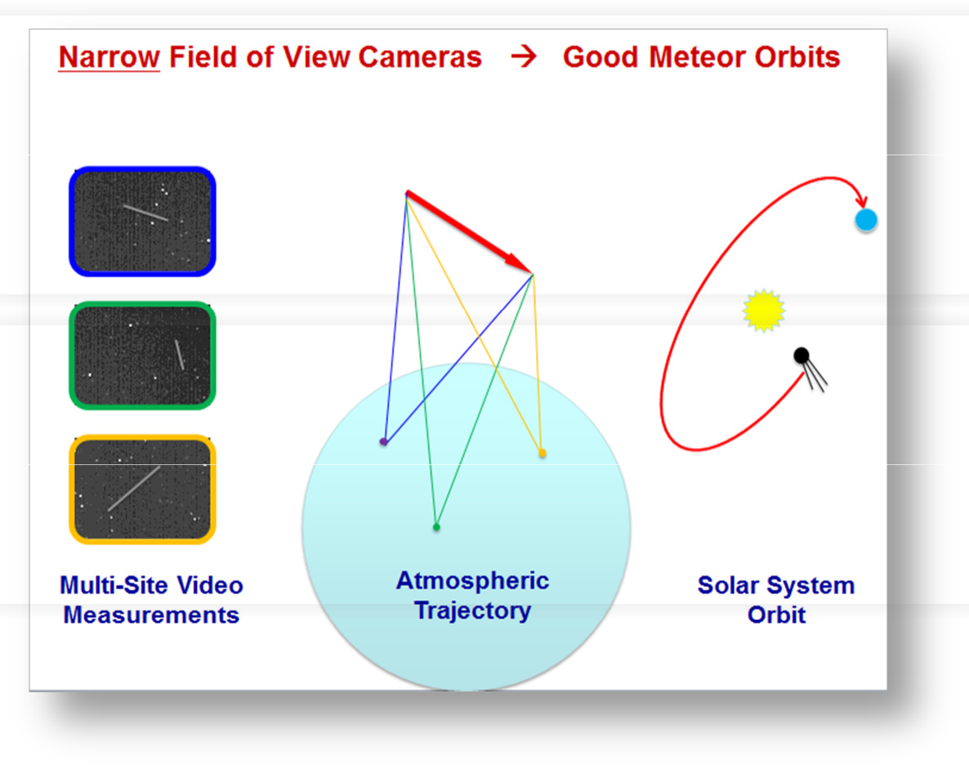In 2011, there were over 400 or more known meteor showers. 300 of those were not confirmed. The purpose of the NASA/SETI CAMS project is to confirm the known meteor showers and discover new ones. You can visit "https://www.ta3.sk/IAUC22DB/MDC20 07/" or just Google search "Meteor Data Center"
A meteor shower is caused when the Earth passes through the dust trail of a comet or asteroid that has previously passed through Earth's orbital path without colliding with the comet. A meteor shower implies the presence of a potentially hazardous comet. If the dust trail can hit the Earth, so could its parent
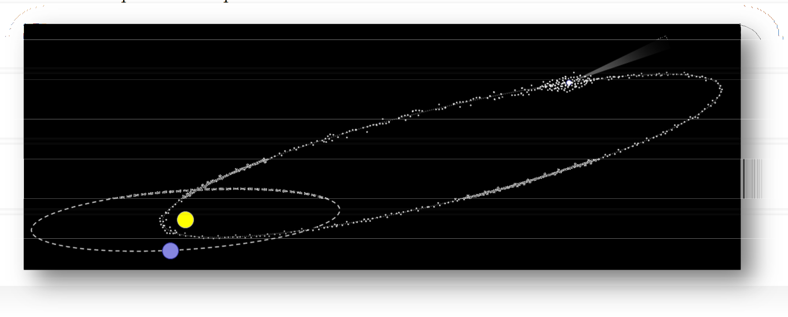comet. The dust trail shares the same orbital path as its comet. In principle, it will be possible to guard against such impacts by looking along the meteoroid particle stream orbit to those spots where the comet would be in such a dangerous position - possibly providing a few years of warning. There is no real need to find all the comets associated with all the meteor showers, only those comets that would be in the position to impact Earth need to be located.

Using the CAMS array, since November, 2010, hundreds of meteor showers have already been detected and new ones have been discovered (See http://cams.seti.org for updates). Over 50,000 orbits were calculated in the first year of operation! In 2019 there were over 619 cameras worldwide in 116 sites in 23 networks. Almost 360,000 orbits calculated in just 2019 alone. See IAU’s Meteor Data Center for lists of showers. This image shows the growth since 2007 of the meteors detected per year. The black and blue lines depict CAMS orbits.

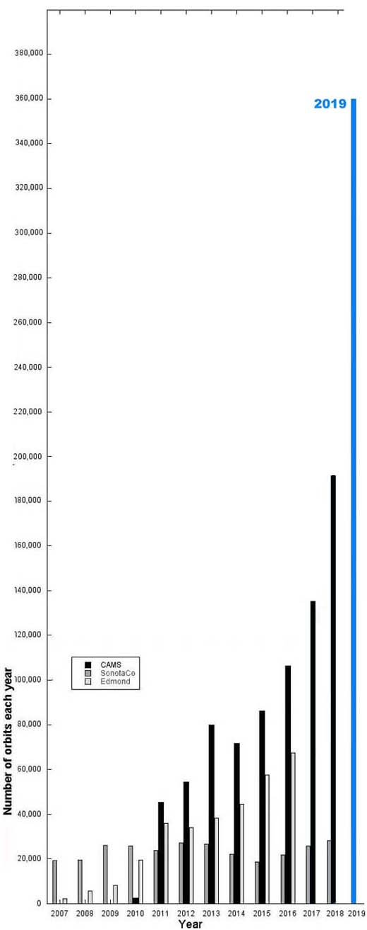

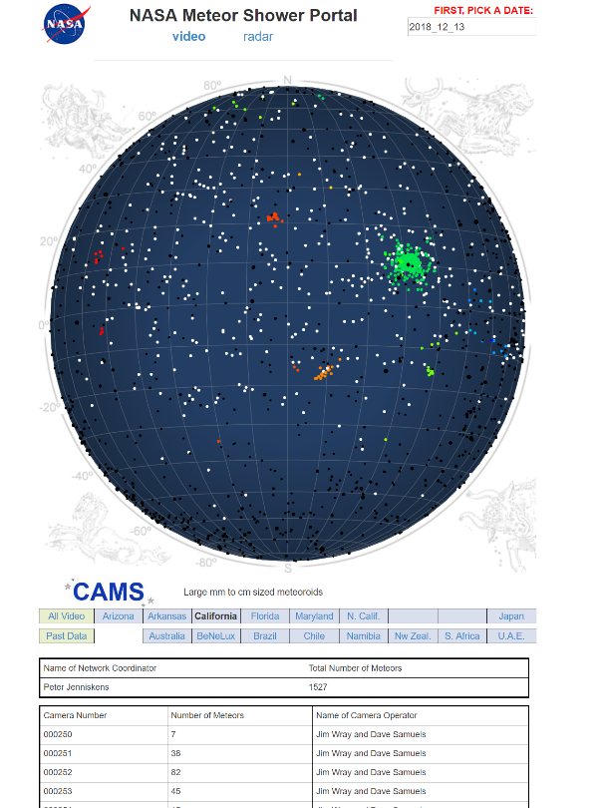
For an updated interactive view of meteors, see the FDL site (http://cams.seti.org/FDL/index.html). You can see in this screenshot where it shows a map of the night sky with several meteor showers (colored dots) detected by CAMS, along with the cameras, count, and their site operators contributing to the coincidence/triangulations.
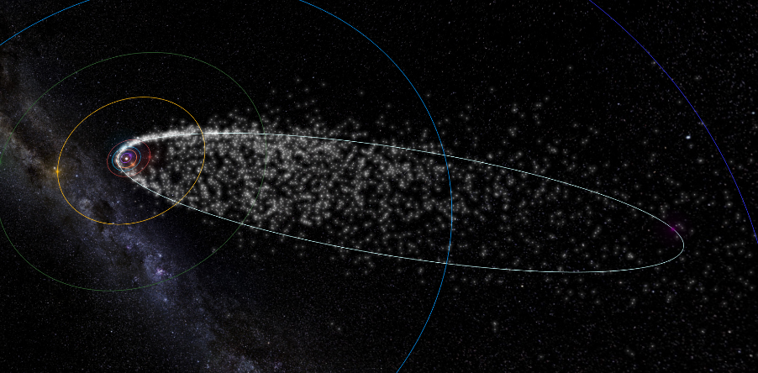
Clicking on a dot presents an animated depiction of the meteor shower’s orbit.

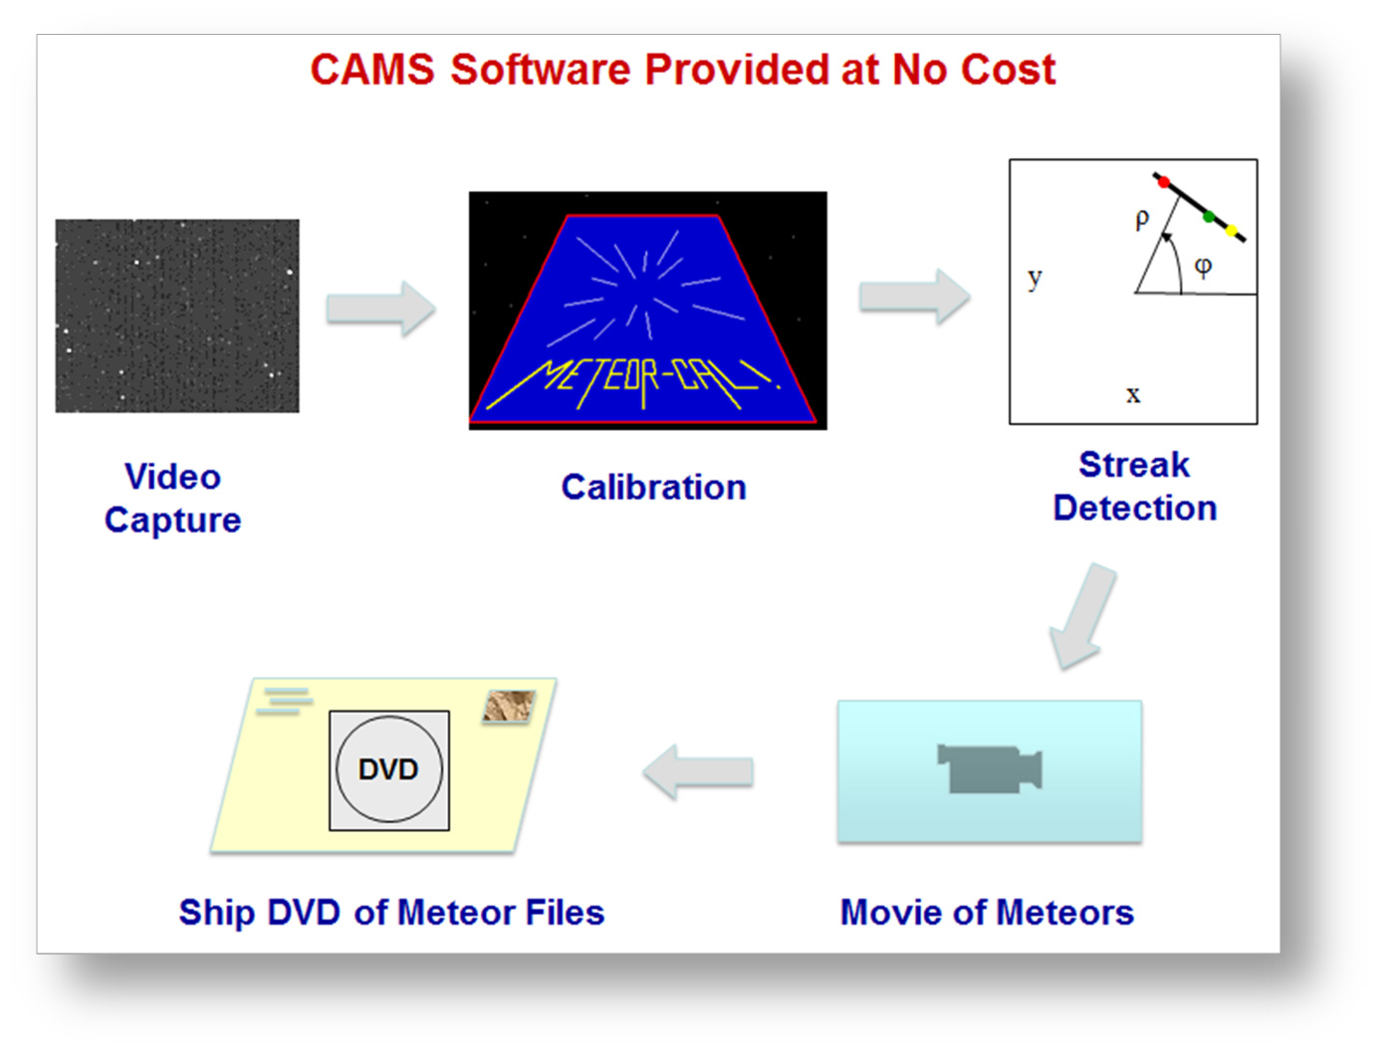A CAMS system takes movies from a highly sensitive video camera at 30 fps and searches for signs of meteors in the video frames. This detection is done locally using software that is provided at no cost, in order to reduce the volume of files sent back to NASA/SETI. Data, in the form of small text files, is sent back to a central coordinator at NASA/SETI where triangulation (coincidence) from other sites is performed to ascertain additional information, such as speed, angle of attack, altitude, and finally the orbital elements of the particles. Only two
cameras need to capture the same meteor to determine the orbital elements of the particle stream. The more cameras that can detect the same meteor, the more accurate the orbital data becomes - as well as providing a higher meteor count for all overlapping stations. Also, the more sky coverage, the more likely it is to detect a meteor in another part of the sky belonging to the same particle stream.

Before you begin, you will need the following items:
Good News: Jeff Jones worked out a deal with A/V Supply in California for special pricing on Watec camera, C/CS adapter, and lens. This is only for individuals who are purchasing the configuration we use. The price on the cameras has jumped to $345 due to a parts shortage as a result of the quake/tsunami in Japan.
Contact Julian and mention Jeff Jones or the account code JON18 for the discount.

 | Watec WAT902H2 Ultimate | $345.00
 | C/CS 5mm Spacer | $9.00
 | Pentax C61215KP 12mm f/1.2 lens | $87.88
SUB: |  | $441.88
- Required:
  - Video Capture device - The following devices have been tested:

    - Sensoray Model 812 8-channel frame grabber ($216 or $202 in qty 2+). This is the workhorse of the CAMS system worldwide. These are PCIe boards and sometimes don’t fit in small form factor systems.
    - EasyCap 116 USB ($31) We suggest purchasing two of these so you have one as a backup - it is a critical path and it can fail.
    - Other video capture devices have been used. Some produce very poor images and some are unreliable. The recommendation is to check with us before purchasing to determine if your device has been vetted and proven to work with CAMS. Since CAMS is supported mostly by volunteers, it
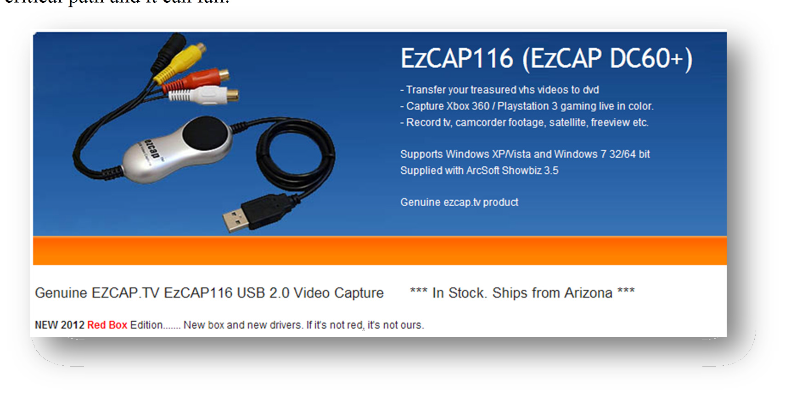

Warning: According to "http://www.easycap.tv/", the original EasyCAP device has been pirated and is not the fake one available on the amazon.com link below. The one at the Amazon.com link below is the one that I use and it works. I have tested that device on Windows 7 64, and it does work on XP and Windows 2003 64. It is difficult to determine who is telling the truth. Some have stated that the devices with the gold contacts is the original, where the devices without the gold contacts is the fake.
Note: The older version of EasyCap DC60 is about $8 and has proven to drop video frames and data. While it will work in some cases, it is better to get the "plus" version. However, the 116 is the official non-pirated product.
•
    - http://www.ebay.com/itm/EzCAP-116-easycap-DC60-XP-Vista-Windows-7-/200623434994

    - http://www.amazon.com/Easycap-Version-Capturer-Camcorder- Compatible/dp/B0044XIQIW/ref=sr_1_1?s=electronics&ie=UTF8&qid=1338269556&sr=1-1

  - CAMERA – There are several cameras to choose from. Ideally, a Watec 902 H2 Ultimate is used. However, these are over $400. There are pros and cons for these though. They are good and reliable and produce good images for years. However, for the price of one camera and the more expensive ½ inch lens, you could purchase 10 of the cheaper 1/3” cameras each with a f/1.0 lens.
    - Watec WAT-902H2 Ultimate (about $400)
      - http://www.spytown.com/watec-wat-902h2-ultimate-eia.html ($308)
      - http://www.avsupply.com/Watec/wat-902h2-ultimate.php
      - Watec WAT-AD901 1210 (about $29) - Sometimes, the 12 VDC power supply does not ship with the camera. You may need to purchase one. You may be able to scrounge one up from an old 12VDC adapter laying around like I did. Just be sure that the connection is the correct polarity before plugging it into the camera. If you are not in the US, you may need a different power supply.
      - http://www.spytown.com/watec-wat-ad901-1210.html ($29)
      - http://www.amazon.com/Watec-WAT-AD901-220VDC-300DH- 525EX/dp/B006WXR6X8/ref=sr_1_1?ie=UTF8&qid=1339544094&sr=8-1 ($29 no tax, no shipping)
    - Sony ExView HAD II 960H based 1/3” camera. (between $13 and $70) Contact us before purchasing. Various cameras have been successfully purchased from various Chinese vendors. Be sure to ask the vendor to remove the IR cut filter before ordering. You may need to remove the IR cut filter yourself with a heat gun.

  - LENSES – It’s important to purchase the correct lens for your camera. For the ½” cameras, the 12mm f/1.2 Pentax lens (or comparable) is used. Better focal ratios are not readily available and very expensive. For the 1/3” cameras, there are several vendors offering f/1.0 lenses for $8-$15. These are IR lenses. It is important for the 1/3” cameras that the focal length of the lens is purchased based on the elevation angle of the pointing of the camera (to maintain the target spatial resolution). 6mm for cameras pointing 74 – 90 degrees. 8mm for cameras pointing 45 – 74 degrees. 12mm for cameras pointing lower than 45 degrees. You can practically make an all sky array with sixteen 1/3” cameras using these
    - For Watec only: 12-mm f1.2 Pentax lens (about $110)
      - http://www.spytown.com/pentax-c61215kp.html
      - http://www.nextag.com/Pentax-C61215KP-12MM-F1-616003011/prices-html
      - (also at AV supply)
    - C-CS mount adapter (about $16. You most likely need this to reach focus. See the section 1.2. Attach the Pentax 12mm f/1.2 lens below about reaching focus)
    - http://www.bhphotovideo.com/c/product/569849- REG/Pentax_C80035_C80035_C_CS_Mount_Adapter.html
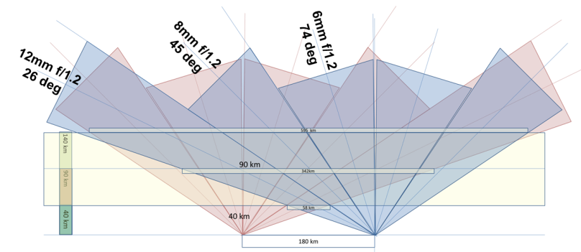
  - Video cable for outdoor use (I like to use RG6 cable with F-type to RCA on one end and F-type to BNC on the camera end. You can get the skinny cable to make it easier and I don't see any difference in interference. You can buy both skinny and regular RG6 cable at Home Depot.
    - Or 50ft from home depot (http://www.homedepot.com/h_d1/N-5yc1v/R- 202698875/h_d2/ProductDisplay?langId=-1&storeId=10051&catalogId=10053) $14
  - BNC Male to F Female adapter $2.90
    - (http://www.showmecables.com/viewItem.asp?idProduct=1062).
  - F Female to RCA Male adapter $1.22
    - http://www.showmecables.com/viewItem.asp?idProduct=2103

  - Camera housing $25
    - http://www.surveillance-video.com/sa-605.html
    - If you are going to mount the camera to a building or structure,
    - http://www.spytown.com/everfocus-fhb-300hb.html $35 with Heater/Blower
    - Spytown shipping is too high.
Additional equipment:
    - Extension cords ($10)
    - Wall timer ($15-$20) (I found that the electronic model is more reliable and doesn't lose time during power outages)
http://www.lowes.com/pd_149289-95325-LW68465_0 0 s%3FNtt%3Dutilitech%2Btimer&facetInfo=

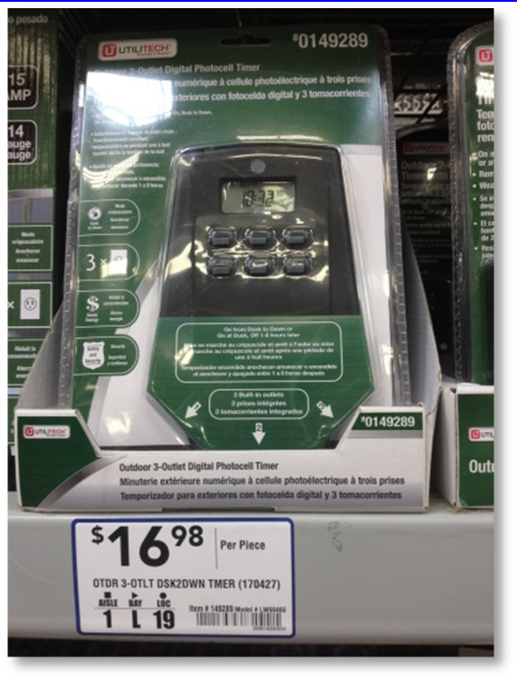

or you can go the traditional route with the inexpensive mechanical Christmas tree timers that need to be constantly checked for accurate time:
http://www.christmaslightsetc.com/p/Outdoor-Timer/Photo-Control-Controllers-/-Timers-/-Light- Testers-/-Faders--20704--107.htm

    - ShockBuster Ground Fault Circuit Interrupter (GCI) portable safety outlet. $13 from Lowes. Part number #30339011.
http://www.lowes.com/ProductDisplay?partNumber=145275-33536-30339011&langId=- 1&storeId=10151&productId=1135923&catalogId=10051&cmRelshp=rel&rel=nofollow&cId=P DIO1
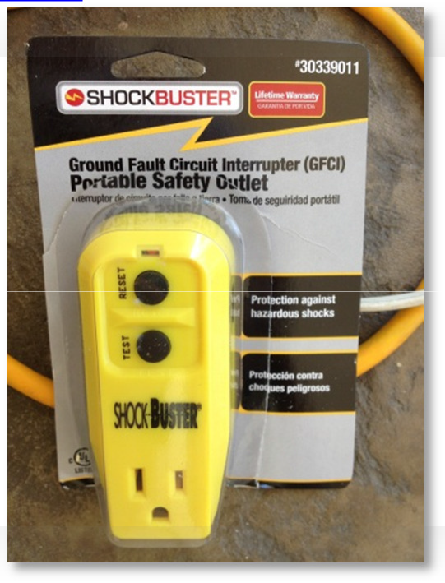
    - Tripod or other mounting system ($10 - $100)
http://www.walmart.com/ip/Sony-39-Lightweight-Camera-and-Camcorder-Tripod-VCT- R100/4948189
A word of caution: While mounting the cameras on the roof works and it seems like a good idea, it might be less than ideal. Climbing on the roof to perform maintenance duties, such as focusing and pointing and lens cleaning can be troublesome. You may be better off mounting the cameras in a location more accessible.
    - RG6 (cable tv) cable is best for long distances. Would require F-type screw-on adapters for the bayonet and RCA male ends
    - 2 External hard drives - CAMS is highly data intensive. It is important, in order of priority, to get the storage devices that provide the proper service. CAMS captures about 6 GB per camera per night. We typically like to try to keep at least 30 days of data before culling any of it. We also prefer to implement a 2-Tier or 3-Tier storage management for working storage (Tier 0 or 1), working Archival storage (Tier-2) and permanent offline storage (Tier-3). See the paper “CAMS Storage Management.pdf” for more information.
      - Another option is the Thermaltake Dual Bay Docking Station ($70). This compatible with 2.5" and 3.5" internal SATA hard drives. The dual bay station allows you to backup from drive to drive. Each drive requires its own eSATA port or USB 3.0 for maximum performance (3,000mbps). They also have a single bay unit for $20 less. With this, you can use cheaper 3.5" drives without having to purchase an enclosure for each.
      - You can get External USB 2.0 or even USB 3.0 external hard drives for under $100 ea. I personally recommend units that are powered by the USB buss. http://www.amazon.com/Western-Digital-Passport-Essential-Portable/dp/B0041OSQ9S

Task 1 - Set up the Camera
This section has a lot of details, but it really is quite simple and only takes a few minutes.
  - Set the camera settings as follows. These instructions are for the WATEC cameras. Similar settings for the Sony based cameras can be attained. Contact us for settings that others have found successful. Also see “IMC2014_Paper_ThirdInchCamerasForMeteorSurveillance_Samuels-Wray_Final.pdf”.
For Watec 902 H2, follow these steps:
    - BLC = 1 and 2 ON, 3 OFF. This setting sets the backlight to the full chip and not just a portion of it.

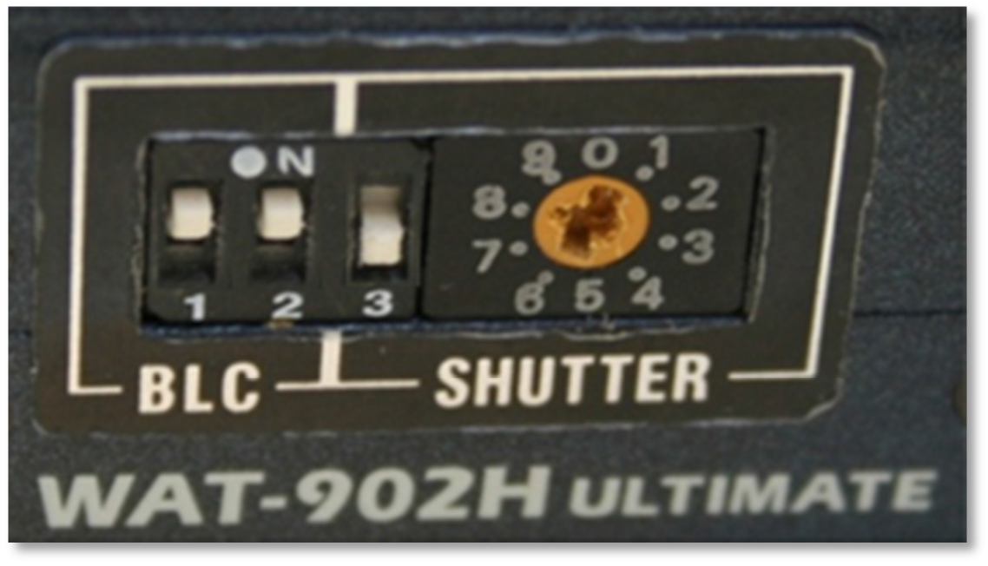
    - SHUTTER speed. Setting switch 3 to off causes the camera to be in 1/60 second shutter speed, which is the same as switch 3 ON and the shutter speed setting to 8.

It is useful to set the shutter speed to 7 and then set the switch 3 to OFF. Essentially, what this does is it sets the shutter speed to 1/60 second for normal CAMS nighttime operation. However, it sets the shutter speed to 1/100,000 sec when it is ON. That way, if you need to do some daytime testing, the 1/100,000 shutter speed is easily accessible and you won't have to fumble around for the manual to figure out what the daytime setting is. Just remember to set switch 3 back to OFF when you're done.

Warning: Don't use a metal screwdriver to change these settings. The best thing to use is a plastic screwdriver. Using a metal screwdriver for these settings can easily damage the main board inside the camera.
    - AGC (automatic gain control) - set to LO or MGC. Some suggest setting to LO. The camera used for these instructions had to be set to MGC (manual gain control) in order to capture enough stars to be able to calibrate. Any AGC setting will skew the photometry, so the best setting is a MGC setting where the gain is at the threshold of producing images as noise free as possible but with as many or more stars than LO produces.
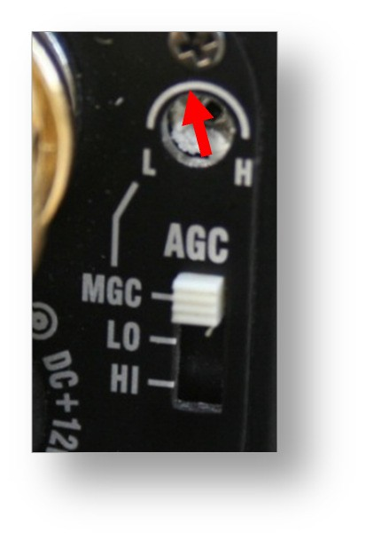
Probably the best advice is to set the AGC to MGC and adjust the L-H gain setting until the image appears to show the same number of stars as the AGC LO setting does. However, I have found that a slight increase in gain over the AGC LO setting produces easier to see meteors during confirmation but the drawback is a slight increase in noise (which increases the number of false positives). The goal is to reach a balance of signal to noise. Too much gain and a clear night with 30 meteors will produce 800+ false-positives. When the gain is set correctly, a clear night with 30 meteors will produce only about 200-270 false-positives.

Warning: If you're going to use the MGC settings, don't use a metal screwdriver to change these settings. The best thing to use is a plastic screwdriver. Using a metal screwdriver for these settings can easily damage the main board inside the camera.
    - 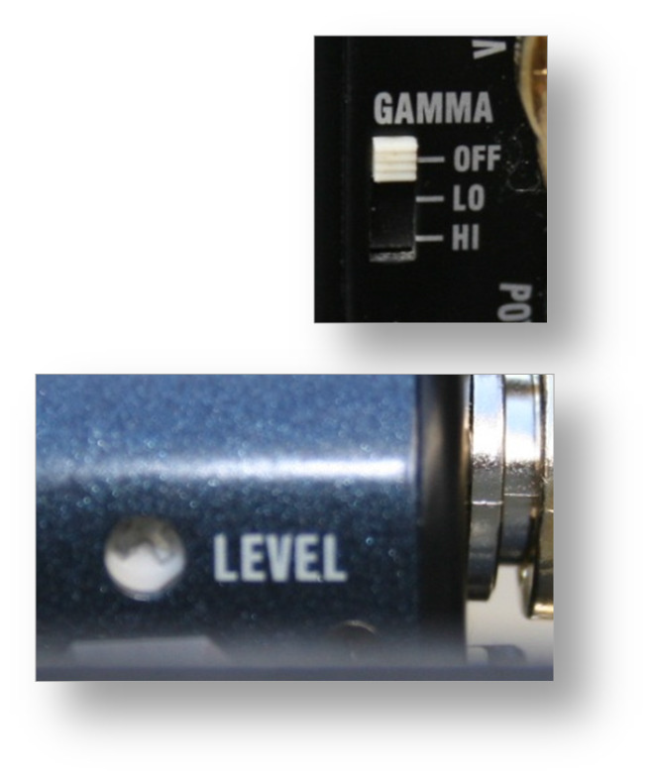GAMMA - Set to off. The higher the gamma setting, the higher the noise. In addition, the higher the gamma setting, the lower the number of brightness levels, which is not good for getting accurate photometry measurements.
    - LEVEL - Experimenting with the settings of the LEVEL control hasn't exhibited any difference.

Warning: If you're going to use the LEVEL settings, don't use a metal screwdriver to change these settings. The best thing to use is a plastic screwdriver. Using a metal screwdriver for these settings can easily damage the main board inside the camera.
  - Attach the Pentax 12mm f/1.2 lens
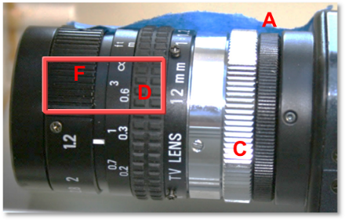
    - Use the C-CS mount adapter (5mm silver knurled ring (C) shown in the picture). The camera in this picture has a CS adapter (A) already included as part of the camera (the black 3.5mm knurled ring on the right).


C
Single-CAMS
CAMS

A few comments:
The Watec camera comes with a 3.5mm black knurled ring adapter (A) that provides an interface between the camera opening and the lens. This 3.5mm adapter (A) is considered part of the camera. With that adapter, the camera is considered a CS style camera, which expects a 12.50mm backfocus lens. This 3.5mm adapter is designed to be adjustable to suit a variety of lens designs.
However, for our use, this adapter is between 0.7 and 0.9mm and is too thin for the C-mount lens we're using while screwed all the way in. This Pentax lens is a C-mount lens, meaning that it has a 17.56mm backfocus. Therefore, with the additional knurled silver 5mm C-CS-mount adapter ring depicted (C), it should reach focus on stars with the lens set to near infinity. However, because the 3.5mm adapter (A) is still too thin, the lens will reach focus on stars (infinity distance), but only with the focus set to about 10 inches (D), instead of the infinity setting. Also, the smooth silver ring (E) is considered part of the lens. The right- most point of (E) is where to measure the 17.56mm from. (D) is the focus ring and (F) is the aperture ring.
To reach focus, you have three choices:
      - As-is - Screw the 3.5mm adapter (A) all the way in and set the lens to about 10 inches (D); You can mark the lens with a silver Sharpie pen where the infinity focus setting is if you like for future reference. This is probably the simplest and recommended approach. It only affects the FOV and image scale very slightly.

      - Calibrated - Set the lens focus setting to near infinity (not all the way to infinity because you have to be able go past infinity while focusing to tell that you've gone too far to know where the focus setting should be) then loosen the hex set screws (C) for the 3.5mm adapter (A) and unscrew the adapter (A) (probably about 0.8mm) while imaging until it is in focus. Then tighten the set screws (C).

      - Without the 5mm C-CS adapter ring (C), set the lens focus setting to near infinity (not all the way to infinity because you have to be able go past infinity while focusing to tell that you've gone too far to know where the focus setting should be) then loosen the 3 hex set screws (C) for the 3.5 mm adapter and unscrew the adapter (probably around 5mm) while imaging until it is in focus. Be sure to re-tighten the set screws. There is a drawback to this method - the lens may not be stable in this configuration because the 3.5mm adapter is unscrewed so far. It will be wobbly during focus and you may find it difficult to retain the same focus setting after re-tightening the setscrews after making focus
CAMS-
Unscrewed 10
about 5mm



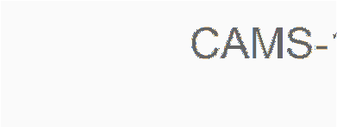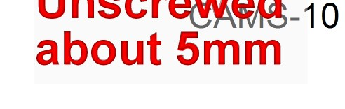
© 2013 All rights reserved.

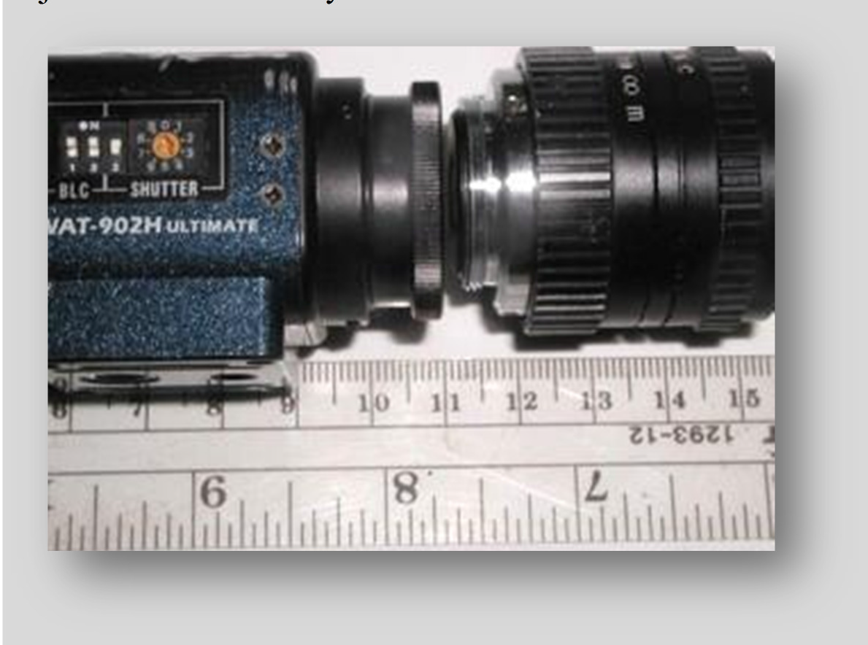
adjustments while they are loose.
Since the second method doesn't really improve anything, I feel that the first
method is the easiest and is what I would recommend.

The next picture shows the spacing required to get the lens to focus on stars at the near infinity focus setting with the 5mm C-CS adapter properly installed.

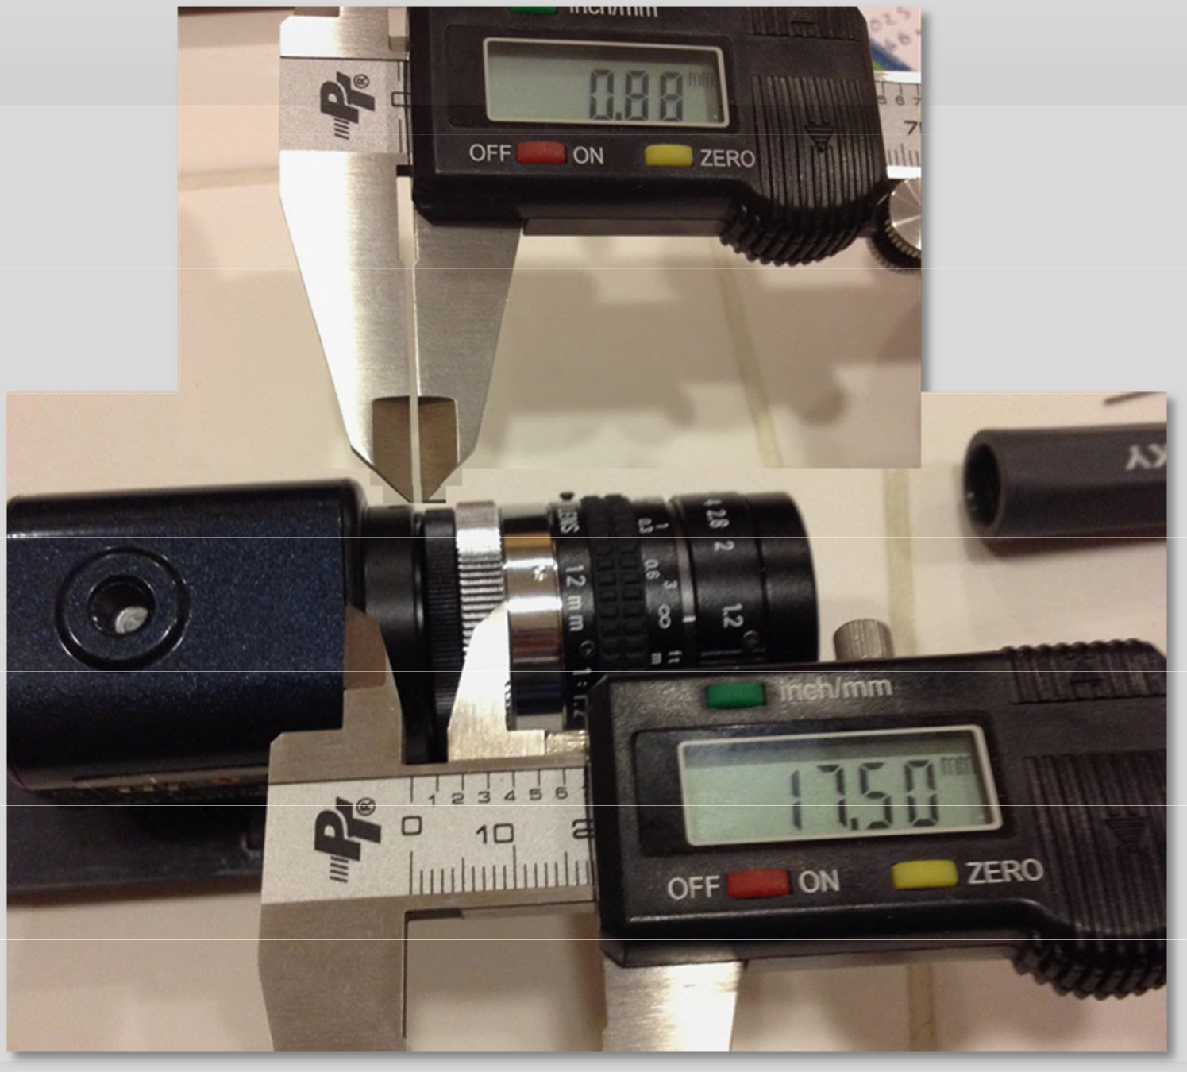

The total lens backfocus for a C-mount lens is about 17.56mm. This is measured when the lens is at focus on something at infinity distance. Note how, in this image, the black 3.5mm adapter (A) is unscrewed 0.88mm instead of unscrewing the 5mm silver adapter (B). This image shows the correct approach to calibrating by unscrewing the adapter to correct the spacing if you elect to do it this way. You can see in this image that the focus setting is near the infinity mark and the focal ratio is set to f/1.2.

Note where the 17.50 mm is measured from. The right side of the knurled silver ring (C) is the back plane of the lens where the measurements are taken from. Also note that there is a 0.88mm gap to the left of the 3.5mm adapter (A). This is the correct place to adjust the spacing.

Note that the focus mark is set to near-infinity and there is a 0.88mm gap.
    - Set the aperture setting all the way open (f/1.2).

Note: If you are experimenting with this in the daylight, you will notice that a higher focal ratio/aperture setting will allow you to see things in the room or outside. However, this will cut out a lot of light during the evening and reduce

the effectiveness of the data. Be sure that when you finally configure for evening meteor recording that the aperture is set to 1.2.
    - Focus the lens so that it is either about where you see it in the picture or so that the infinity symbol is under the 1.2 notch, depending on which adapter configuration you have. You will fine-tune the focus once the system is inside the weatherproof enclosure, the software is installed, and it is dark enough to capture stars in the camera.
  - Set up the weather-proof enclosure and wiring.
    - Clean the window inside and out while you have the chance to get your hands inside. The glass often ships with a slight hazy film over it and this will be your last chance to clean it without removing the camera and recalibrating, etc.
    - Mount the camera to the plastic mounting plate to the forward-most position on the plastic plate. If the plastic mounting plate is already attached to the rails, you have two choices for mounting the camera to the sliding plastic mounting plate:
      - Unsnap the plate from the rails. It might be a little difficult, but you can try to jiggle and force the plastic mounting plate out of the rails. Attach the camera with the provided 1/4 - 20 screw; then snap the plastic mounting plate into the rails.
      - You can remove the back of the enclosure using the small screws and slide the plate out the back. Attach the camera with the provided 1/4 - 20 screw; slide the plate back on to the rails; and replace the back of the enclosure.
    - Attach the plastic mounting plate to the rails with a screw, attach the mounting plate far enough back such that the end of the lens is about 3/8" from the inside window of the enclosure. You need to ensure there is a cushion of air between the window and the lens so as not to capture humidity between the two. Also, it is a good idea to leave enough room to be able to unscrew the lens for whatever reason without having to remove the camera from the rails.
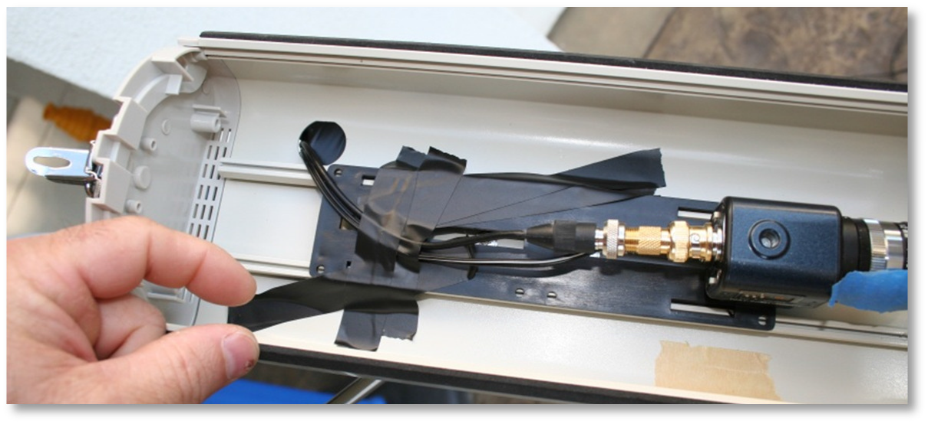

Update: Don't use tape as shown in the picture. The tape didn't work for more than 2 months. I eventually put a screw through the plastic platform into the rail

to prevent the plastic platform from slipping. The problem became evident when I started to see some vignetting near the bottom of the FOV.
    - Thread the video cable separate from the power adapter cable so that you can later change the configuration by placing the power supply inside the enclosure during the winter to warm the enclosure. You will thread the video cable through the cable punch-out at the bottom-rear of the enclosure. My enclosure came with some plastic cable grommets to protect the cables from chafing. However, I had to remove them in order to get the F-connector through.

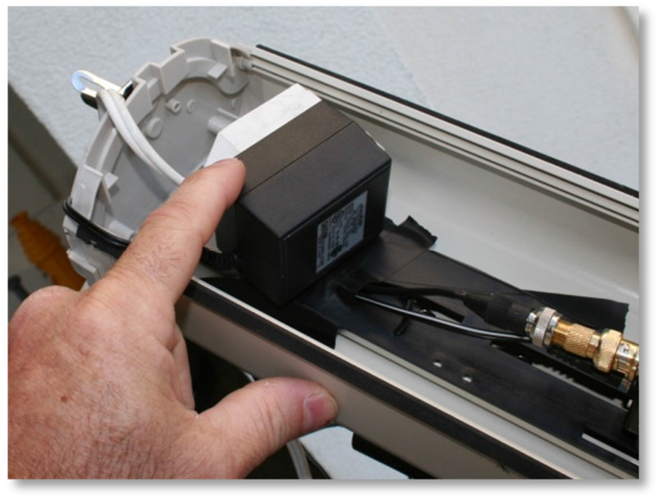
    - Attach the enclosure to the tripod.
Here, the enclosure is pointing downward.
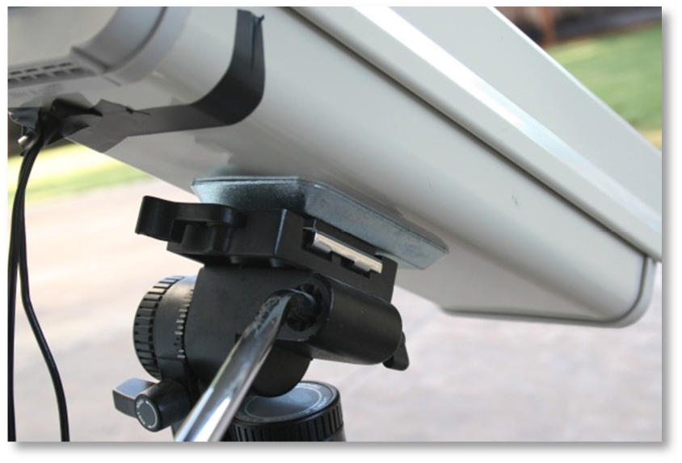
    - Attach the video cable to the BNC Male to F Female adapter and then attach that to the camera's BNC connector. Then tape the video cable to the plate as shown in the pictures. Also attach the 12vdc power connector to the camera and secure the power cable to the adapter plate with tape.
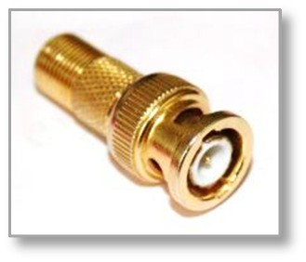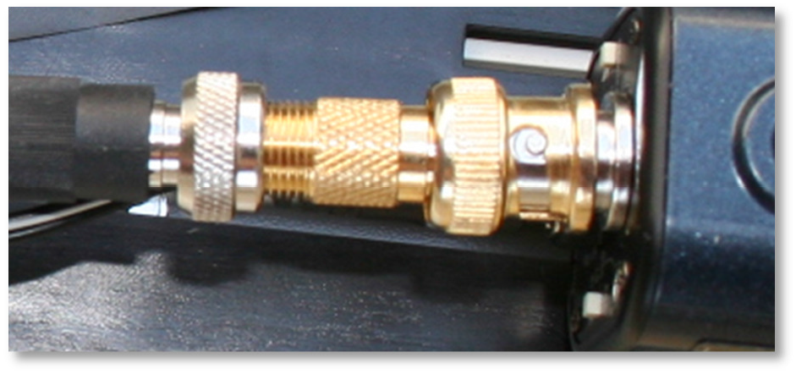

    - 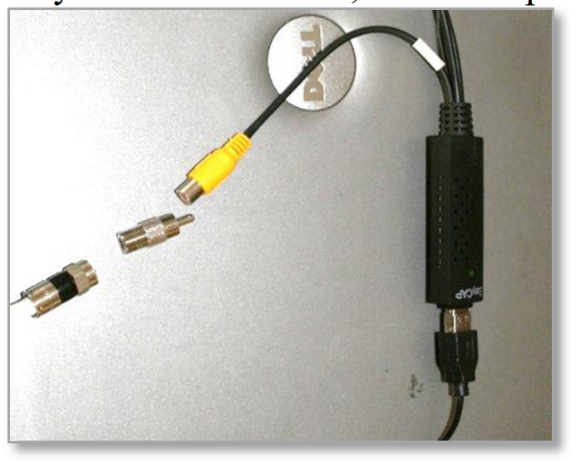On the other end of the video cable, connect the F Female to RCA Male adapter. You can also connect the RCA Male adapter to the yellow female plug on the EasyCAP at this time, but don't plug the USB cable into the computer yet.

    - Connect an extension cord to the 12VDC power supply. Connect the other end of the extension cord to the wall timer. Configure the timer for photoelectric mode or run CheckTwilight to determine the Wall Timer ON and Wall Timer OFF times and then plug the timer into an outlet. Cover the timer and all connections with saran wrap or something to protect against the rain and dew. There is a report on the web that states that the timer isn't even splash resistant.

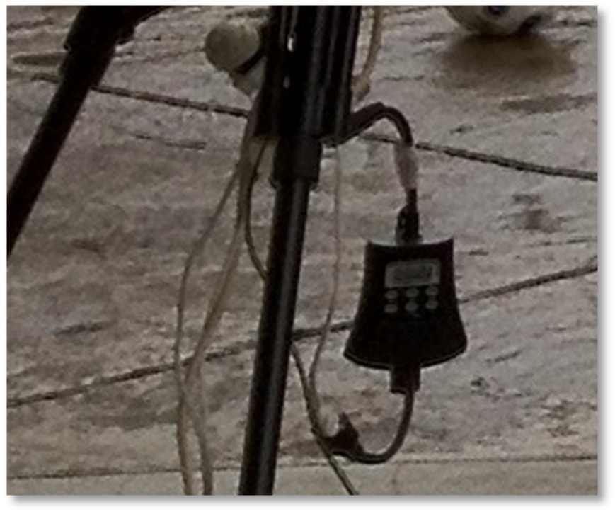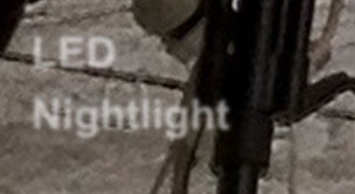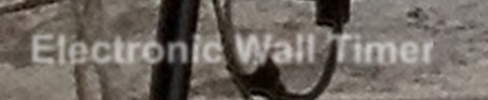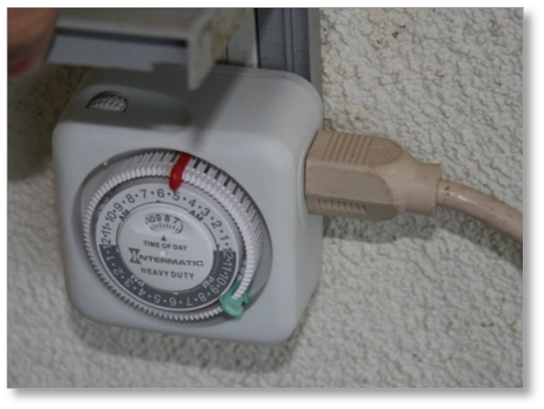
LED
Nightlight
Electronic Wall Timer
Electronic Wall Timer Mechanical Wall Timer

Update: I found that attaching the wall timer to the wall on the porch, which is now out of the weather, I don't have to worry about rain getting onto the timer. Also, since I'm running two cameras now, and I've moved the camera mounts to another part of the backyard, it is beneficial to me to have the LED nightlight also connected to the wall timer so I can check whether the power is on without going outside. Without the nightlight, there is no indication whether the power is on.
    - There is also a portable GFCI available for about $13 from Lowes that provides a level of safety against water intrusion on your electronics. Plug this into the wall, then plug the timer into the ShockBuster, then plug the extension cord to the

timer.

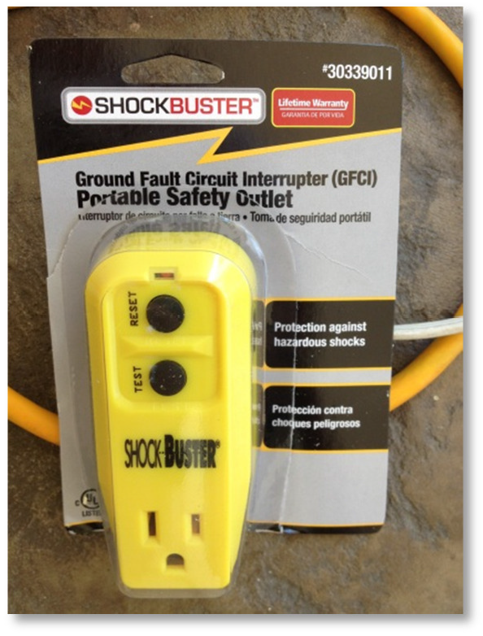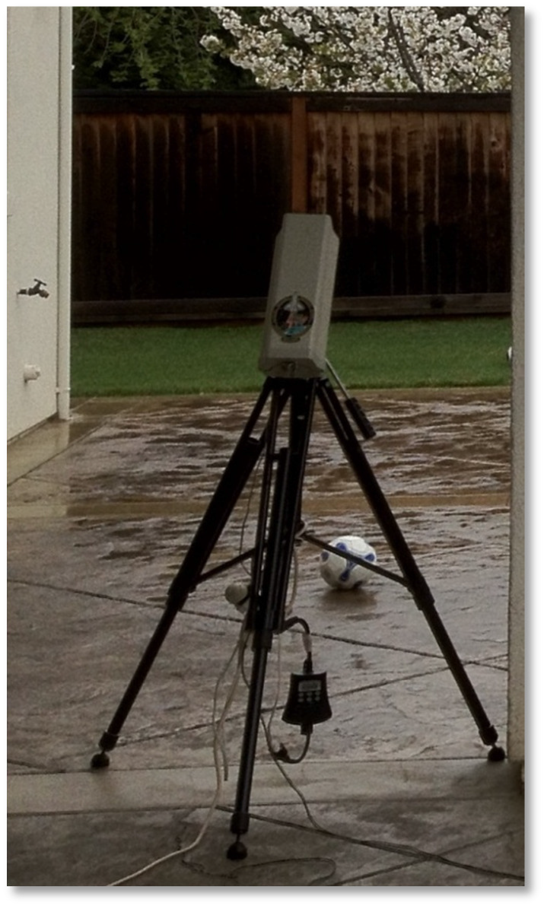
    - Tape the punch-out hole to prevent bugs and water from entering the enclosure.

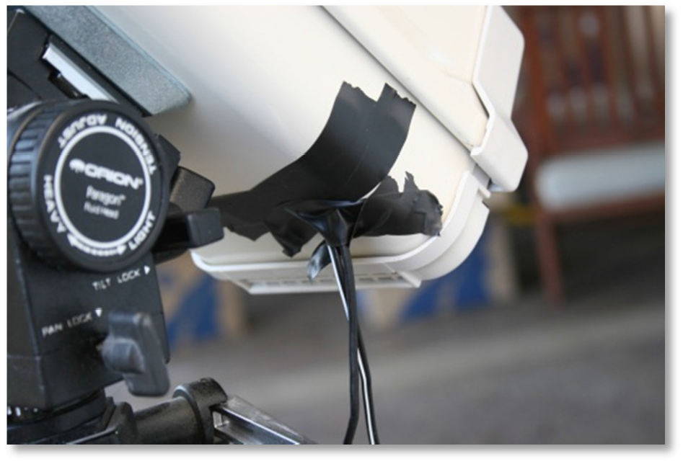
  - Install the video capture driver from the manufacturer.
  - Install the video capture software from the DVD.
The reason to install the video capture software that comes with the capture card is so that you can use it to test the video connection in case something goes wrong and also to configure the driver. It is always best to test the hardware with the software that comes with the hardware.

  - Configure and test the software... ensure that you get an image. It should be a white image. Unplug the video cable from the video capture device and it should go black. Plug it in again and it will go white. If you have set the shutter to the 1/100,000th second setting, you should be able to turn the SHUTTER switch 3 to ON. You should be able to see images in the daytime for preliminary adjustments and preliminary focusing. Just be sure to switch it back to OFF.
  - Reboot

Task 2 - Clock Synchronization (IMPORTANT!)
For this project, it is imperative that the clocks of all systems are synchronized to a certain level of accuracy from the UTC standard. We don't care how you maintain your Windows clock, we just require that you keep it synch'd. within about 0.5 seconds of UTC. You should know that Microsoft Windows only synch's the Windows clock at boot up. After that, for months, it uses the Windows clock. As it turns out, the hardware clock on PC's are fairly accurate - typically enough for about one day of processing.
However, the Windows clock can be out of synch by several seconds to even a minute within a few minutes of booting up! There are a few solutions to this. One is to use a GPS device to keep the Windows clock in synch every few minutes. This requires extra equipment and adds expense, but it would be the best approach, as long as it synchs the hardware clock with each new synch. The other is to use a utility like Dimension 4 or Meinburgh, which use the NIST time servers and synchs to those time servers frequently - and it synchs both the hardware clock and the Windows clock at the same time. At an even more frequent interval, it synchs the Windows clock to the hardware clock. Therefore, you can configure Dimension4 to synch with a NIST time server every hour, but synch with the hardware clock once every minute. Doing this has been shown to keep the Windows clock accurate to 0.01 - 0.1 seconds.
It's important to use a reliable server. Instead of using one server, which could go offline without warning or even cut you off for hitting too often, use a pool server, such as pool.ntp.org. See NTP support site for more information on pool servers. https://support.ntp.org/bin/view/Servers/NTPPoolServers

Dimension4 can be downloaded from the following URL:
http://www.thinkman.com/dimension4/download.htm

Task 3 - Introduction to the AutoCams Menu System and Cams Programs
The CAMS programs are an assortment of stand-alone console programs developed by programmer/scientist Pete Gural. Typically, console programs are executed from a command prompt (also known as a DOS window). AutoCams is a DOS batch scripting language based menu driven "wrapper" around the CAMS console programs. The AutoCams menu system is designed to facilitate your daily workflow by first selecting the date/capture session, then stepping through the menu options.
Note: Most of the CAMS programs can be run either from a command prompt or by double- clicking on them from Windows Explorer. When these programs require input, a File Open dialog appears that allows you to navigate to and select a file or directory for the program to work on. In other places, you are prompted within the console window for input in the same manner as the old 1980s style DOS programs input. However, this document will only attempt to explain how to use the CAMS programs from the AutoCams scripts so as not to confuse most of the readers.

When the CAMS programs run, they produce results - typically by placing files into subdirectories at a location controlled by the user. At the same time, they often display scrolling information and/or results in the same console window or adjacent console windows. The resulting files sometimes need to be examined or manipulated before running the next program in the process.
The order in which the programs are to be run and manipulation of the results in preparation for the next step in the process is called the "workflow". Knowing which program to run in the correct order and how to locate and manipulate the results in preparation for the next step in the workflow can be difficult to teach to the average user. A menu system, AutoCams, was created by Dave Samuels and it was design it so that it works kind of like a checklist in a 1980's style menu system. It helps the average user repeatedly produce consistent and accurate results. In addition, AutoCams was designed to run the amateur CAMS systems autonomously, night after night, until the hard drive is full. Using AutoCams in autonomous mode, there are only a few situations where the user has to interact with the system, such as:
- Performing a manual calibration for those nights when automatic calibration was not achieved
- To resolve errors when they occur
- When the disk full warnings appear.
- Making archive backups and burning DVDs
- To perform the optional Confirmation task (which can't be automated)
The AutoCams menu system takes some getting used to. It was designed to run in either interactive
mode or autonomous mode.
Interactive AutoCams - In interactive mode, the premise is to start with the step numbered 1 and continue, step after step, until all the steps are complete. There are some steps that are optional so you'd skip those steps. Some steps, like the manual calibration step, are only required if another step fails or if some of the steps are processed out of order (This can sometimes happen when resolving problems).

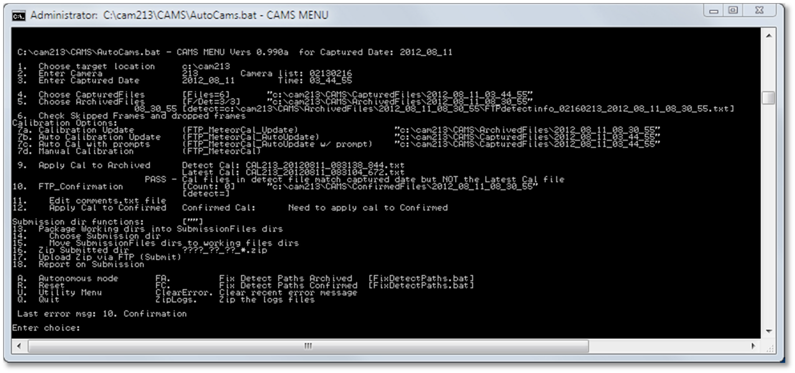
The interactive AutoCams menu has a second utility menu that you can reach by entering U. The utility menu items start their numbering at 31. As a shortcut, you can enter utility menu items from the main menu and vice versa.
Autonomous AutoCams - In autonomous mode, all automatic steps are performed as configured. The AutoCams.Params.ini file has a configuration setting, "autonomouslevel" that can be configured so you can choose the level of autonomous operation. The default is "autonomouslevel=apply". This will stop the autonomous operation after the automatic calibration step. If you change this setting to "autonomouslevel=ftp" (without the quotes), it will perform all operations and upload each morning to the coordinator's FTP server except for those batches that fail any of the tasks leading up to the point where it should upload. When the Windows Task scheduler is properly configured and a good wall timer is installed to control the power to the camera, all necessary functions are performed and completed a few minutes after capture completes. Logs are created and stored in the session's Logs directory until step "13. Package Working dirs into SubmissionFiles dirs", at which point the logs are moved into the "SubmissionFiles\<date>_<camera>_<time>\<camera>\Logs" directory. One log file, "AutoCams_full.log", contains a compilation of all the log files with the log entries sequenced in the order of execution. Very often, this is the only log file needed.

Failed Sessions
One last item of business that needs to be discussed is what to do on completely clouded-out nights. The scientists have asked for you to create a "comments_<camera>.txt" file and submit the session as normal. You don't need to perform the optional confirmation step for these dates. The comment should indicate something terse, like "overcast", "completely overcast", "completely rained out", "failed to capture", etc.

CAMS-19

© 2013 All rights reserved.

Update: The current version (1.00a) of AutoCams autonomous mode processing default has been modified to stop autonomous processing after step "9. Apply Cal to Archived". The reason for this was to give the end-user a chance to examine the files, perform confirmation, resolve issues for cloudy nights, etc. To restore the operation to full autonomous mode is a simple task of changing the "AutoCams.Params.ini" file. Change the "autonomouslevel=apply" to the last step that you want it to autonomously execute. Valid step names are (in order):
cal
apply applyconfirmed submit
zip ftp

Some who have changed their autonomous level to full autonomous mode by setting "autonomouslevel=ftp" find difficultly with the FTP server, which sometimes disconnects the session before the transmission has time to complete. This leaves a partially uploaded file on the FTP server that is corrupt. We now determine if the files is corrupt or not by downloading the zip file immediately after uploading it, performing an MD5 encryption hash of the downloaded file, and comparing it with the MD5 encryption hash of the file before it was uploaded. The hash codes should be identical. Finally, it unzips the downloaded file and checks for corrupt zip file by checking the success or failure return code from the zip program. This should tell you whether you need to re-upload. AutoCams will add a sequence code to the zip file for each attempt, since it is assumed that you don't have delete privileges on the FTP server.

Note: The AutoCams system is an assortment of batch scripts. The source code for the scripts can be modified by a knowledgeable person. For example, if the scripts don't function properly, you do not need to wait for someone to fix them. However, it is best to communicate any required changes to Dave Samuels (dave@davesamuels.com) so that a new version of the scripts can be properly maintained, versioned, and distributed with the changes. Making extensive changes to the scripts on your own may prohibit us from being able to provide assistance.

Task 4 - Directory Structures.

Note: In release 0.990a and later, a new naming convention is employed. A more unique naming scheme was required to avoid loss of data by the overwriting of multiple capture sessions from the same camera on the same night. Some have suggested that this is an infrequent situation, but experience is showing that it is more frequent than we assumed. The .EXE programs were not changed to accommodate these name changes. Therefore, if you don't use AutoCams, you will eventually lose data unless you manually take the necessary steps to avoid overwrites. Thus, the scripts perform these directory and filename changes outside of the programs and change the names back to names that are compatible with the .EXE programs when they require it. This will add some confusion in the beginning, but I'm sure it will be clear as people get used to it. Doing this will

allow the computer to make appropriate autonomous decisions without user intervention. These changes will involve the following name changes:
- FTPdetectinfo_0ccc_yyyy_mm_dd.txt will change to: FTPdetectinfo_0ccc_yyyy_mm_dd_hh_mm_ss.txt
- The zip files will change the name from: yyyy_mm_dd_ccc.zip to: yyyy_mm_dd_ccc_hh_mm_ss.zip
or yyyy_mm_dd_ccc_hh_mm_ss_#.zip
- Stripping the headers from the detect files will no longer be performed. The detect files in the ArchivedFiles and ConfirmedFiles directories will be named as follows and these will also be copied into the EmailFiles directory. The zip file will contain only the necessary files to perform coincidence and re-calibration if necessary:
FTPdetectinfo_0ccc_yyyy_mm_dd.txt to: FTPdetectinfo_0ccc_yyyy_mm_dd_hh_mm_ss.txt FTPdetectinfo_0ccc_yyyy_mm_dd_hh_mm_ss_scanned.txt (in the zip file)
and
FTPdetectinfo_0ccc-#.txt to: FTPdetectinfo_0ccc_yyyy_mm_dd_hh_mm_ss.txt FTPdetectinfo_0ccc_yyyy_mm_dd_hh_mm_ss_confirmed.txt (in the zip file)
The "_scanned" and "_confirmed" suffix is used to differentiate between the detect files from those operations. The original CAMS programs do not take this into consideration.

Directory Structure - The CAMS directory structure is quite specific. You can install the CAMS software on any directory of any drive. However, the directory structure inside that starting location is specific. The default installation location is C:\CAMS. For this documentation, we will assume that the executable directory is "C:\CAMS". If you installed the software under "F:\astronomy", you would need to place all the executables and scripts into "F:\astronomy\CAMS". The software requires that the directory from which the program is run is called CAMS. If you set the Starting Location to "F:\astronomy\CAMS", the software will assume that the software and subdirectories is under "F:\astronomy\CAMS\CAMS".
Several subdirectories of CAMS are used for various file management reasons. Some have names that are dictated by the .exe programs and others are dictated by the AutoCams scripts. The required directory structure for the .exe programs is as follows (assuming C:\CAMS as the home directory):
ArchivedFiles Cal CapturedFiles ConfirmedFiles
Important Note: These directories are referred to as the "working directories".

CapturedFiles - Contains the image frames captured by the camera(s). A new subdirectory is created each time the capture is started. Each subdirectory is named according to the date and time the capture was started. For example, 2011_12_13_01_56_38. The date and time represent the UTC time (Zulu or GMT if you prefer). If you stop capture and start it again on the same date, you will have two subdirectories. For example, if you stopped capture and restarted on 2011_12_13 at 02:10:14 UTC, you'd have both directories (2011_12_13_01_56_38 and 2011_12_13_02_10_14) under the CapturedFiles directory. Each subdirectory under CapturedFiles contains primarily files following the naming pattern of FF*.bin. We often refer to these in conversation as the "FF files". Each of these files represents about 8.5 seconds of video (specifically, 256 frames at your frame rate
29.97 NTSC or 25 PAL) (8.5 seconds for NTSC and 10.24 seconds for PAL). The file names are encoded with the camera number, UTC date, UTC time, milliseconds, and frame counter. Each FF file for an NTSC video camera is 1,228,820 bytes. This directory can be quite large on a winter night of over 12 hours of capture (5400 FF files per camera!)
Cal - Contains the calibration files. All the calibration files follow the naming pattern of CAL*.txt. These file names are also encoded with the camera number, UTC date, UTC time, and milliseconds. The UTC time is often 4.27 seconds (5.12 seconds for PAL) different from the matching UTC time in the matching FF file that was used for calibration. This is because the calibration file names use the middle of their 8.5 seconds (10.24 seconds for PAL) and the FF files use the beginning of their capture time. Also in the Cal directory is the CameraSites.txt file. This file contains the Lat/Long of each of your cameras. In addition, the camera settings files (e.g. w902H2U_12mm.txt) are there for the programs and scripts to read to determine the camera properties.
ArchivedFiles - This directory contains a list of subdirectories that are date/time encoded similar to how the CapturedFiles subdirectories are encoded. Each date/time encoded subdirectory contains a subdirectory that contains a detection file as well a copy of each FF file that has one or more detections in it. The ArchivedFiles subdirectory contains a subset of the files from CapturedFiles, on average between 1/7th to 1/20th of the number of files in the CapturedFiles subdirectory.
The detection file is named according to the following pattern: FTPdetectinfo*.txt. There are a few different variations of the name of this file. So most of us just call it the "detect file" for short.

Timeframe | Detect file naming scheme
2011 Aug - 2011 Dec | FTPdetectinfo.txt
2011 Dec - 2012 May | FTPdetectinfo_0ccc_yyyy_mm_dd.txt
2012 May - 2013 Jan | FTPdetectinfo_0ccc0CCC_yyyy_mm_dd.txt  (multiple cameras are supported)
2013 Jan - Present | FTPdetectinfo_0ccc0CCC_yyyy_mm_dd_hh_mm_ss.txt  (Accommodates multiple sessions per night)

In Jan, 2013, after working with multiple submissions for multiple stations for performing and scripting Coincidence processing, it was determined that the May, 2012 naming was still insufficient in handling multiple sessions on the same night with the same camera - whether the camera was in the same position or whether it was moved for each of those sessions. Due to lack of consensus, the CAMS .exe programs were not modified to accommodate this requirement (and it is a requirement). However, starting with the Jan, 2013 release, the scripts accommodate for this using the following naming scheme for the detect file:
"FTPdetectinfo_0ccc0ccc_yyyy_mm_dd_hh_mm_ss.txt"
There was also a time where the detect file date/time stamp reflected the time of the first detection, which was almost always different from the CapturedFiles date/time stamp. Having them the same was another convenience that we try to maintain, but you might find use cases that we didn't accommodate for in the scripts.
ConfirmedFiles - This directory contains a detection file that refers to only those detections that are manually tagged and confirmed as meteors or those where it is too difficult to tell whether it is a meteor or a bird or something else. (When in doubt, confirm it). The ConfirmedFiles directory has subdirectories similar to the subdirectories of the CapturedFiles and ArchivedFiles. The number of files under the ConfirmedFiles subdirectory is often 1/10 to 1/20 of the number of files in the ArchivedFiles directory... or about 1/70th to 1/200th of the number of CapturedFiles.
------------------------
The remaining directories are used by the AutoCams scripts:
Cal\BinFiles Logs SubmissionFiles Submitted
Temp Transmitted
Cal\BinFiles - This directory is a directory used by the AutoCams scripts. It was created so that a copy of the FF file used for calibration could be stored in case a subsequent night's processing requires it. We refer to one of these FF files as the "FF file used for calibration". For example, Suppose that 2012_08_11 was a good clear night and a valid calibration was made. The FF file used for that calibration is stored in the Cal\BinFiles directory. The next morning you perform some maintenance and clean up the existing directories and archive them to make space for new data.
Now suppose that on 2012_08_12, the sky was too hazy to obtain a reliable calibration. Using the good calibration from 2012_08_11 would be fine, but the CapturedFiles directory for that night may no longer exist in your Working Folders because of the maintenance performed. Without a copy of the FF file used for calibration from the 2012_08_11 night, you would not be able to include the "FF file used for calibration" with the submission. Having a copy in the Cal\BinFiles directory solves this potential problem.
Logs - This directory contains the log files for the different batch scripts. Most of the scripts create their own log files. Each entry in the log files is prefixed by the date and time of that entry.
Attempts are made to maintain the indent level when jumping in and out of subroutines. A log file

"AutoCams_full.log" contains a collection of all the log entries ordered by time instead of separated out by the batch script that was run. Once a session date/time is established, a corresponding Log\<date time> directory is created and the logs are redirected to that new location. During Submission preparation (option 13), the corresponding Logs\<date time> directory is moved under the corresponding SubmissionFiles directory.
SubmissionFiles - This directory has its own substructure that mimics the "working directories" structure. Under SubmissionFiles, each capture session has its own directory, named after the capture session date, first camera in the camera list, and the capture session starting time ("SubmissionFiles\2012_08_11_998_03_44_55\"). Under each date, another subdirectory for the first camera exists ("SubmissionFiles\2012_08_11_998_03_44_55\998\"). If you are running two cameras, you will only see a directory for the first camera in the cameralist. Each camera directory contains a complete copy of the "working directories" for that capture session along with a Logs directory and an EmailFiles directory. This makes it easier to move the files in and out of the working directories for additional processing. The EmailFiles directory is a special directory that is created during submission preparation that contains files that are used to assist in consolidation, reporting, and submission. Remember, the FF files are not submitted daily like the detection files are. The EmailFiles directory contains a copy of the comments_???.txt file.
Submitted - This is a directory that is used during creation of the ZIP file that will be uploaded to the local network coordinator's server. It is created from a subset of the files under the SubmissionFiles directory, so the subdirectory structure is similar. However, it does not include the FF files or log files. In the Submitted directory, you will often find .ZIP files that are named the same as matching subdirectories under the Submitted directory. These are .zip files that have been created but have not yet been uploaded (transmitted) to the local coordinator. Sometimes you will find more than one zip file with the same date (the file will have a numbered suffix such as "2012_08_11_998_03_44_55_2.zip"). These are zip files that were created after another zip file was already created. The reason for this is because, since anonymous FTP servers don't allow you to overwrite a file what you have already uploaded, we need to keep track of their file names and only upload a new zip file each time.
Transmitted - When the upload script is run and the upload is verified, all the uploaded zip files are "moved" to the Transmitted directory.

You should probably keep these around for a while and archive them. There have been many times when the scientists have asked for additional copies. You can use this directory to help you keep track of the dates that have been transmitted to the local coordinator. Dates that are missing should be an indicator that you have some back processing to do.
Temp - This is a directory primarily used for verifying the FTP upload and Coincidence processing. The way the verification works is as follows:
- First, the .zip file is MD5 hashed to determine if it is an empty zip file.
- Then, the MD5 hash "before upload" value is saved for the zip file prior to uploading.
- The .zip file is then uploaded to the FTP server using the DOS FTP command line utility.
- Then, the script attempts to download that same file to the Temp directory.

- The script then determines the MD5 hash code for the downloaded file (as the "after download" value) and compares that hash value to the zip file's original hash value.
- Finally, the downloaded zip file is unzipped to "..\Temp\Zip". If errorlevel is zero, then the file is OK, the upload is deemed to have succeeded, and the copy in the Temp directory is deleted. If it is not there, the upload is deemed to have failed.

Task 5 - Download and configure the CAMS software
  - If you are not a new user, you should make a backup copy of all the files in the CAMS and CAMS\Cal directories before starting. The new release shouldn't
  - Download the zip file(s) from www.davesamuels.com/cams and unzip to C:\CAMS.
Feedback from users indicates that we need to add instructions for exactly which files to download. Details will be in the _readme_AutoCams.1.xxx.pdf file:
    - Download both zip files:
AutoCams_1.xxx_scripts.zip (for example: AutoCams_1.00a_scripts.zip) AutoCams_1.xxx_base.zip (for example: AutoCams_1.00a_base.zip) AutoCams_1.xxx_other.zip (for example: AutoCams_1.00a_other.zip)
    - Unzip the AutoCams_0.xxxx_scripts.zip file to "C:\CAMS" first.
    - Then, unzip the AutoCams_0.xxxx_base.zip file to the "C:\CAMS".
    - Then unzip the AutoCams_0.xxxx_other.zip file to "C:\CAMS".
    - If there are .zip files that have a subsequent order number from the first, download and unzip those too. (They act like service packs or patches) Those must be unzipped in the correct sequence.
  - FOR NEW USERS ONLY:
If you are a new user and you don't already have AutoCams.Params.ini and AutoCams.bat.ini, you will need to edit those to configure them to match your system. Details on all the AutoCams.Params.ini options are listed in Section 24 below. The order of the sections doesn't matter, but it might make it easier for you to peform the compare if you reorder your sections to match the order of the sections in the "new" file (The order of the sections in the "new" file are organized by the AutoCams steps that use them. This section will cover what needs to be done to get you started using the defaults.
    - Rename: "AutoCams.bat.new.ini" to: "AutoCams.bat.ini"
    - Rename "AutoCams.Params.new.ini" file to: "AutoCams.Params.ini".
    - Edit "AutoCams.Params.ini".

Regarding Comments: The AutoCams INI files use double slash "//" as comments, but they have to be the first two characters on the line. . Also, "rem"

or "rem " are valid comment prefixes, but they have to be at the beginning of the line.
      - Do a Find/Replace and change all instances of "998" (without the quotes) to the camera number you've been assigned.
      - In your [AUTOCAMS] section, ensure that the bat_vers value matches the version of the zip file. If it doesn't, change the value. (Sometimes I make mistakes and forget to do this before a release) Note: bat_vers is a new entry.
      - There should be several "autonomous=" entries, but only one of them is not commented out. If you have been running in full-autonomous mode, comment out the "autonomouslevel=apply" entry (using "//") and uncomment the "//autonomouslevel=ftp" entry. Otherwise, if you want a different autonomous level setting, make that change here. Only one autonomouslevel entry can be uncommented though.
      - Ignore the "[SIMULATION]" section entries.
      - Save and close Notepad.
    - Create or Copy the Twilight.csv.txt file according to section 8.
  - FOR UPGRADING USERS WHO HAVE ALREADY BEEN USING AUTOCAMS:
If you have been using AutoCams prior to this the 0.990d release and you are upgrading, You need to there are a few things that must be done manually to incorporate the new release.
Details on all the AutoCams.Params.ini options are listed in Section 24 below. However, this section will cover what needs to be done to get you started using the defaults.
    - Rename your "AutoCams.Params.ini" file to: "AutoCams.Params.old.ini".
    - Rename: "AutoCams.Params.new.ini" to: "AutoCams.Params.ini".
    - Edit "AutoCams.Params.ini".

Regarding Comments: The AutoCams INI files use double slash "//" as comments, but they have to be the first two characters on the line. . Also, "rem" or "rem " are valid comment prefixes, but they have to be at the beginning of the line.
      - Do a Find/Replace and change all instances of "998" (without the quotes) to the camera number you've been assigned.
      - In your [AUTOCAMS] section, ensure that the bat_vers value matches the version of the zip file. If it doesn't, change the value. (Sometimes I make mistakes and forget to do this before a release) Note: bat_vers is a new entry.

      - There should be several "autonomous=" entries, but only one of them is not commented out. If you have been running in full-autonomous mode, comment out the "autonomouslevel=apply" entry (using "//") and uncomment the "//autonomouslevel=ftp" entry. Otherwise, if you want a different autonomous level setting, make that change here. Only one autonomouslevel entry can be uncommented though.
      - Ignore the "[SIMULATION]" section entries.
      - Save and close Notepad.
  - Start AutoCams and notice the version displayed at the top of the menu.
  - Adjust the DOS window buffer size to keep things from wrapping. For details, follow these steps:
    - Click the System Menu (Top left icon of the DOS window). The System Menu appears.
    - Select Properties. The Properties dialog appears.
    - Check "Quick Edit Mode" and "Insert Mode".
    - Select the "Layout" tab.
    - Change the Screen Buffer Size to:
- Width=180
- Height=9999
    - Click OK.
    - In XP, a dialog appears asking if you want to save this setting for future instances or this one only. Select the one that Saves for all future instances.
  - Test the DLL compatibility using the following steps:
There are different versions of the runtime DLLs depending on which version of Windows you are using. If these steps don't work, you may need to do a google search for downloading and installing the correct msvcr100.dll and vcredist_x86.exe libraries.
    - Enter U to go to the Utility menu.
    - Enter 55 to run the "CameraLiveViewer". If there is a DLL incompatibility, you might get an application error dialog.

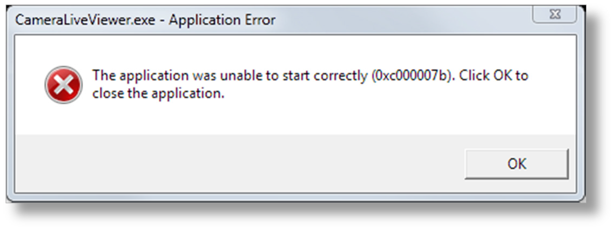

    - If this occurs, from a C:\CAMS command prompt, enter the following command:

copy /y msvcr100_32bit.dll msvcr100.dll

The CameraLiveViewer windows should appear. If the program runs, but you cannot capture video, you will need to resolve that outside of the CAMS system.
    - Press Ctrl+P two distinct times to exit the CameraLiveViewer.
    - Test again.
    - If CameraLiveViewer still doesn't work, double-click vcredist_x86.exe. This will install the runtime libraries that are required. For Windows 7 systems, this library is included and this step would not normally need to be performed.
    - Test again.
  - If you are a New User, perform these steps:
    - Determine the latitude and longitude of your camera. You can use this web site:
http://www.getlatlon.com/
If that doesn't work, try this:
      - http://maps.google.com/maps?sholabs=1
      - Scroll down to the LatLng Marker and Enable it.
      - Click Save Changes.
      - Enter your address and press the search button.
      - Zoom in to the part of your property to enough detail as you like.
      - Right-click on the spot where your camera is placed and select:
Drop LatLng Marker here.
    - Edit "C:\CAMS\Cal\CameraSites.txt" using Notepad and add the site information to the bottom of the file. Be sure to only use spaces (do not use tabs) to align the text columns. Ideally, you can copy a line of text and paste it to the end of the file. Then change the values of the camera number, latitude, longitude, etc. You need to be sure to use only a camera number that was assigned to your site. For example:

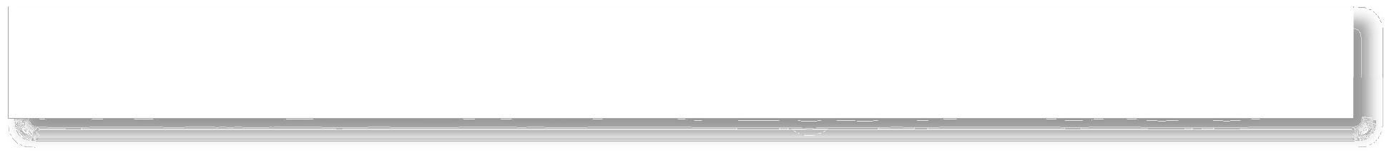
C:\CAMS\Cal\CameraSites.txt
CAM# Latitude North Long Alt(km)
Camera Descr file
Abbr Site Name
123456789a123456789b123456789c123456789d123456789e123456789f123456789g123456789
212···+36.66499·+121.66305···0.016······W902H2U_12mm.txt·······SA···Salinas
    - Save and Exit Notepad.
    - Edit "C:\CAMS\LASTSETTINGS.txt" using notepad.

    - Change the Longitude and Latitude to match your site's coordinates.
    - Save and Exit Notepad.
    - Start AutoCams.
    - From the AutoCams menu, enter option 1 (to choose the target location)
    - Enter C:
    - Enter AutoCams menu option 2 (to enter your camera number).
    - Answer "Y" if you see your camera in the list.
    - Enter option "48" to Save the configuration.
    - Enter "U" to show the Utility menu.
    - Enter option 55 (CameraLiveViewer) to test the software.
    - At night, with CameraLiveViewer running, point the camera in the general direction of a star field that has bright enough stars to locate and use the focus ring on the camera lens inside the weatherproof enclosure to focus the camera. Be sure to secure the lens and the aperture rings so that they won't move after you have reached focus.

Tip: Spend the necessary time to attain accurate focus now. Doing so now will prevent you from having to recalibrate the camera due to refocusing later. You will likely need to recalibrate manually every time you touch the camera. You may need to start by pointing it at the moon or a nearby streetlight to get a rough focus.
    - Point the enclosure/camera in the general direction of the ALT/AZ that you were assigned for your camera. Check with a planetarium program to locate the stars that match your field of view (FOV).

Tip: If you have a green laser available, you can hold it on the enclosure (or temporarily tape it to it) so that they are both pointing in the same direction. You will be able to see the laser in the CameraLiveViewer window. You can use this to help you position your camera more precisely. If you don't have a green laser, you might have luck taping a straw to the enclosure and use it as a kind of sighting scope. To attain very accurate pointing, you will perform capture, then calibrate. Then you will examine the ALT/AZ values of the calibration and make pointing adjustments until you reach the recommended ALT/AZ.

CAMS-29

© 2013 All rights reserved.

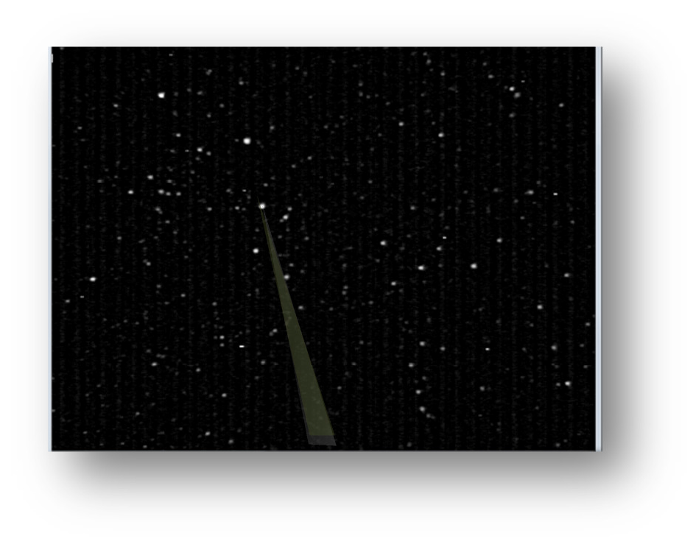

Task 6 - Calibrate the FOV (Manual Calibration).
The field of view (FOV) needs to be calibrated so that there is an accurate record of the RA/DEC and flux for each meteor track. The way this works is that the program compares an image created from averaging actually 256 frames of video with a simulation of the same region of sky that is created from a database of up to 8.5 magnitude stars (C:\CAMS\STARS8TH_VBVRI.txt).
There are four methods for calibration. First is FTP_MeteorCal.exe. The second is FTP_MeteorCal_Update.exe. The third is FTP_MeteorCal_AutoUpdate.exe, and FTP_MeteorCal_AutoUpdate with prompts.
Use FTP_MeteorCal.exe under the following circumstances:
- when you first set up the system
- whenever the camera is moved
- when you can't obtain a "Mean O-C" under 2.5 with sufficient number of stars (at least 50 stars) with FTP_MeteorCal_Update.exe or FTP_MeteorCal_AutoUpdate.exe, and re-running FTP_MeteorCal_Update.exe several times doesn't improve the numbers.
- When AutoCal fails
  - Capture a few frames for you to use for calibration by performing the following step:
    - From a command prompt enter the following commands:

cd \cams
CaptureTwoAndDetect.bat 2 <your camera number> 0.01 "c:"

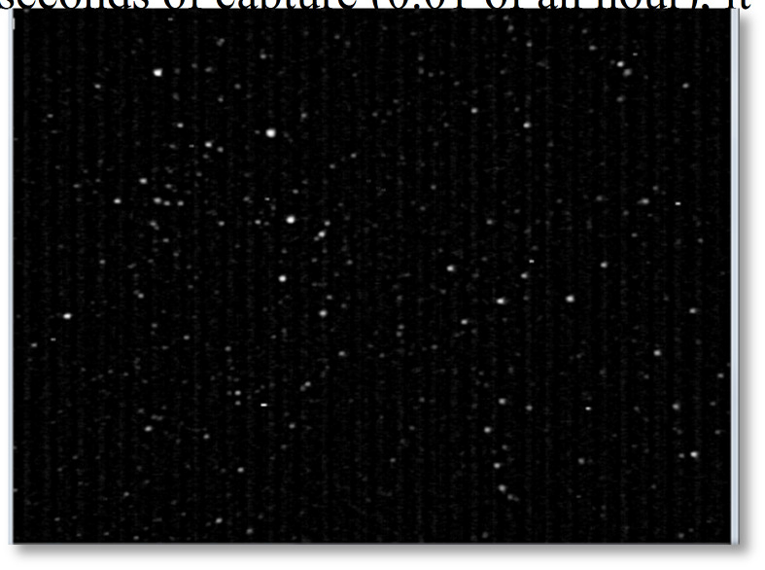The program will respond with a text window and a graphic window. After about 36 seconds of capture (0.01 of an hour), it will terminate on its own.

  - Run AutoCams option 3 to point AutoCams to the most recently created CapturedFiles directory.
  - Run AutoCams, option "7d Manual Calibration".
  - Enter the target camera to manually calibrate:
<your camera number>
  - Enter the timestamp of the FF you intend to use for calibration (in hhmmss format): [Press [Enter] to skip, [P]review, or [Q]uit]:
Press Enter
  - Press Enter
  - Navigate to and select an FF...bin file that has a star field that you recognize. The FF files will be located in a subdirectory of the C:\CAMS\CapturedFiles directory. The subdirectory is named with the most recent date/time.
  - Use a planetarium program to locate the center of the FOV (or use the RA/DEC that was calculated for you).

Tip: Use a planetarium program, such as StarryNight, TheSky, Cartes du Ciel, etc. to determine the RA/DEC and Alt/Az at the time of day the .bin file was captured.
Cartes du Ciel means "Sky Chart". You can download it for free from:
http://www.ap-i.net/skychart/start
The planetarium program can be adjusted to the same UTC time as the time shown in the video frame. Move the planetarium program to point to the same constellation that you recognize.
If you have previous calibrations that are close enough, you can use the RA/DEC values from those. Another improved method is to use the AutoCams "7d. Manual Calibration". It will prompt you for the time of the FF file you will be using for calibration and calculate your new RA, DEC, and FOV values for you.
  - Enter the FOV width in degrees: 32

  - Enter FOV center Right Ascension (degrees):
(obtain this from the planetarium program and multiply the hour by 15) Example: 22hr 09m is 9/60 + 22 = 22.15. Then multiply that by 15.
22.15 X 15 = 332.25. So, you'd enter 332.25.
  - Enter FOV center Declination (decimal deg):
Example 54.21 for 54 deg 13' 9" (obtain this from the planetarium program)
Example: 13.15/60 + 54 = 54.219
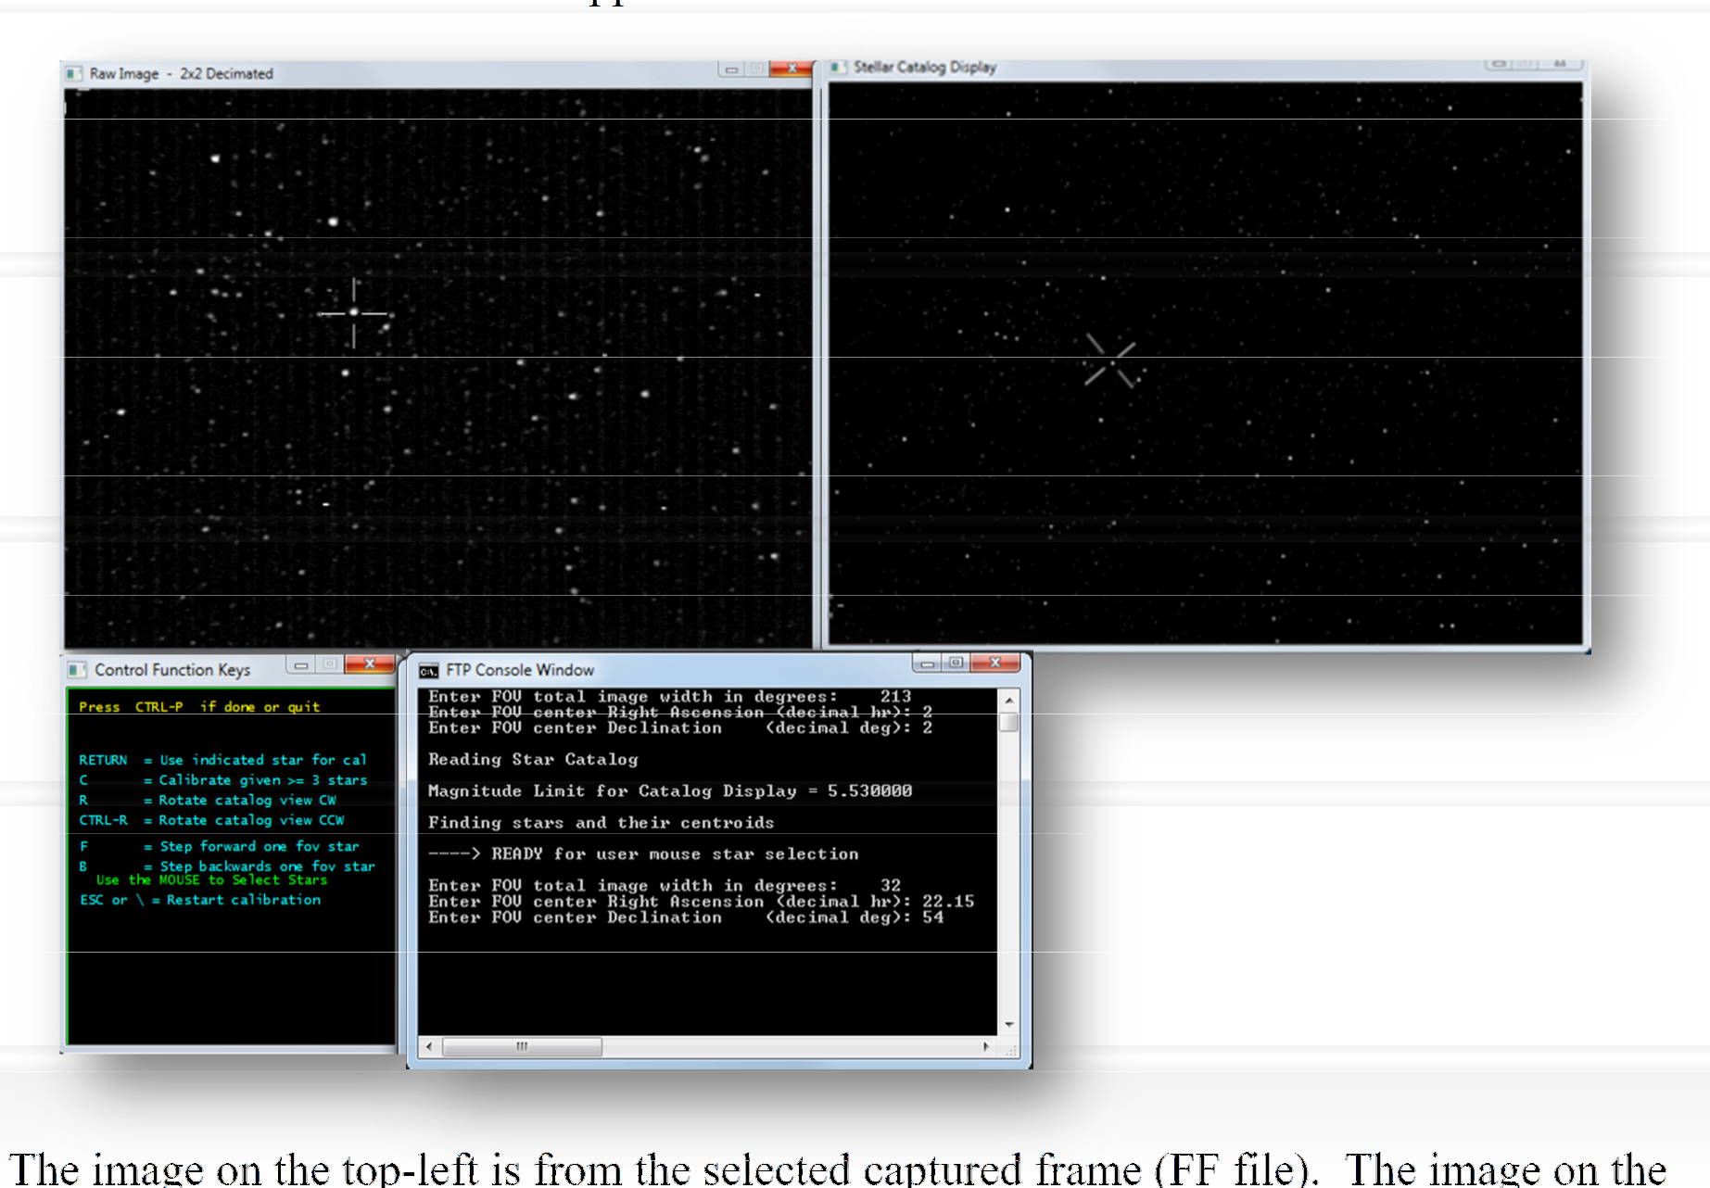The four calibration windows appear.

top- right is produced from a database of stars over 8.5 magnitude. The window on the bottom-left is a window containing some instructions on how to skip forward or backward, to rotate the FOV, etc. The console window on the bottom-right is where you enter values and where it displays feedback during calibration.

The image on the top-left is from the selected captured frame (FF file). The image on the
The application will usually select a star on the left and right. Very often, it is difficult to match the stars that the application chooses for you. Just ignore that and select the star on the left that you recognize and do that same on the right.
  - Select a star on the right (from a database) that matches a star on the left (from the captured frame).
  - Select the matching star on the left (from the captured frame) and press the RETURN key to accept. Be very careful to select the proper star. Avoid stars that have closely positioned

stars adjacent to them. In that case, press F to skip forward to the next star. You can go back by pressing the B key.
  - Repeat until at least 6 stars have been carefully matched/calibrated (try to calibrate the center and the corners first).
  - Once 6 stars are calibrated, the application will facilitate the selection of stars by choosing the star on the right and automatically matching it with the closest star on the left.
  - You should be able to just press RETURN for those that match. However, if you don't see a star on the left in the crosshair, press the F or B keys to move forward/backward to the next choice. You don't want to calibrate on noise, hot pixels, satellites, doubles, or other artifacts. Also, for the first 60-80 or so stars, press F if a star appears very close to another star or too close to the edge.
  - Continue this accurate manual calibration until about 80 stars have been calibrated.
  - At this point, press "C" to Calculate.
  - It will display:

Number of calstars used = 114 0.949523 0.417211 Mean O-C = 0.950 +- 0.417 arcmin
Do another calibration outlier purge (1=Yes,0=No)
  - The key value you are looking for is a "Mean O-C" value of 0.50 or less. If it is greater than or equal to 0.50, press 1 to exclude some of the outlier's (Stars with a less than accurate alignment - very often, these have a larger +- value) and then it will re-calculate and show a new Mean O-C and the number of calstars used. If you can't achieve a Mean O-C of under
2.50 - 0.50 with sufficient number of stars (50, but not less than 40), you will need to re-do the FTP_MeteorCal.exe procedure again and be extra careful to skip doubles, hot pixels, etc. or use a different frame that has better video fidelity or less noise.
  - Once you achieve the best Mean O-C value with about 50-60 stars, press "0", then Ctrl+P to process and save.

You should not need to, but if you want to rotate the database display during calibration you may do so by pressing R or Ctrl+R.
  - It is a good practice to then run an option "7b. Auto Calibration Update" after a manual FTP_MeteorCal.exe in order to refine the calibration further. A good rule of thumb is to try for 1/10th of a pixel of accuracy or better. Don't use an FF file that is earlier in the night than the one chosen for the manual calibration. When you perform multiple calibrations for the same night, it is a good idea to delete the CAL files from the Cal directory that you don't want to use. Otherwise, the Apply function may choose a less than accurate calibration file. The Apply function tries to use the most recent date/time.

Task 7 - Manual Re-Calibration Example Run:

  - Here is an example of performing a Manual re-calibration using option "7d. Manual Calibration"...
This might be helpful in running a manual cal when autocal fails. Here is a sample output…
    - means what you enter;
Yellow
Gray | m
Green

    - eans something you should read or pay attention to;
    - means a result that you should be aware of

c:\cam213\CAMS\AutoCams.bat - CAMS MENU Vers 1.00a for Captured Date: 2012_08_11

- Choose target location c:\cam213
- Enter Camera 213 Camera list: 0216
- Enter Captured Date 2012_08_11 Time: 03_44_55

4. | Choose CapturedFiles | [Files=3] | "c:\cam213\CAMS\CapturedFiles\2012_08_11_03_44_55"
5. | Choose ArchivedFiles | [F/Det=3/3] | "c:\cam213\CAMS\ArchivedFiles\2012_08_11_08_30_55"
08_30_55 [detect=c:\cam213\CAMS\ArchivedFiles\2012_08_11_08_30_55\FTPdetectinfo_02160213_2012_08_11_08_30_55.txt]
6. Check Skipped Frames and dropped frames Calibration Options:

7a. Calibration Update | (FTP_MeteorCal_Update) | "c:\cam213\CAMS\ArchivedFiles\2012_08_11_08_30_55"
7b. Auto Calibration Update | (FTP_MeteorCal_AutoUpdate) | "c:\cam213\CAMS\CapturedFiles\2012_08_11_03_44_55"
7c. Auto Cal with prompts | (FTP_MeteorCal_AutoUpdate w/ prompt) | "c:\cam213\CAMS\CapturedFiles\2012_08_11_03_44_55"
7d. Manual Calibration | (FTP_MeteorCal)
- Apply Cal to Archived Detect Cal: CAL213_20120811_091104_906.txt
Latest Cal: CAL213_20110915_044643_829.txt
PASS - Cal files in detect file match captured date but NOT the Latest Cal file
- FTP_Confirmation [Count: 0] "c:\cam213\CAMS\ConfirmedFiles\2012_08_11_08_30_55"
[detect=c:\cam213\CAMS\ConfirmedFiles\2012_08_11_08_30_55\FTPdetectinfo_02160213_2012_08_11_08_30_55.txt]
- Edit comments.txt file
- Apply Cal to Confirmed Confirmed Cal: Need to apply cal to Confirmed

Submission dir functions: [""]
- Package Working dirs into SubmissionFiles dirs
- Choose Submission dir
- Move SubmissionFiles dirs to working files dirs
- Zip Submitted dir
- Upload Zip via FTP (Submit)
- Report on Submission

  - Autonomous mode FA. Fix Detect Paths Archived [FixDetectPaths.bat]
R. Reset FC. Fix Detect Paths Confirmed [FixDetectPaths.bat]
U. Utility Menu ClearError. Clear recent error message
Q. Quit ZipLogs. Zip the logs files Last error msg:
Enter choice: 7d

Enter the target camera to manually calibrate: 213 [AutoCams.bat:LOGEXEC] set bat_camera=213
[RETURN-AutoCams.bat:LOGEXEC] [bat_logexec_returncode=0] [set bat_camera=213] [AutoCams.bat:LOGEXEC] find /v "" "c:\cam213\CAMS\temp_cal_instructions.txt"

---------- C:\CAM213\CAMS\TEMP_CAL_INSTRUCTIONS.TXT

The captured date is: 20120811
The most recent applicable Cal file is: CAL213_20120811_091104_906.txt The detect file is using Cal: CAL213_20120811_091104_906.txt
("CAL213_20130228_080706_749.txt")
[RETURN-AutoCams.bat:LOGEXEC] [bat_logexec_returncode=0] [find /v "" "c:\cam213\CAMS\temp_cal_instructions.txt"]

call "c:\cam213\CAMS\ValidateCal.bat" /cal "c:\cam213\CAMS\Cal\CAL213_20120811_091104_906.txt"
CAL213_20120811_091104_906.txt, [Cal stars=50] MeanO-C=0.325+-0.131 Scale=2.763 [ALT=55.281 AZ=330.466] [RA=297.017 DEC=63.667]

' RA=297.017, DEC=63.667, time=09:11:04 ' FOV=29.5 AZ=330.466 ALT=55.281

"c:\cam213\CAMS\Cal\CAL213_20120811_091104_906.txt"

Enter the timestamp of the FF you intend to use for calibration (in hhmmss format) [press [Enter] to skip, [P]review, or [Q]uit]: 083100

call :CALC_CAL_VALUES "297.017" "63.667" "083100" "09:11:04" "c:\cam213\CAMS\Cal\CAL213_20120811_091104_906.txt"
[-67] [exit code=1]
[-1005] [exit code=1]

In the MeteorCal program:
- Press ESC to re-enter FOV, RA, and DEC at any time during star matching
- Do the manual star matching from right to left
- Press Enter after each match
- Press F and B to skip forward or backward
- When you have matched about 80 or more stars, press "C"
- Then press "1" to discard outliers until the star count gets between 50 and 60.
- Finally, press Ctrl+P to complete the calibration and return to the menu.

' Now, considering the new FF file with a time segment value ' of 083100, you will want to enter the following values:
' FOV = 29.5
' RA = 286.9670
' DEC = 63.667 '
' FF213_20120811_083100... '

Move the instructions window to a location where you can use it as a reference.

Press Enter to continue or [Q]uit:

call "c:\cam213\CAMS\FTP_MeteorCal.exe" 213 "c:\cam213\CAMS\Cal"

---------------------------------------------------------
METEORCAL 1.40 - Copyright 2010 Peter S. Gural
---------------------------------------------------------

Opening dialog box to search for FF213*.bin files

Enter FOV total image width in degrees: 32
Enter FOV center Right Ascension (decimal deg): 286.9670 Enter FOV center Declination (decimal deg): 63.667

Finding stars and their centroids Reading Star Catalog
Magnitude Limit for Catalog Display = 9.000000

----> READY for user mouse star selection
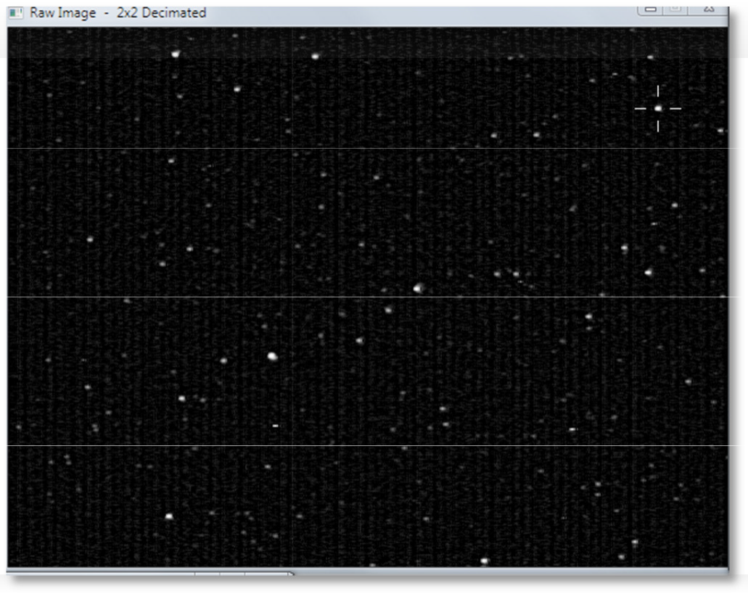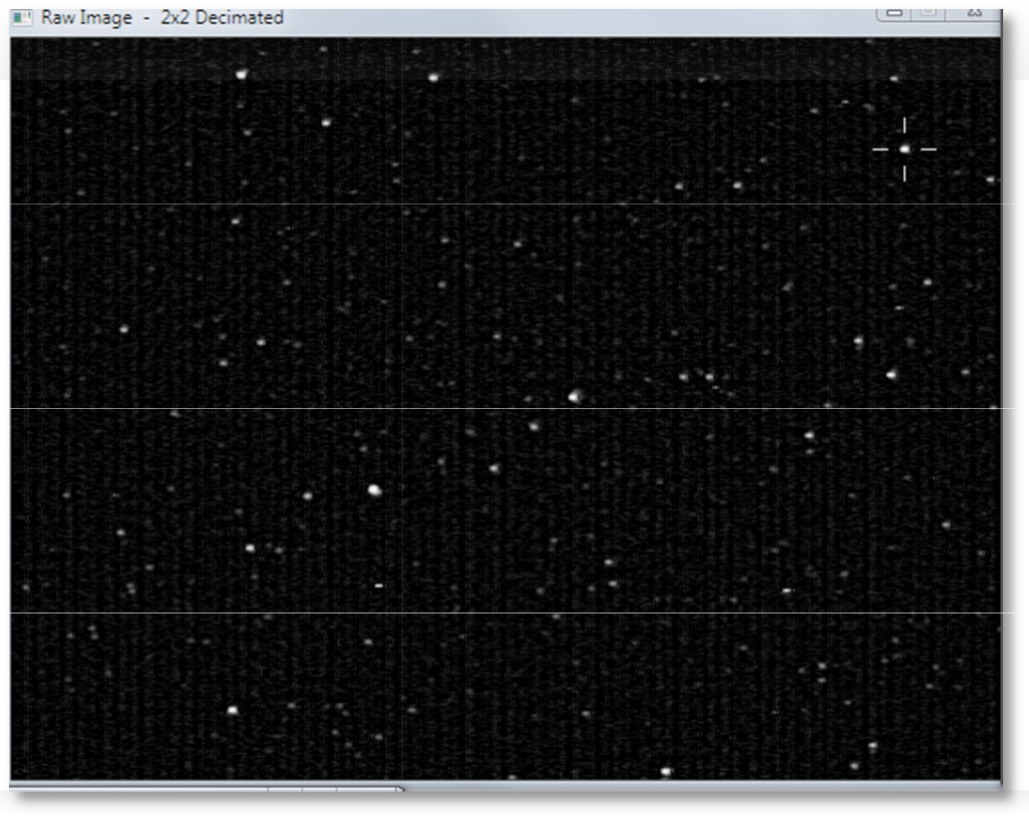star mag V = 7.36 B-V = 1.28 R = 6.62 IR = 5.92

CAMS-3

© 2013 All rights reserved.

Now you do the manual star matching from right to left, press C when you have a significant number of cal stars matched, and press "1" to discard outliers until the star count gets between 50 and 60. Finally, Press Ctrl+P to complete the calibration and return to the menu.
*********** Star #1 ***********
*********** Star #2 ***********
*********** Star #3 ***********
*********** Star #4 ***********
*********** Star #5 ***********
*********** Star #6 ***********
*********** Star #7 ***********
*********** Star #8 ***********
*********** Star #9 ***********
*********** Star #10 ***********
*********** Star #11 *********** Etc…
C
Calibration completed ----------------------------

Field of View Size | = | 20.8 X 27.2 deg
FOV center Azimuth | = | 330.3 deg East of North
Elevation | = | 53.7 deg Above Horizon
Plate scale = 2.8 arcmin/pixel Plate Roll wrt Std coords = -117.4 deg
Camera Tilt wrt Horizon = 0.8 deg
FOV center RA | = | 254.14 deg = | 16.94 hr
FOV center Dec | = | 64.32 deg
Cubic calibration completed ----------------------
Field of View Size = 22.1 X 29.6 deg
FOV center Azimuth = 330.3 deg East of North Elevation = 53.7 deg Above Horizon
Plate scale = 2.8 arcmin/pixel Plate Roll wrt Std coords = -117.3 deg
Camera Tilt wrt Horizon = 0.8 deg FOV center RA = 16.94 hr
FOV center Dec = 64.31 deg
1 Xcoef = 8.885037e-017 Ycoef = -4.336809e-017 x Xcoef = -3.677461e-004 Ycoef = 7.123382e-004 y Xcoef = -7.085541e-004 Ycoef = -3.720296e-004 xx Xcoef = -1.158927e-008 Ycoef = 4.430910e-009 xy Xcoef = -9.863902e-009 Ycoef = 1.205106e-009 yy Xcoef = -1.008194e-009 Ycoef = 4.514046e-011
xxx Xcoef = -1.342416e-010 Ycoef = 2.158130e-010 xxy Xcoef = -2.789358e-010 Ycoef = -5.431456e-011 xyy Xcoef = -1.189345e-010 Ycoef = 2.197064e-010 yyy Xcoef = -2.774268e-010 Ycoef = -4.729159e-011
-----
Mean O-C = 2.736 +- 5.244 arcmin
Number of calstars used = 192 1.258318 0.872481 Mean O-C = 1.258 +- 0.872 arcmin
Cam 213 - Do another calibration outlier purge (1=Yes,0=No)

Number of calstars used = Mean O-C = 0.448 +-
 | 58
0. | 18

0.447932 0.183810
4 arcmin

Cam 213 - Do another calibration outlier purge (1=Yes,0=No)
Check Calibration: CTRL-P to ACCEPT
Escape or \ to Start Over
Hit ENTER key to return to main menu

SU | CCESS
 | Be su | re to write down the date/time of the FF file used for calibration.
- call "C:\CAMS\ValidateCal.bat" /cal "C:\CAMS\Cal\CAL213_20120605_105631_326.txt"
CAL213_20120605_105631_326.txt, [Cal stars=58] O-C=0.448+-0.184 Scale=2.762 [ALT=53.724 AZ=330.345] [RA=254.1820 DEC=64.319]

- Next steps are:
- 1) Run AutoCams option "7b. Auto Calibration Update" to fine tune this manual calibration ' 2) Run AutoCams option "9. Apply Cal to Archived" once you have a good calibration

Press any key to continue . . .
7.2.

Task 8 - Understanding and Setting up the Twilight table.
The twilight table is a text file generated from a Microsoft Excel spreadsheet that calculates the sunset/sunrise/dawn/dark, and other parameters for every day of the year for 5 years. It requires that you enter some data about your site. If you don't have Microsoft Excel, have someone else edit the table with your Lat/Long and time zone and then they can send you the generated "twilight.csv.txt" file. The "twilight.csv.txt" file is read by LaunchCapture.bat and CheckTwilight.bat. In this task, you will modify the Excel spreadsheet, save the calculated values to a comma-separated values (CSV) text file, and run CheckTwilight.bat to report the launch characteristics for the LaunchCapture.bat file via the Windows Task Scheduler at the same time each day (you will create this scheduler task in the next task).

Note: The Daylight Savings calculation is embedded in this spreadsheet. Whether daylight savings is used for each date is determined based on the C10 and D10 fields that you can enter. However, if there is a chance that some part of this calculation makes it fail, and if that happens, there are a few things you can do to troubleshoot.
First, scan the table of dates under column H. Watch for when the 0 changes to 1 and then back again to 0. The dates these changes occur in the table should match the DST rules of your locale. If C10 and D10 are correctly entered and if column H has errors, there are a few solutions.
One is that your computer could be set to UTC time and then no DST offsets would be used. The DST calculation is set in the fields of column H. If you have issues with this, contact your central administrator and they will either give you a spreadsheet file that is compatible with your area or a text file that is compatible with your area. The Excel spreadsheet isn't required, only the text file.
See the following web sites for DST tables containing DST dates and rules for different regions of the world (because web sites come and go, I will list several links):
http://wwp.greenwichmeantime.com/daylight-saving-time/usa/dst-2007.htm
http://www.webexhibits.org/daylightsaving/g.html
http://worldtimezone.net/daylight.html

CAMS-1

© 2013 All rights reserved.

  - Using Microsoft Excel, open the "C:\CAMS\twilight.xlsm" file. The spreadsheet appears:

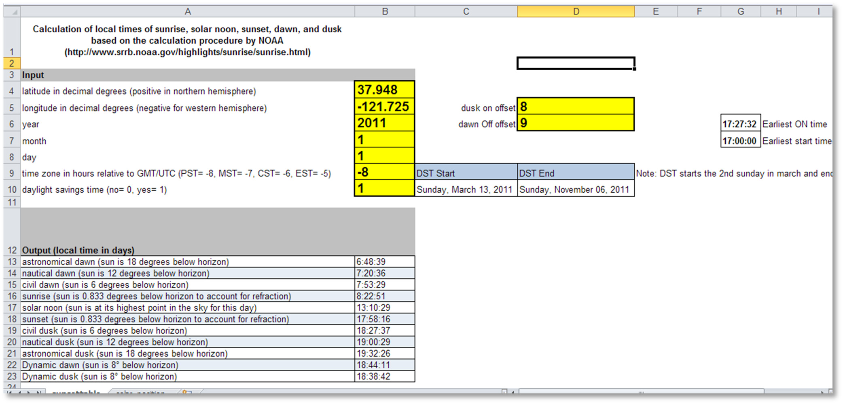
  - If there is a button at the top that shows "Enable Content" or "Enable Editing", click that. Otherwise, you will not be able to edit or save your changes properly. (This is a new function of Office 2007 and 2010).
  - Complete the form by entering the appropriate values in the yellow fields:

- B4 - Latitude: | 37.31488
- B5 - Longitude: | -121.60542 | (Negative values for Western hemisphere)
- B6 - Year: | 2011 | (enter the year of Jan 1 of the current year)
- B7 - Month: | 1 | (always enter 1, for January)
- B8 - Day: | 1 | (always enter 1, for January 1)
- B9 - Time zone: | -8 | (enter the number of hours offset for your time zone.
Use negative numbers for the western hemisphere. Do not include daylight savings offsets in this value)
    - B10 - Daylight Savings: 1 (Enter 1, if DST is used in your timezone, otherwise, enter 0. The proper local time will be calculated
for each date, based on B9, C10, and D10.
    - C10 - DST Start: 03/13/2011 (enter the date when daylight savings starts. If B10 is set to 0, this field is ignored. Since 2007, the
DST calculation in the USA was changed)

CAMS-2

© 2013 All rights reserved.

    - D10 - DST End: 11/06/2011 (enter the date when daylight savings ends. If B10 is set to 0, this field is ignored)
    - D5 - Dusk ON offset: 8 (enter the sun angle in degrees when it is dark enough to turn on the camera. Error on the side of capturing
5 minutes or so of white frames)
    - D6 - Dawn OFF offset: 9 (enter the sun angle in degrees when it will be no longer dark enough to capture meteors. Error
on the side of 5 minutes or so of white frames)
  - Take note of the value of "G7 - Earliest start time hour". This is a value, truncated to the hour. This field needs some explanation:
The "Earliest start time hour" field is calculated by scanning column E (Dusk ON) and looking for the earliest value throughout the year that appears in the column. You would typically think of Dec 21 as the longest night of the year. However, when you consider the dusk sun angle, the earliest ON time is not Dec 21. Finally, the value is adjusted to the lowest even hour. For example, in northern California, 17:27:32 is the earliest start time using 8 degrees for the dusk sun angle. The "Earliest start time hour" is then set to 17:00:00, which is the time that you should set your Task Scheduler to. At that time of each day, the LaunchCapture.bat script will run.
The LaunchCapture.bat script looks up the current date in the twilight.csv.txt file and fetches the Camera ON time for that date, along with the OFF time and other values. Then it calculates the length of time, in seconds, between the current time and the Camera ON time. Then it sleeps for that many seconds. Essentially, this puts the launch code to sleep until the Camera ON time. All these machinations are done to solve a few issues:
- The system can be run as unattended as feasible.
- The Dusk/Dawn is changing every day, so you won't need to constantly adjust the Camera ON/OFF times and the Task Scheduler start trigger.
- You don't want to captured multiple gigabytes of extra white-out until it is dark enough to capture stars and meteors.
The Duration value is calculated from the Camera ON time or the Current Time. When LaunchCapture.bat is executed before the scheduled Camera ON time, the delay is used and the caption bar indicates a progress bar "XXX-------" showing how much time is left to wait until the scheduled Camera ON time (which is also displayed in the title bar of the console window)
If, for some reason, the LaunchCapture.bat script is executed after the scheduled Camera ON time, there is no delay and the Duration value is adjusted to run from the current time until the Camera OFF time. The image below shows an example of the LaunchCapture.bat script output when it was launched at 17:05:59 where the Camera ON time is 18:44:44. In this case, the dusk sun angle is set to 8 degrees below the horizon and the dawn sun angle is set to 9 degrees below the horizon.

CAMS-3

© 2013 All rights reserved.

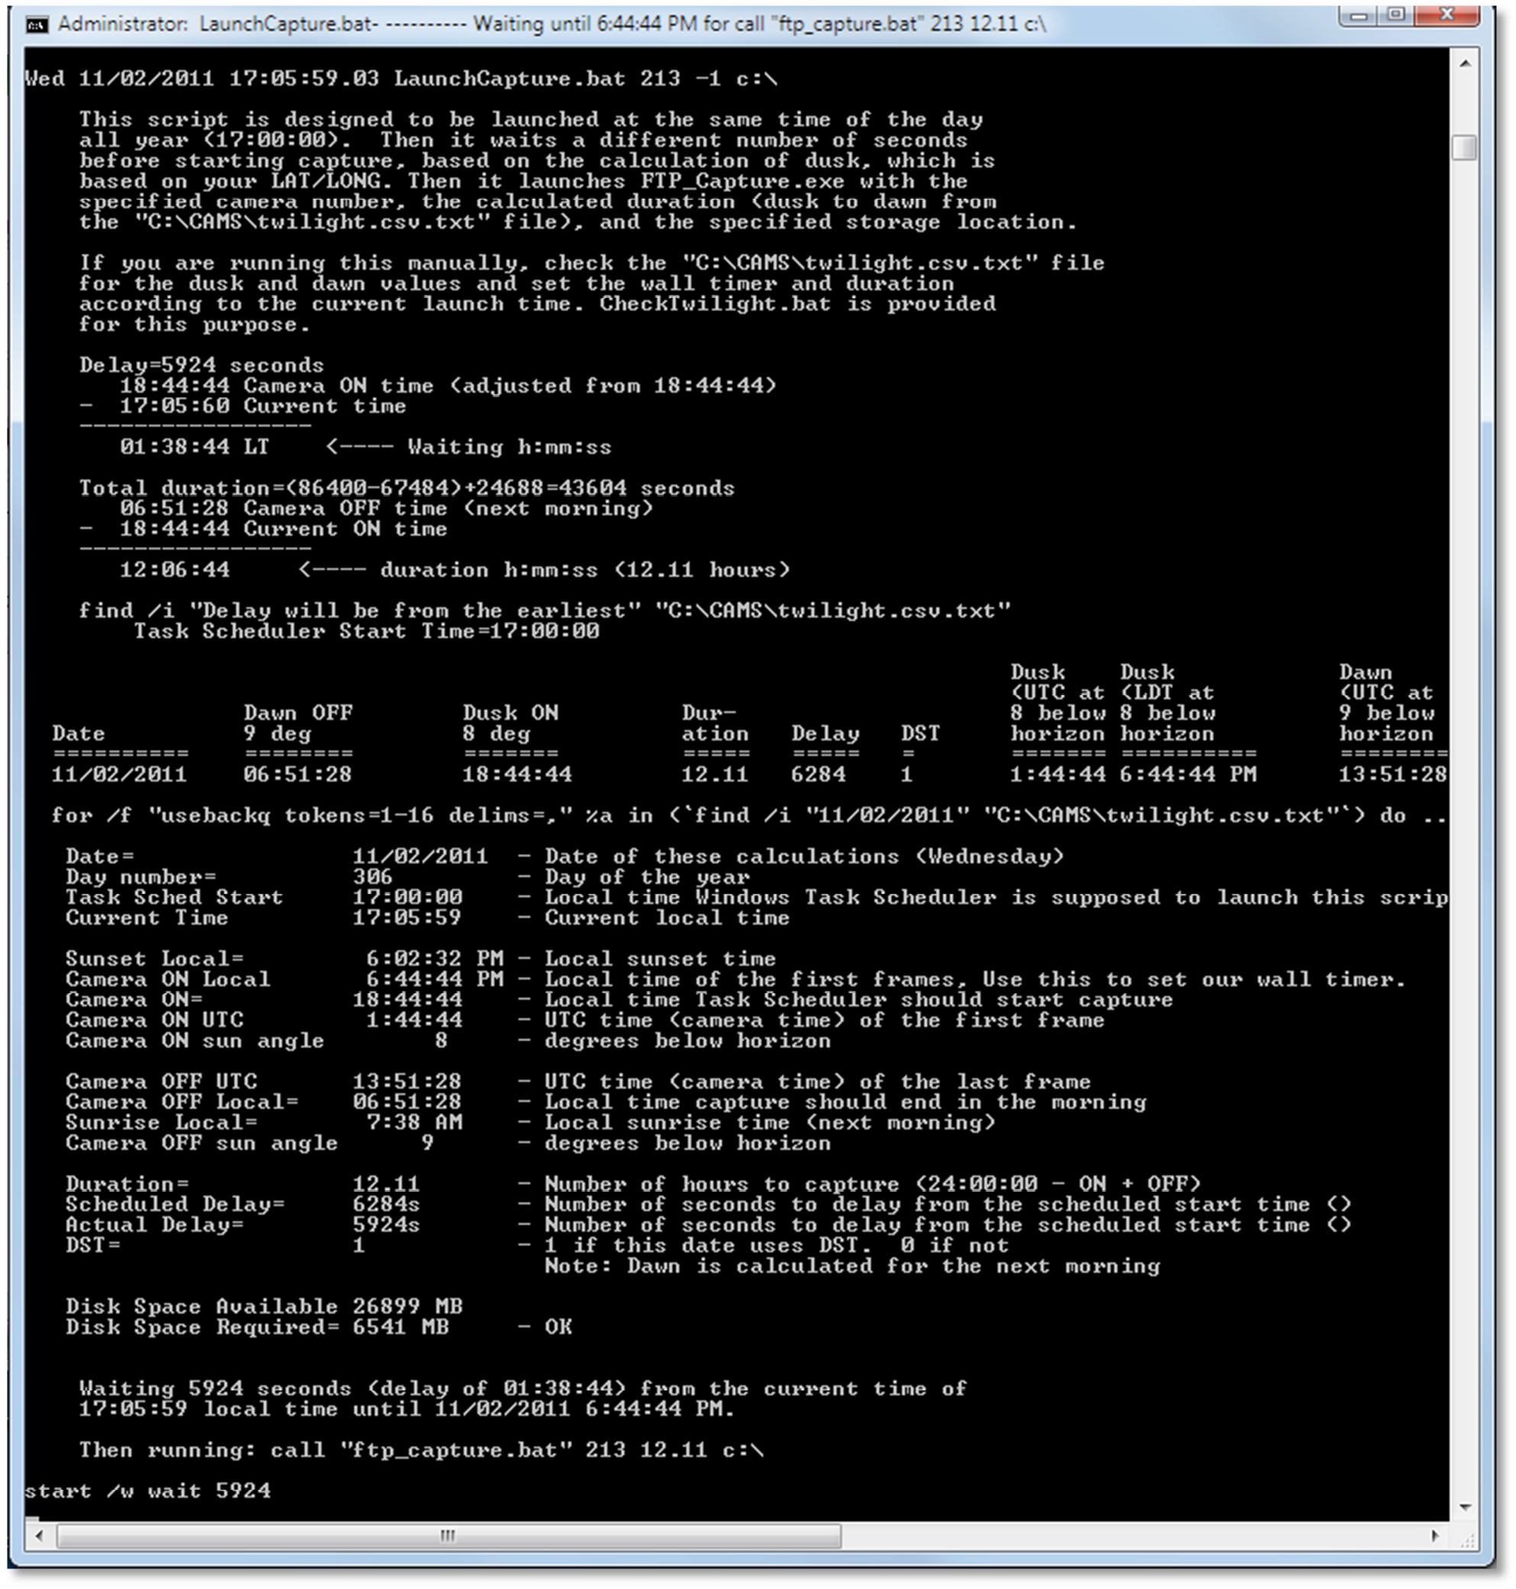

  - To save your changes to the editable spreadsheet, from the Excel menu, select File > Save.
  - To generate the "twilight.csv.txt" text file. This can be done either by using Save As or Copy/Paste:
    - Using Save As:
      - From the Excel menu, select File > Save As.

CAMS-4

© 2013 All rights reserved.

      - For "Save as type", select "CSV (Comma delimited) (*.csv)".
      - For "File name", enter "c:\cams\twilight.csv".
      - Then locate the file name in the "C:\CAMS" directory and rename it to "twilight.csv.txt".
    - Using Copy / Paste:
      - Using Notepad, open "C:\CAMS\twilight.csv.txt".
      - Select All.
      - Press the delete key (not Cut). Delete.
      - In Excel, click inside the spreadsheet.
      - Press Ctrl+A, to select all.
      - Press Ctrl+C, to copy into the clipboard.
      - In Notepad, Paste.
      - Save.
  - Validate the changes using CheckTwilight.bat...
    - From a command-shell, in the C:\CAMS directory, enter the following command:

C:\CAMS>CheckTwilight
    - CheckTwilight should show the sunset/sunrise to match the proper values for your location. See below...
Note: you can also check your table by using AutoCams option "42".

CAMS-5

© 2013 All rights reserved.

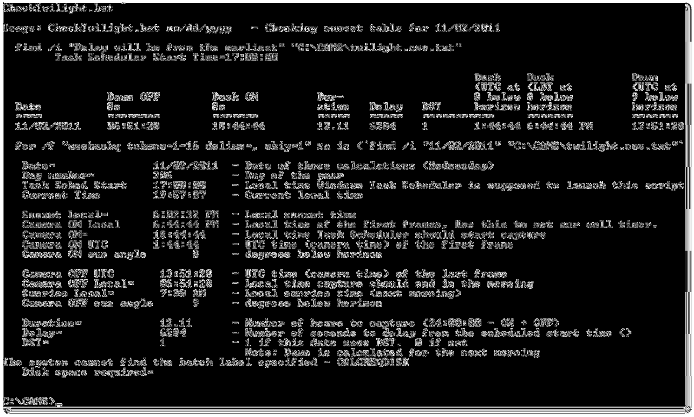

Task 9 - Setting up the Task Scheduler
Note: The Windows Task scheduler behaves differently on practically every version of Microsoft Windows. The location of the program is even at a different location of almost every different version of Windows.
  - Start the Windows Task Scheduler according to the method on the version of Windows you are using. For example, on Windows 7, you can run the following command from Start > Run:
taskschd.msc /s

In Windows XP, the Task Scheduler is found in Start > Programs > Accessories > System Tools > Scheduled Tasks.

  - 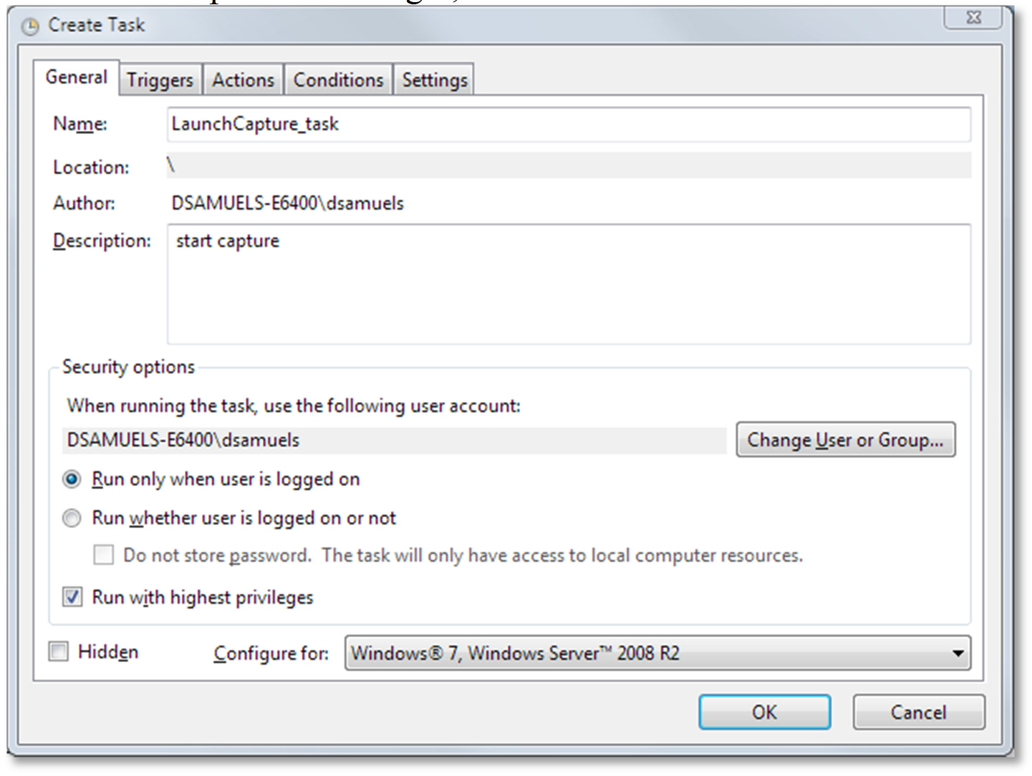In the Actions pane on the right, select "Create Task...". The Create Task dialog appears.

  - The form should contain the following configuration:
    - For Name, enter: LaunchCapture_task
    - For Description, enter: start capture.
    - Run only when user is logged on
    - Run with the highest privileges

  - 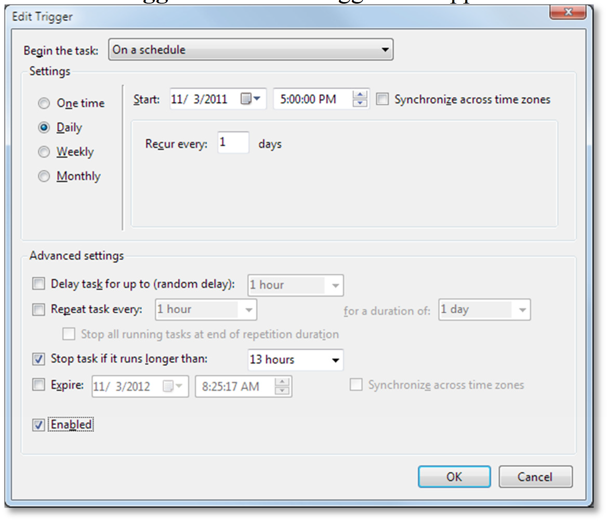Select the Triggers tab. The Triggers tab appears.

  - The form should be configured as follows:
    - Begin the task: On a schedule
    - Settings: Daily
    - Start: (enter the value reported by CheckTwilight.bat as the "Task Sched Start". For example, 17:00:00 for northern California means to enter 5:00:00 PM)
    - Recur every: 1 days
    - Advanced settings are all unchecked except:

      - Stop task if it runs longer than:
13 hours

(Note: You'll have to manually enter the text "13 hours". The closer to the pole you
- Enabled
  - Click OK. The Triggers dialog is dismissed.
  - Select the Actions tab.

  - 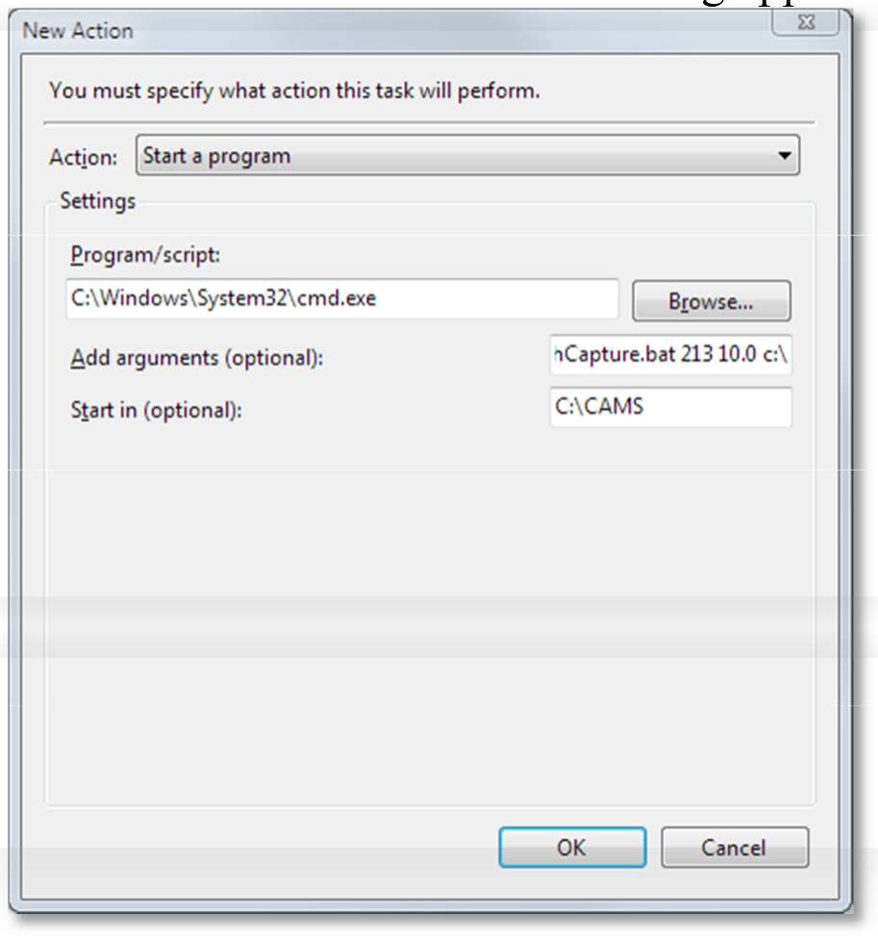Click Edit.... The New Action dialog appears.

  - The form should be completed as follows:
    - Action: Start a program
    - Program/script: c:\windows\system32\cmd.exe
    - Add arguments: /k c:\CAMS\LaunchCapture.bat <your camera number> 0.02 c:\ autonomous
    - Start in: C:\CAMS
Note: If your system can't handle simultaneous capture and detect, then do the following:
Edit the AutoCams.Params.ini file and uncomment the section that matches your configuration in the [CAPTURE] section.
  - Click OK.

  - 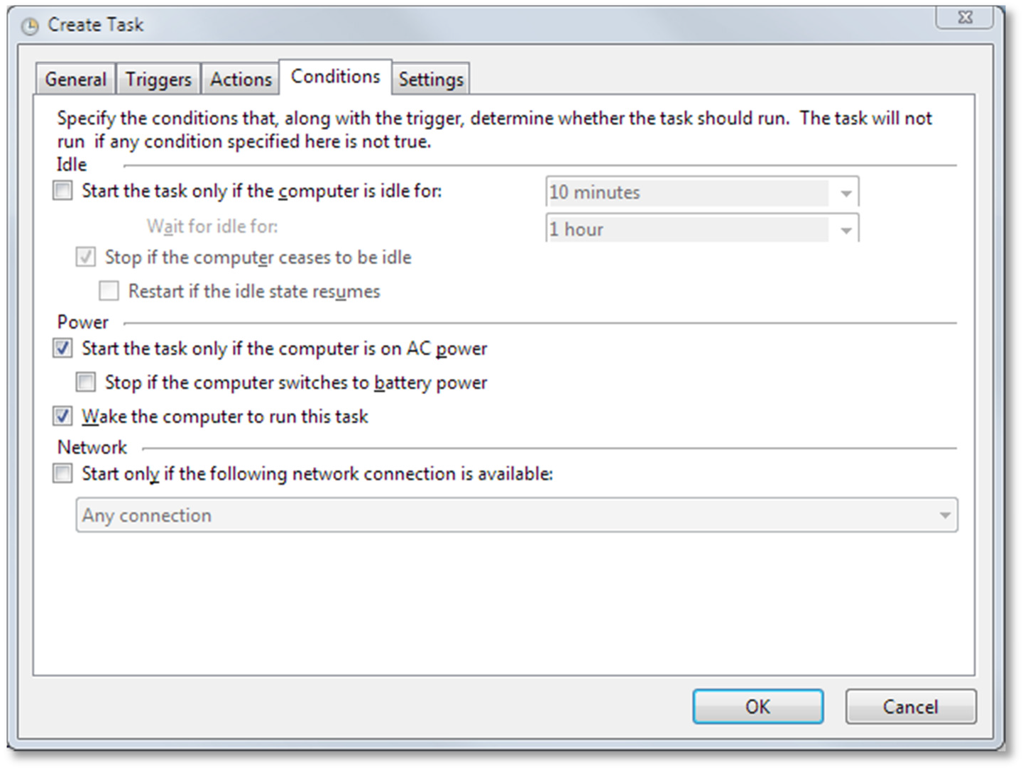Select the Conditions tab.

  - The form should be completed as follows (all uncheck except):
    - Start the task only if the computer is on AC power.
    - Wake the computer to run this task.

  - 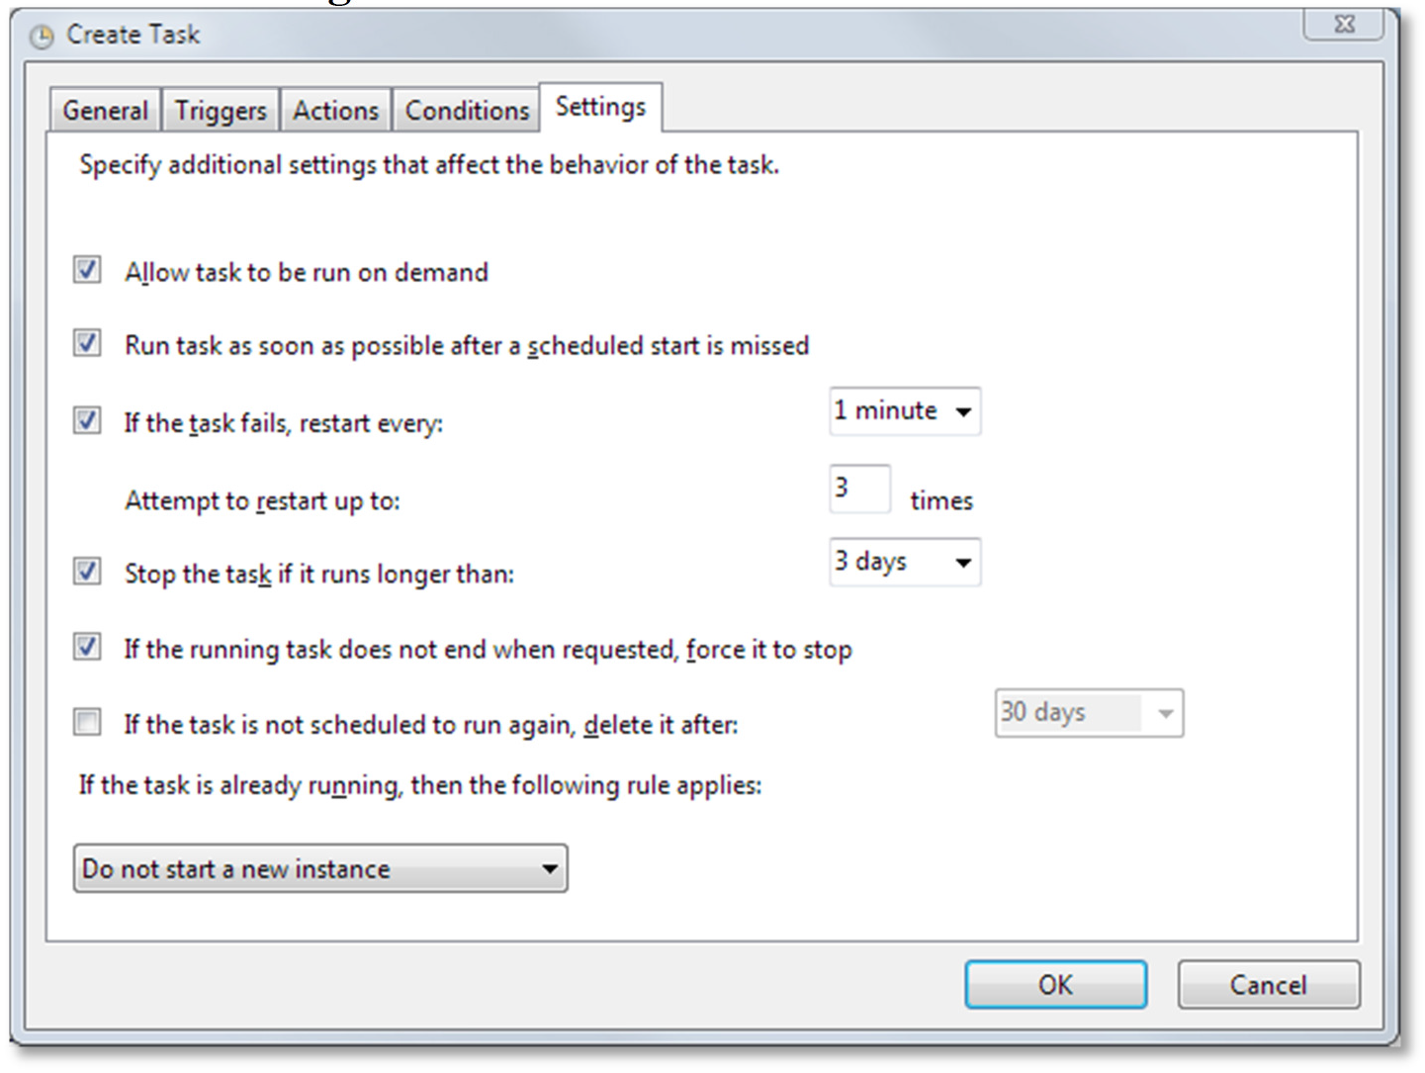Select the Settings tab.

  - The form should be configured as follows (All checked except):
    - If the task is not scheduled to run again, delete it after...
    - If the task is already running, then the following rule applies:
Do not start a new instance
  - Click OK.
  - Test it by selecting the "  Run" action in the Actions pane on the right. It should launch the LaunchCapture.bat script and show you a similar output as the CheckTwilight.bat script output.
  - Make any corrections as necessary and repeat until it is correct.
  - Close the Task Scheduler window.

Task 10 - Summary of the daily procedures
This section outlines the procedures that will be performed daily. What is most important is that data is not lost and that it gets transmitted to NASA.
See section Task 19 - Autonomous Mode Instructions for Autonomous Mode daily procedures.
These daily steps take less than 5 minutes per night of capture. More if you have issues to resolve. If you have enough storage, you can let the system run unattended for a week or so and perform the manual steps after the fact. The main thing is the keep capture going. The second most important thing is to keep the Reprocess step going (if you're not using the new CaptureAndDetect program).

If you don't capture, the project will be missing that data. If you don't reprocess, you will get behind and it is difficult to catch up.
  - Capture video (Capture And Detect)
This step should be configured to happen automatically according to the twilight.csv.txt file each day at the optimal time for the optimal duration. See Task 11 - Capturing Video.
If you need to start capture manually, it is probably best to start the capture process by running the scheduled task again. For details, follow these steps:
    - Start > tasksched.msc /s
    - In the pane on the left, select: Task Scheduler Library. The list of schedule tasks appear.
    - Right-click on your AutoCams recurring task and click Run.
  - Identify the Source directories (sometimes referred to as Target Location) This step should automatically be handled in autonomous mode.
    - In the AutoCams menu, enter the values for "1. Target Location", "2. Camera", and "3. Captured Date". AutoCams will remember the target location and camera number. Save the configuration using option "48".
    - The new CaptureTwoAndDetect.bat script automatically updates the AutoCams.bat.ini configuration file so that the directories are already selected and it's ready to use. If it doesn't, or if you're processing another date, [R]eset and start over with "3. Enter Captured Date".
  - Reprocess [also known as Meteor Scan]
This step should automatically be handled in autonomous mode if your computer can handle the real-time capture and detect without dropping frames. .
The AutoCams option "44. Multi-tasked Meteor Scan" script performs the MeteorScan routine (using multiple instance of FTP_Reprocess.exe). When it finds a possible meteor, it records the information into the "C:\CAMS\ArchivedFiles\<target directory>\ftpdetectinfo_*.txt" file. This procedure is now incorporated into the CaptureTwoAndDetect script. In the AutoCams system, this has been moved to the Utility menu since the CaptureTwoAndDetect program now performs this in real-time.
Note: If you're going to use Option 44, you probably ought to take the chance to run Auto Cal first.
  - Calibrate

This step should automatically be handled in autonomous mode if autonomouslevel=cal or higher is configured.
There are four methods for calibration. First is AutoCams option "7d. Manual Calibration" (uses FTP_MeteorCal.exe). The second is option "7b. Auto Calibration Update" (uses

FTP_MeteorCal_AutoUpdate.exe). The third option "7c. Auto Cal with prompts" (same as option 7b, but it allows you to override the minimum stars and maximum O-C values).
Option "7a. Calibration Update" is now obsolete and it will be dropped soon (uses
FTP_MeteorCal_Update.exe).
Use option 7d. Manual Calibration whenever the camera is moved, or if you can't obtain a "Mean O-C" under 2.5 with sufficient number of stars (at least 50 stars) with Auto Cal.
Preferably, the autoupdate will do the job for you.
The ValidateCal.bat script can be used to check that the Mean O-C and that the minimum number of stars used. The ValidateCal.bat script can be run for the currently selected date by entering "36. ValidateCal.bat". Or from a command prompt:

validatecal.bat /cal cal???_20110811_*.txt
If the calibration is performed after the meteor scanning procedure, use option "9. Apply Cal to Archived" (uses FTP_ApplyCal2Detectinfo.exe) to apply the calibration to the detect file after-the-fact.
  - 9. Apply calibration to detect file

This step should automatically be handled in autonomous mode if autonomouslevel=apply
or higher is configured.
Use this script to apply the new calibration file that you generated in the previous step to the
detect file that is in the ArchivedFiles directory.
  - 10. Confirmation
This step cannot be automated and remains a manual task. However, you only need to perform this step if you want to track the meteor counts locally.
The Confirmation step is optional. However, if you get a chance to run it, it will give you an idea of the level of activity each night. If you perform the confirmation process meticulously enough, the detect file from the ConfirmedFiles directory can be used during Coincidence processing instead of the detect file from the ArchivedFiles directory. In that case, the ConfirmedFiles subdirectories are usually much smaller.
  - 11. Edit "comments.txt"
This step cannot be automated and remains a manual task. You should provide one or more comments if your system could not auto-calibrate or if you were clouded out or couldn't record for some reason.
Creates a comments_ccc.txt file (where "ccc" means the three-digit camera number) during confirmation and record your comments and observations in that file. It will be reported in the MeteorCount.*.bat scripts and included with the submission files.
  - Collect

This step should automatically be handled if autonomouslevel=submit or higher is configured.

With the AutoCams menu system, this is option "13. Package Working dirs into SubmissionFiles dirs". Maybe this should be called "13. Prepare session for submission". It doesn't actually submit it. It arranges the files to a place where zip files are more easily made.
The step involves moving the files out of the "working directories" and into a location that makes them easier to manage. Use the AutoCams option 13 for this, which launches the StageFromConfirmed.bat script with some command line arguments. It will move the files out of the working directories (ArchivedFiles, CapturedFiles, and ConfirmedFiles) into a dated directory under the SubmissionFiles directory tree. It also scans the files and makes some new files that are useful for the coincidence process and organizes the files into a Submitted subdirectory tree.
We called this target directory name "SubmissionFiles" because this is where we stage the files for submission. First, all the original source files and directories (the working directories) are moved under this directory. Then, it manipulates the files and generates the appropriate files that will be used in the actual transmission. To do that, it creates an EmailFiles directory, under which some special files are created by analyzing the original source files. Then it copies the actual submission files to a directory named "Submitted". (The name isn't exactly correct, because technically, nothing has been submitted. We originally thought that it would work that way, but things have changed over time and the names haven't been changed to match the actual function.) The new subdirectory under the Submitted directory will contain a replica of the directory structure that can be reproduced on the coordinator's system. This makes it easier for our system to create a zip file of that directory structure and to transfer it to a central coordinator's system for Coincidence processing.
Watch for "Total Validation Errors = 0" at the end of the procedure. If it indicates that there were any errors, you will need to Undo the submission, repair the issues, and run 13 again.
Anytime you use menu option "15. Move SubmissionFiles dirs to working files dirs" to work on files, you should put them back into the SubmissionFiles directory using option 13 again. For example, let's say that you have already transmitted a batch to your coordinator that was not confirmed prior to transmission. You would use option 15 to move the files into the working directory tree, perform the confirmation (option 10), then run 13 again to put them back... only this time, it would include the confirmation files that you just created. (In that case, you should also run 16 to create a zip file for your archives that includes the confirmation).
  - Transmit

This step should automatically be handled in autonomous mode if autonomouslevel=ftp is configured.
In this step, you will upload/transmit the zip file to your coordinator as your submission according to the schedule arranged between you and your coordinator.

When you run option "17. Upload ZIP via FTP (Submit)", it also moves the zip file to the Transmitted directory if it successfully transmits the zip file to the server. You can view that directory to see what's been transmitted (or what hasn't been transmitted). A utility script "52. List Untransmitted Zips" will list those directories that haven't been successfully transmitted.
  - Archive
Make archive copies of the files to DVD. We do this in case they need to be reprocessed using new algorithms. Each night, there are over 6GB of data captured and processed.
However, only a part of that needs to be archived. When your coordinator tells you that it is safe, you will delete the CapturedFiles subdirectory for the dates your coordinator approves. Then you can make a DVD of the remaining files under the SubmissionFiles directory.
AutoCams option "61. Pre-DVD Archive" facilitates this step.
It is a good idea to back up the SubmissionFiles directory and the Zip files to an external hard drive once a week for safekeeping.

Note: See the Task below labeled "MakeArchiveDateZip.bat". The section describes how to properly archive the files for storage at NASA.
  - Submit Archives
This step involves two different steps. (1) Uploading detection files, configuration files, and calibration files to NASA/SETI. (2) Copying the BIN files to a DVD and mailing the DVD(s) to NASA/SETI.

Task 11 - Capturing Video
In autonomous mode, this step will be performed automatically.
Typically, you will rely on the Windows Task Scheduler to execute the LaunchCapture.bat script at the same time each day. LaunchCapture.bat performs a bunch of checks, analyzes the twilight.csv.txt table and then eventually makes the call to CaptureTwoAndDetect.bat with command line arguments that govern the capture process.

Note: The AutoCams.Params.ini file now contains settings to govern which capture mode is to be executed:

[CAPTURE]
//capture_mode=capture
//capture_mode=captureanddetect capture_mode=capturetwoanddetect bat_captureexe=FTP_CaptureTwoAndDetect.exe cameralist=213 216
archive_flag=-1
// -1 = Don't perform background detection (for slow systems that can dual capture but not detect)
// 0 = Leave FF files in CapturedFiles dir
// 1 = Copy FF files from CapturedFiles to ArchivedFiles dir (takes extra I/O + CPU)
// 2 = (default) Move FF files from CapturedFiles to ArchivedFiles after completion

In the [CAPTURE] section, you will also need to set the bat_captureexe, cameralist, and archive_flag variables. The "archive_flag" variable is set to -1 if you want to suppress the use of real-time detection for capture and detect modes.

In the following discussion, Camera ON time means "recording start time" and Camera OFF time means "stop recording time".
Here is a brief summary of the LaunchCapture.bat functions:
- Gets the current time and compares it with the scheduled Camera ON time based on the sunset/dusk calculations in the twilight.csv.txt file.
- If the scheduled Camera ON time has already passed, then the current time is used as the Camera ON time in determining the Duration for the capture. No matter when the LaunchCapture.bat script is started, the Duration value should not calculate to a value to exceed the scheduled Camera OFF time. In other words, the Camera OFF time will always be honored.
- If the current time is before the Task Sched Start time, the delay before starting the camera is calculated and the script is put to sleep until the scheduled Camera ON time. A progress bar and the scheduled Camera ON time are displayed in the title bar until the delay period is over and the script awakens to launch CaptureTwoAndDetect.bat. You are free to use the computer in any fashion necessary (except rebooting) during this delay period and it will not interfere with any processing on the computer.
- The script also calculates the required disk space based on the Duration value and the estimated size of the FF*.bin files. Then it presents a warning if you don't have adequate disk space... however, it continues to capture until the actual executable fails.
The LaunchCapture.bat script takes the following command line arguments:
  - Camera number - Example: 998
  - Duration - Example: 1
This is the number of hours to capture. The script ignores the value of this argument, but it must be present. You may use 0, 1 or any other number, like 0.2.
  - Target location - Example: C:
This is the base location. It is in the form of drive:\path. However, whatever you provide here will only serve as the base directory, under which the "..\CAMS" directory structure will be created. For example: On 08/03/2011, if you use "H:\cams\2011", the CapturedFiles directory will be placed in a directory named something like this: "H:\cams\2011\CAMS\CapturedFiles\2011_08_03_06_57_56".
  - autonomous - This is optional. If you specify autonomous, it will trigger some of the processing to execute in automous mode after capture completes, such as Auto Cal, etc.
The FTP_Capture???.exe programs capture video in 256 frame intervals and stores them in a proprietary format. It takes up to four command-line arguments for controlling the application in batch mode. If any command-line argument is missing, the application will prompt for it. With batch systems, you want to avoid situations where programs prompt for input in batch processes. This process should be handled by the LaunchCapture.bat and CaptureTwoandDetect.bat scripts that are executed by the scheduled task. However, you may encounter problems and you can troubleshoot by running the executable directly, provided you supply the proper command line

arguments. You can also run it manually from the AutoCams menu if you ever need to start the capture process manually. This will guarantee that the command line arguments are proper.

Extremely Important: It is important to dedicate the computer to only capturing during the capture timeframe. Performing even the simplest tasks will result in dropping some frames. Ideally, the capture is run on a computer that has at least two CPUs. Hyperthreading can help. If you have an i5, or i7 processor hyperthreading is enabled by default, which apparently doubles the amount of I/O it can handle. When hyperthreading is enabled, the virtual CPUs run at less than half the speed of the core they are created from. The net effect of a single CPU able to run a certain number of operations per second will only be able to run approximately a sum total of half that many operations per second when it is running as if it is 2 virtual cores. (In other words, 4 hyperthreaded CPUs are slower than a 2 CPUS configured in a dual core system) This is a well-documented and repeatably tested fact of hyperthreading. You will find individuals who argue with this, however, their arguments are typically not substantiated with repeatable empirical test results... or the testing used is insufficient to measure. If you can measure that your system does not drop frames with hyperthreading enabled, you wouldn't necessarily NEED to change the BIOS, but why run at half speed? Having said all that, hyperthread does improve on the number of I/Os that can be handled at the same time, therefore, it is probably encouraged with the CAMS system.
- The command-line format is: FTP_CaptureAndDetect <mode> <camera number> <duration>
<target location>
  - Mode - 2=MOVE (recommended), 1=COPY, 0=no move or copy, -1 (no detection).
  - Camera number - Example: 212
  - Duration - This is the number of hours to capture. Remember that this value will need to be lengthened as winter approaches and the nights get longer. Example: 10.5 for 10 hours 30 minutes. You can use the CheckTwilight.bat script to help you determine the duration.
  - Target location - This is the base location. It is in the form of drive:\path. However, whatever you provide here will only serve as the base directory, under which the ..\CAMS directory structure will be created. For example: On 08/03/2011, if you use "H:\cams\2011", the CapturedFiles directory will be placed in a directory named something like this: "H:\cams\2011\CAMS\CapturedFiles\2011_08_03_06_57_56".
If you specify this command-line on 08/03/2011 at 6:57:56 UTC:
ftp_capture 212 10 c:
It will capture video for camera 212 for 10.0 hours and store the video files in: "
C:\CAMS\CapturedFiles\2011_08_03_06_57_56"
There is a naming convention for the resulting captured files. For example, a capture file named this:
"FF212_20110803_065810_358_0000256.bin" is a capture file for camera 212, started on 08/03/2011 at 06:58:06.358 UTC, for the first 8.5 seconds (the first 256 frames). The timestamp reflects the middle of the 8-second capture time, not the starting time. The remaining numbers (0000256) identify frame numbers or the frame count.

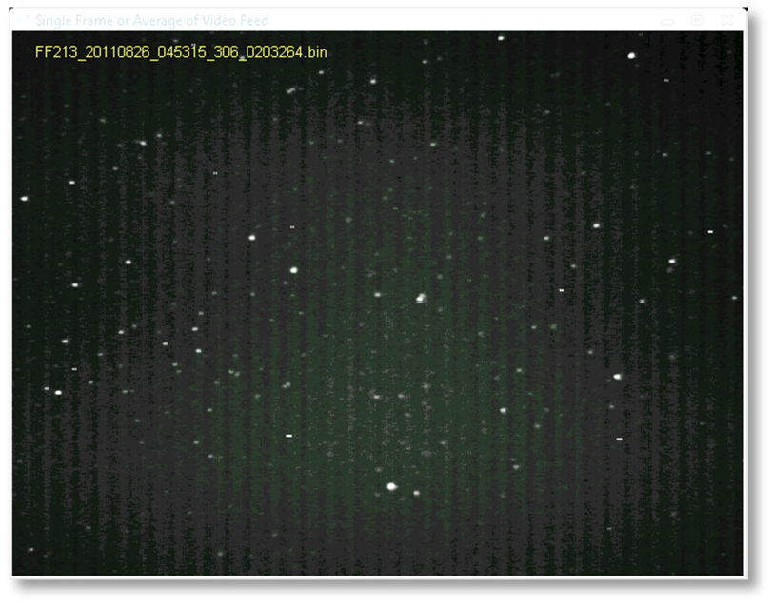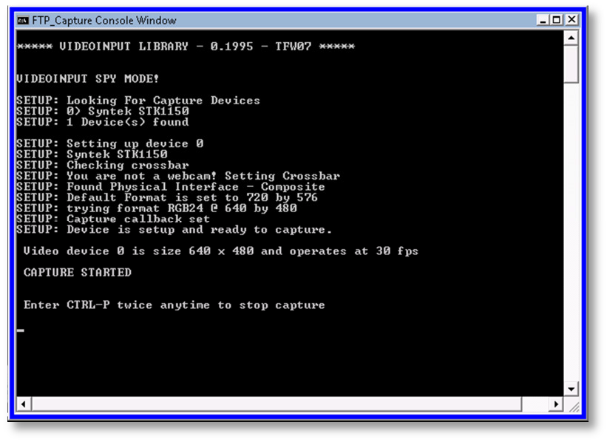
  - More information:
FTP_Capture or FTP_CaptureAndDetect or FTP_CaptureTwoAndDetect or FTP_CaptureFourAndDetect, can be run by double-clicking on the executable or from a command-line.
When you double-click these executables from Windows Explorer, the program will run in interactive mode, where it will prompt the user to enter the camera number, duration of the capture in hours, and the target location.
If the duration entered is zero, the user is prompted to manually start and stop the capture process. If the duration is greater than zero, the program automatically starts the capture and stops after the designated time has elapsed. If the duration is negative, the program calculates the negative duration value as a sun angle and stops and starts capture based on that sun angle. (AutoCams doesn't use the Sun Angle option)
Alternatively, if the application is run from a command-line, optional command-line arguments can be provided to parameterize the execution of the program:
FTP_CaptureAndDetect [[[[mode] [camera number]] [duration hours]] [target location]]
Examples:
FTP_CaptureAndDetect
The user is prompted for the camera number, duration, and target location
FTP_CaptureAndDetect 2 212
The user is prompted for the duration, and target location
FTP_CaptureAndDetect 2 212 10.5
The user is prompted for the target location
FTP_CaptureAndDetect 2 212 10.5 "h:"
The program runs with the provided parameters.

CAMS-18

© 2013 All rights reserved.

FF files means "Flatfield Temporal Pixel Video Capture and Compressed". This is a proprietary video file format designed specifically for the purpose of this application. These video files cannot be viewed using standard viewers. You would need to convert them to another format to be able to review the video - various conversion utilities are provided for this purpose and they will be documented.
A folder is created for saving the FF files based on the date/UTime at the start of the capture. UTime means UTC time.

UTC is kind of the same thing as Greenwich Meantime, but there are significant differences. For the purpose of this discussion, it is the universally coordinated world clock time at longitude zero. UTC is used throughout these applications. Local time (civil time) is calculated as the UTC time added or subtracted from the timezone offset. Pacific Daylight Time is UTC -7 hours and Pacific Standard Time is UTC -8 hours.
The higher level directory is always user-specified and the "\CAMS\CapturedFiles\" is appended to the user-provided [target location]. For example: a capture that starts on Jan 5, 2011 3:11:05 UT and the target location specified was "D:\cams\2011" would have the FF*.bin files placed into the folder "D:\cams\2011\CAMS\CapturedFiles\2011_01_05_03_11_05\".
  - Manually terminating the Capture.
Don't just close the windows or terminate the process unless absolutely necessary. This will cause corrupt FF files and an incomplete/corrupt detect file. Instead, you have two options. One is to pause capture, and the other is to Cancel capture.
    - To Pause Capture, press CTRL+P.
    - To Cancel Capture, press CTRL+P twice. Then wait until all the windows close themselves.

WARNING: If you interrupt capture and then start it again, you will have multiple working directories with the same date. However, the 0.990 release, you can submit multiple capture sessions per night without problem.

Task 12 - Calibrating

In autonomous mode, calibration is automatically performed so there would be no need to perform this task unless the autocal during autonomous mode operation fails.
There are four methods for calibration. First is AutoCams option "7d. Manual Calibration" (uses FTP_MeteorCal.exe). The second is option "7b. Auto Calibration Update" (uses FTP_MeteorCal_AutoUpdate.exe). The third option "7c. Auto Cal with prompts" (same as option 7b, but it allows you to override the minimum stars and maximum O-C values). Option "7a.
Calibration Update" is now obsolete and it will be dropped soon (uses
FTP_MeteorCal_Update.exe).

Use option 7d. Manual Calibration whenever the camera is moved, or if you can't obtain a "Mean O- C" under 2.5 with sufficient number of stars (at least 50 stars) with Auto Cal. Preferably, the autoupdate will do the job for you.
  - 7b. AutoCal and 7c. AutoCal with Prompts
    - Auto calibration iterates through the FF files in the specified directory and performs these steps for each one:
      - Checks the FOV for the star count.
      - If the star count is less than the target number (usually 50 or higher, see AutoCams.Params.ini > [CALIBRATION] bat_calnstars and bat_starcountthreshold), then it skips to the next file in the list.
      - Otherwise, it checks the Mean O-C value. If the Mean O-C value is greater than the target amount (2.50 or lower, , see AutoCams.Params.ini > [CALIBRATION] bat_caloc), it will perform an outlier purge until either the star count falls under the target number or it succeeds in achieving the Mean O-C value. If it achieves the target Main O-C value with the target star count, then it logs those values and moves on to the next FF file in the list. When it completes the list of FF files, it creates a CAL file in the C:\CAMS\Cal directory based on the FF file that produced the best calibration values.
Autocal produces a file, named AutoCalUpdate.log in the source directory. In the case where autocal fails, you can examine the log to determine possibly the best file to use for a manual calibration. The file listed in the log with the highest number of stars and a lower Mean O-C value would be a good choice.
  - Cal Update [obsolete]
    - From the AutoCams menu, select step "7a. Calibration Update". This step will automatically select a calibration file from the Cal directory to use as a basis for this calibration update.
  - 7d. Manual Calibration
Task 7 -Manual Re-Calibration Example Run: above describes the steps for performing the manual calibration. Use AutoCams menu option 8.

Task 13 - Apply Calibration to Detect File

In autonomous mode, this task is unnecessary unless there is an error and the calibration has to be performed manually.
The MeteorScan routines work like this. When it finds a possible meteor, it records the event information into the "detect file". For each event, the FF file and its CAL file are listed in the detect

file. The X/Y pixels and RA/DEC coordinates of the event are recorded in the section for that event. The problem is, the calibration step is almost always performed after the scan is complete (especially with the capture-and-detect style programs are run). The MeteorScan routine uses the most recent CAL file available, which is typically from a date previous to the one it is processing. Therefore, it becomes necessary to patch the detect file with the new calibration file after calibration. At the same time, the RA/DEC coordinate values of each event need to be skewed by the difference between the calibrations as well as magnitude information. The "9. Apply Cal to Archived" and "12.Apply Cal to Confirmed" scripts do this job (uses the FTP_ApplyCal2detectinfo.exe program).

Note: This script will soon change its behavior in the following manner:
- Before calling the FTP_ApplyCal2detectinfo.exe program, it will rename all the CAL files in the Cal directory (except the latest created for that date) to something that will not be visible to the .exe program. This is to avoid the confusing mess of what happens when there are Cal files that are based on a newer FF file than an AutoCal-generated cal file. This renaming function will apply to all Cal files except the latest file generated for the date in question.
- Whether Apply succeeds or fails, the files will be renamed back.
  - From the AutoCams menu, select option "9. Apply Cal to Archived".
  - Then follow the prompts.
It is imperative that the correct CAL file is applied to the detect file. One good test is to open the detect file with Notepad and check if the CAL file listed for each event is the expected CAL file for the date in question. If it is not, you will need to correct the reason why it is not working and try again.
In interactive mode (when you're not using the AutoCams menu to launch it), the program produces an FTPdetectinfoC.txt file in the target directory. You will need to use that C file to validate that the program functioned as expected and then delete the original. Here is a command that will do that for you:

move /y ftpdetectinfoC.txt FTPdetectinfo.txt
  - Calibration Troubleshooting:
Sometimes, there are troubles with calibration. A bad calibration one night will affect all subsequent nights. If you find that a night, or several nights in a row, are not processing properly, check the calibration files starting with the night before they seem to start going bad. You can rename all subsequent nights to something like "xCAL299_*.txt" and then run the AutoCams "7b. AutoCal" option. Or manually calibrate that oldest bad date. You should be able to autocal after that... at least for the clear nights. Overcast and partly overcast nights also produce problems. Option "7c. AutoCal w/ prompt" was designed to facilitate that.

Task 14 - 44. Multi-tasked Meteor Scan
The FTP_Reprocess.exe program performs the MeteorScan routine. When it finds a possible meteor, it records the information into the detect file. This can take several hours. The new autonomous mode performs this task in near-realtime and is no longer necessary unless the

CapturedFiles need to be manually re-scanned for whatever reason. If that is the case, you'd be better off running the "44. Multi-tasked Meteor Scan" option from the Utility menu instead. This option will take advantage of the fact that your computer has multiple CPUs and divide the workload of reprocessing into as many chunks as the number of CPUs you have. The length of time for the multi- tasked reprocess is literally (1/Processors) the amount of time. The problem is that you are left with multiple output files that need to be merged. The utility menu has the "44b. Merge Multi-tasked Meteor Scan Files" script to combine the multiple output files into a single detect file. As of the 1.00a release and higher, option 44b is automatically called when option 44 is finished and merges the results for you.

Task 15 - Confirming (optional)
The Confirmation step is optional. However, if you get a chance to run it, it will give you an idea of the level of activity each night. If you perform the confirmation process meticulously enough, you can submit the detect file from the ConfirmedFiles directory instead of from the ArchivedFiles directory. In that case, the ConfirmedFiles subdirectories are usually much smaller.
If you have moved the files to another drive, the detect file will need to be patched so that the FF folder and the CAL folder entries reflect the new location. You can use the FixDetectPaths.bat script to make those changes for you.
  - It may be necessary to use the "15. Move SubmissionFiles dirs to working files dirs" option prior to performing the confirmation step. To undo the submission, follow these steps:
    - From the AutoCams menu, enter "3. Enter Captured Date" and follow the prompts.
    - If it tells you that it can't find the CapturedFiles directory, it is probably because it has already been run through submission. During Submission, it moves the files to another location. They need to be moved back to the working directories to continue.
    - Enter "14. Choose Submission dir" and follow the prompts.
    - Enter "15. Move SubmissionFiles dirs to working files dirs". It will move the files from the SubmissionFiles directories and restore them to the working directories. Also, the CapturedFiles, ArchivedFiles, and ConfirmedFiles directories will indicate the number of files, meteor count, etc.
  - From the AutoCams menu, select option "10. FTP_Confirmation". It will use the target location, camera, and captured date to create command line arguments when launching the program. If you run it in interactive mode, you will need to follow the prompts and navigate to and select the FTPdetectinfo.txt file.
  - It will display your image on the left and a console window on the right. The Console window needs to have the keyboard focus when entering in commands. If you see an event that appears to be a meteor, then press Enter to "accept". You need to error on the side of false-positives. False-positives are OK. When in doubt, accept.
  - Reject by pressing any other key.

  - You can go back as many as 15 events and re-enter your accept/reject decision.
  - You can press "f" to skip to the next FF file. Just remember that it will only be able go back no more than 15 events.

Task 16 - Collecting
The step involves moving the files to a location that makes it easier to manage. Use "StageFromConfirmed.bat" for this. It moves the files to a directory tree under ".\SubmissionFiles\2011_08_05_04_40_44\".

Working directories (before) | SubmissionFiles directories (after)
..\ArchivedFiles\  2011_08_05_04_40_44\ FTPdetectinfo.txt FTPdetectinfo_0213_2012_03_07.txt CameraTimeOffsets.txt LASTSETTINGS.txt  FF*..bin | ..\ArchivedFiles\  2011_08_05_04_40_44\ FTPdetectinfo.txt FTPdetectinfo_0213_2012_03_07.txt CameraTimeOffsets.txt LASTSETTINGS.txt  FF*..bin
..\Cal\  CameraSites.txt CAL213_20110805_050014_038.txt  CameraSites-213.txt | ..\Cal\  CameraSites.txt CAL213_20110805_050014_038.txt  CameraSites-213.txt
..\CapturedFiles\  2011_08_05_04_40_31\  *.bin | ..\CapturedFiles\  2011_08_05_04_40_31\  *.bin
..\ConfirmedFiles\  2011_08_05_04_40_44\ FTPdetectinfo.txt FF*..bin | ..\ConfirmedFiles\  2011_08_05_04_40_44\ FTPdetectinfo.txt FF*..bin comments_213.txt
..\EmailFiles\ Cal-213\
CAL213_20110805_050014_038.txt
CameraSites-213.txt FF213_20110805_050009_751_0035072.bin
213_archived=533, confirmed=52.txt CameraSites.txt CameraTimeOffsets.txt comments_213.txt FTPdetectinfo_confirmed_213.txt FTPdetectinfo_confirmed-213-52.txt

FTPdetectinfo_scanned_213.txt FTPdetectinfo_scanned-213-533.txt LASTSETTINGS.txt
ReprocessParameters.txt submit_213.txt

After this step, you can run "38. Meteor Count Submitted dirs" (uses MeteorCount.submission.bat) to report on the data collected under the .\SubmissionFiles directory tree.

Task 17 - Transmitting
This step involves two different steps.
  - Uploading a collection of detection files, configuration files, and calibration files to NASA/SETI. You will make a single zip file of the collected files and upload then to the FTP server. Use these steps for submission:
    - Use AutoCams option "16. Zip Submitted dir" to create the zip file. If it succeeds, the "Last error msg" at the bottom of the menu will indicate as such. If it fails, you will need to run option 16 again.
    - Use option "17. Upload Zip via FTP (Submit)". If it succeeds, it will indicate as such in the "Last error msg" at the bottom of the menu.
Sometimes the upload fails. This can happen for various reasons, such as network errors, timeouts, busy server, down server, etc. I have found that sometime retrying a few times it will eventually succeed.
You can troubleshoot the problem by using TotalCommander or FTP from a command line and trying to connect to the FTP server manually. If it succeeds, the problem may have gone away or cleared or the problem may be something wrong with corrupted scripts. Check the C:\CAMS\ftp.temp.txt file.
  - When you're ready, you will mail the collected DVDs to NASA.
(2) Copying the FF files to a DVD and mailing the DVD(s) to NASA/SETI.

Task 18 - DVD Archiving
Make archive copies of the files to DVD. We do this in case they ever need to be reprocessed using new algorithms.
A good rule of thumb is to only run 61 after your network coordinator says that they're done with your files and that they no longer need the captured files directories for reprocessing. Also, it is a good practice to run option 61 on a month at a time basis. For example, Let's say it's May, and your network coordinator has just given you the all clear for January. Go ahead and run option 61 for January.

    - Run the "61. MakeArchiveDateZip" script to remove all unnecessary files and to create a zip file for each date.
It leaves behind the SubmissionFiles\date\camera\EmailFiles directory. This directory is small and it is useful from keeping a running tab on the meteor counts.
    - Copy all the zip files to a DVD and mail to NASA/SETI
    - Delete the zip files from your hard drive to make room for more capture.

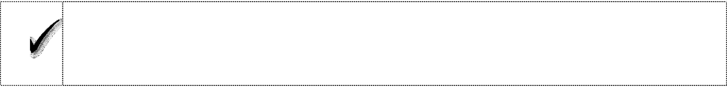

Congratulations! You have successfully configured the camera.

Task 19 - Autonomous Mode Instructions
 
These instructions are for running in autonomous mode. In autonomous mode, there is little to do. However, there are some daily or weekly tasks that you should probably follow.
  - Let the autonomous mode capture, detect, and calibrate the files on a daily basis. (That's the default for autonomouslevel=apply operation).
  - Periodically (it is up to you whether you do this daily, weekly, monthly, etc.), you need to check for failed autonomous mode runs and correct them.
Sessions that need further processing are still in the working directories.

It is best to start resolving problems from the oldest and work forward. This is because of the way calibration files are determined during the preprocessing phase.
Here are some methods for checking on the status of things:
    - One method for determining which dates need manual processing is to use the AutoCams menu and do the following:
      - From the AutoCams menu, select "3. Enter Captured Date". It will list all the dates that haven't completed the submission/transmission process.
    - Another method is to work from the SubmissionFiles:
      - From the AutoCams menu, select "3. Enter Captured Date".
      - Enter S to list the SubmissionFiles directories.
      - Enter the number that is displayed to the left of the desired entry. The CapturedFiles and ArchivedFiles date will change to indicate that it is looking at the SubmissionFiles subdirectory.

CAMS-25

© 2013 All rights reserved.

      - Enter "15. Undo from Submission". It will move the SubmissionFiles for that date to the working files directories.
      - From this point, you can perform the "10. FTP_Confirmation" procedure. You can also re-do the calibration if needed.
      - Once you perform the confirmation, you can optionally enter A (for autonomous mode), and it will proceed in autonomous mode as if it was starting this immediately after capture. If you don't want to use the full autonomous mode to reprocess, use options 13, 16, then 17.
  - Archive (see 10.10 Archive)
  - Submit Archives (see 10.11 Submit Archives)

Task 20 - Calibration Tricks
This section provides some tips and tricks to facilitate manual calibration. A couple of things to note...
The Cal center Dec (deg), Cal center Azim (deg), and Cal center Elev (deg) values shouldn't change from night to night very much. If a calibration produces results where these values change more than a degree, it is an indication that it is either a bad calibration or the camera has moved. If the camera has moved, a manual calibration will be necessary. How can you tell which method to use? Examine a calibration file for another clear night after the night in question. If the values haven't changed, then it is a bad calibration. If the values have changed, the camera may have moved. If you delete the CAL file for the night in question, then run autocal for the subsequent night, if that produces a CAL file with these values the same, the night in question has a bad cal and you need to resolve that before transmitting it.
Important: After performing a manual calibration, it is always a good idea to fine-tune that manual calibration with a calibration update, either autocal or just cal update.

Tip: The RA drifts by approximately 1 degree per day when you consider there are 360 degrees in a circle and 365 days in a year.
  - First, check if you have a valid cal file for that camera in the current position. You can open that cal file and use the RA and DEC values as a starting point. If you want to use this method follow these steps:
    - From the AutoCams menu, enter [R]eset, to reset that date. Optionally, you can use option 3 and enter the date that you want to examine and copy from.
    - Enter option "36. Validate Calibration Files...". It will start listing the calibrations from the most recent to the older ones.

CAL213_20120530_105148_548.txt, [Cal stars=51] O-C=0.371+-0.161 Scale=2.782 [ALT=53.751 AZ=330.717] [RA=247.3660 DEC=64.505]

    - Make note of the date/time parts of the cal file name of the first one that comes appears in the list. You can stop the report any time by pressing Ctrl+C, then answer "N"o, don't terminate the batch job. In the example above, you'd want to write down the following information:
• File name: CAL213_20120530_105148_548.txt
• RA=247.3660
• DEC=64.505
• ALT=53.751
• AZ=330.717
Note: The date/time in the cal file name in the above example is: 05/30/2012 at 10:51:48.548 UTC.
Also, it is a good idea to monitor the ALT/AZ values from time to time to see if there is any migration in the mount over time. These are you best indicators if the camera has moved.
    - Enter AutoCams option 3 and enter or select the date for the day you need to calibrate. For this example, let's say it was 06/05/2012 (pretending that we had 5 days of rain or something).
    - See Task 7 -Manual Re-Calibration Example Run: above.
  - Determine which FF file (either from the ArchivedFiles or CapturedFiles directory) that you will be using for a manual calibration. This will be called the "FF file used for calibration".
    - One method of determining this is to perform the autocal function and watch for frames that have a sufficient number of visible stars. Write down the time section of the good file names.
  - Another trick is to examine the AutoCalUpdate.log file from the autocal pass. You should be able to locate this under the CapturedFiles directory. The log file will list all the files that it examined. You could start your manual Cal using the file name in the log that shows the highest number of stars with the lower value for Mean O-C.
  - Open the most recent calibration file in the C:\Cal directory whose date is the closest date to the date that you're calibrating.
    - Near the top of the file, you will find the following entries, along with their values, that will be useful for this task:
Calibration date Calibration time (UT) Cal center RA (deg) Cal center Dec (deg)

Cal center Azim (deg) Cal center Elev (deg)
    - Calculate the time difference (in hours) between the FF file used for calibration and the time of the calibration file. Note: AutoCams option 7d performs this calculation for you.
      - Example: The FF file used for calibration is FF299_20120209_103741_704_0871680.bin and the recent calibration file was CAL299_20120208_022447_641.txt.
      - Convert the times to decimal hours. This is done by dividing the minutes by 60, then adding the hours:
"103741" = (37/60)+10=10.617
"022447" = ((24/60)+2=2.4 (no need to be accurate to the second)
      - Then subtract 10.617 - 2.4 = 8.217 hours difference.
      - To convert the difference in hours to a difference in degrees, multiply the hours by 15:
8.217 * 15 = 123.255
      - Add this to the RA value in the previous calibration file.
      - Add to the RA value the number of days between the old date and the new date.
      - If the result is greater than or equal to 360, subtract 360 from the result:
194.717 + 123.255 + 1= 318.972
or another example might be:
254.652 + 123.255 + 1= 378.907 - 360 = 18.907
      - Use the result in the manual calibration as the RA (deg) value. Use the same Dec value in the previous calibration file's Dec (deg) value in the manual calibration.
  - If the camera may have moved and you can't attain a valid calibration update or autocal update using a good clear star field, you need to determine new values for both RA and Dec.
    - Use autocal to iterate through the FF files to view them until you recognize a star pattern that you can find in a planetarium program (such as Starry Night or Cartes du Ciel, etc). This will be referred to as the "FF file used for calibration".
    - Use the planetarium program and adjust the FOV to about 32 degrees.
      - Adjust the Lat/Long to your position.
      - Adjust the date/time to the date/time of your FF file to use for calibration. Be sure to adjust for Universal Time.

      - Set the orientation to terrestrial view (which puts the horizon down and the zenith up).
      - Move the view until the Alt/AZ approximately matches the Alt/AZ of the camera position.
      - Move the view a little more until you see stars the match the FOV of the FF file to use for calibration.
      - Obtain the RA/Dec and Alt/AZ from the Planetarium program.
    - Convert the RA value to degrees, if necessary by multiplying by 15. For example:
RA 14h 32m 48.2s
((32/60) + 14 ) * 15 = 218.25 degrees
    - The Dec value does not need to be converted.
    - Use those values when entering in the RA and DEC values into the manual calibration program.

Task 21 - Coincidence
This section will describe how the local coordinator can use the FTP_Coincidence.exe program. The Coincidence software is not broadly distributed because its sophisticated algorithms need to remain proprietary. There are competing projects that could direct funding away from the CAMS project funding if these algorithms get into the wrong hands.
The nature of the Coincidence software is to perform the triangulation and orbital calculations based on two or more triangulated fields.
In all the examples below, we will use Jan 21, 2012 to illustrate what exactly happens during processing.
Here is what we know so far...
  - Important: Make sure that your CameraSites.txt file in the "C:\CAMS\Cal" directory does not have any duplicate entries. It must also have an entry for each camera that Coincidence is going to encounter.
  - Download or copy the submission ZIP files to the C:\CAMS\Temp directory.
  - From AutoCams, select option "[R]eset.
  - From AutoCams, select option "3. Change Date". Manually enter a date in the format MM/DD/YYYY.
  - From AutoCams, select option "54. Coincidence". It will handle all the remaining processing and then launch the FTP_Coincidence.exe program.

The functions it will perform before launching the FTP_Coincidence.exe program are listed below for the date (Example 2012_01_21):

    - AutoCams launches the Coincidence.bat script using the entered captured date (01/21/2012).
    - Coincidence.bat launches and then performs the following steps...
    - Unzips the files to a "C:\CAMS\Temp\Coicidence\2012_01_21" directory. Remember, the submission zip files place copies of the FTPdetectinfo_0camera_yyyy_mm_dd.txt files in the root of the zip file with the headers removed.
    - It then creates an FTPdetectinfo_CaseHeader.txt file that can be worked on and manipulated much quicker than doing it directly in the large combined detect file. This will be prefixed to the combined detect file later.
    - Strips all the headers from all the detect files.
    - Combines all the detect files with their headers stripped so it can perform a detection count total.
    - It performs a meteor count by counting all the ".bin" entries in the file.
    - It obtains the current paths for "FF Folder" and CAL folder" in the detect file so they can be replaced with new paths for use during coincidence processing.
    - The FTPdetectinfo_CaseHeader.txt file is patched to reflect the new detection count total, FF Folder path, and the CAL folder path values.
    - The FTPdetectinfo_CaseHeader.txt is concatenated with the other FTPdetectinfo_scanneded*.txt files, thereby merging all the detection files for all the cameras for the specified date into a single FTPdetectinfoCoinc.txt file.
    - The CoincidenceParameters.txt file is copied from the C:\CAMS directory to the C:\CAMS\versionHistory directory. The reason this is done is to avoid accidental distribution of the coincidence program.
    - Finally, the C:\CAMS\FTP_Coincidence.exe program is launched using the following command line arguments:

FTP_Coincidence "C:\CAMS\Temp\Coincidence\2012_01_21\FTPdetectinfo Coinc.txt"
    - Zips up the resulting displayJPGs and gefdat directories into "Coincident_2012_01_21.zip"

    - Uploads the "Coincident_2012_01_21.zip" file to the upload server.

Some tips you might want to be aware of:

    - Coincidence output will be in two directories: "displayJPEGs" and "gefdat".
    - CoincidentMeteorLog.txt lists the date/time and camera numbers for each event.
    - The "SummaryMeteorLog.txt" file contains additional information, such as the radiant info in RAinf, DECinf; the 3D ground track including begin and end for Lat, long, and height.
    - The "SummaryOrbitLog.txt" file contains the orbital elements for the particle.
    - The "NonCoincidentLog.txt" file contains information on detections that don't have a coincident event from another FF file, ether from the same camera or another camera. However, somehow it contains the RA/DEC and intensity of the singleton event. It would be useful to also add the length of the event, the duration, and the angle across the sky... somehow.
    - The remaining files (that all begin with "CAMS_" are results that are compatible with the FIREBALL software program.
    - The "displayJPEGs" directory contains three .jpg files for each coincident event.
      - CAMS_nnnnn_HeightVsRange.jpg
(Bottom-left Height(km) versus Downrange(km) window)

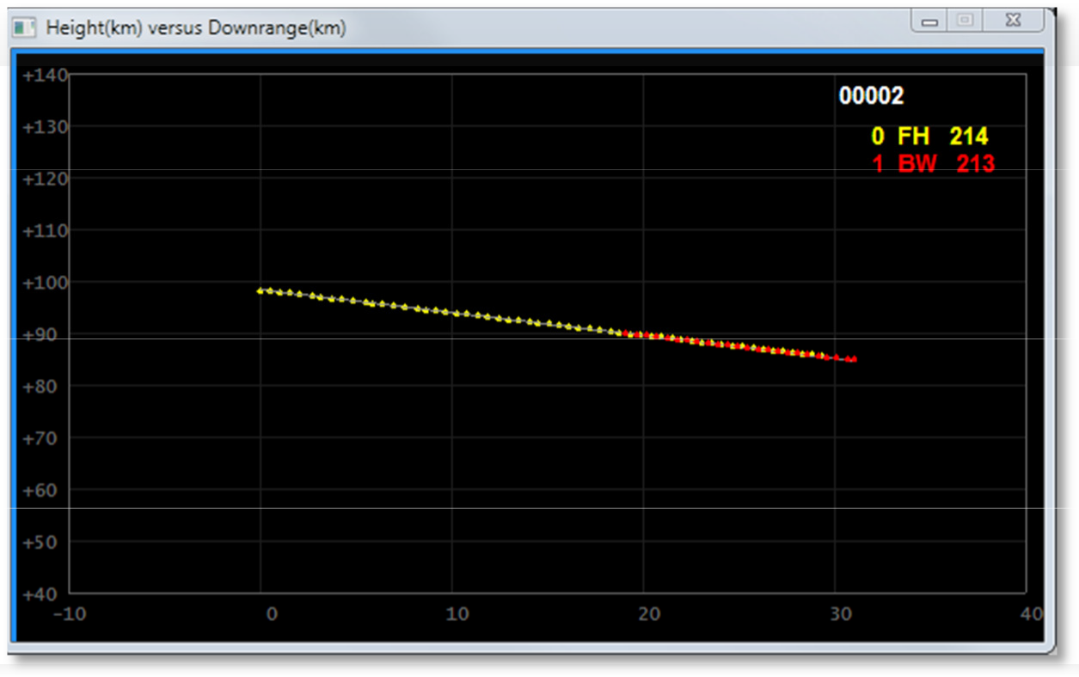

The ideal result is two overlapping lines. In this example, you have camera 0 FH that tracked this meteor from 99km to about 85km height for 30km. Camera 1 BW tracked this meteor from 92km to 84km for about 14km downrange.
      - CAMS_nnnnn_LatLong.jpg
(Top-right Ground Track Offset(km) re Track Center Latitude & Longitude window)

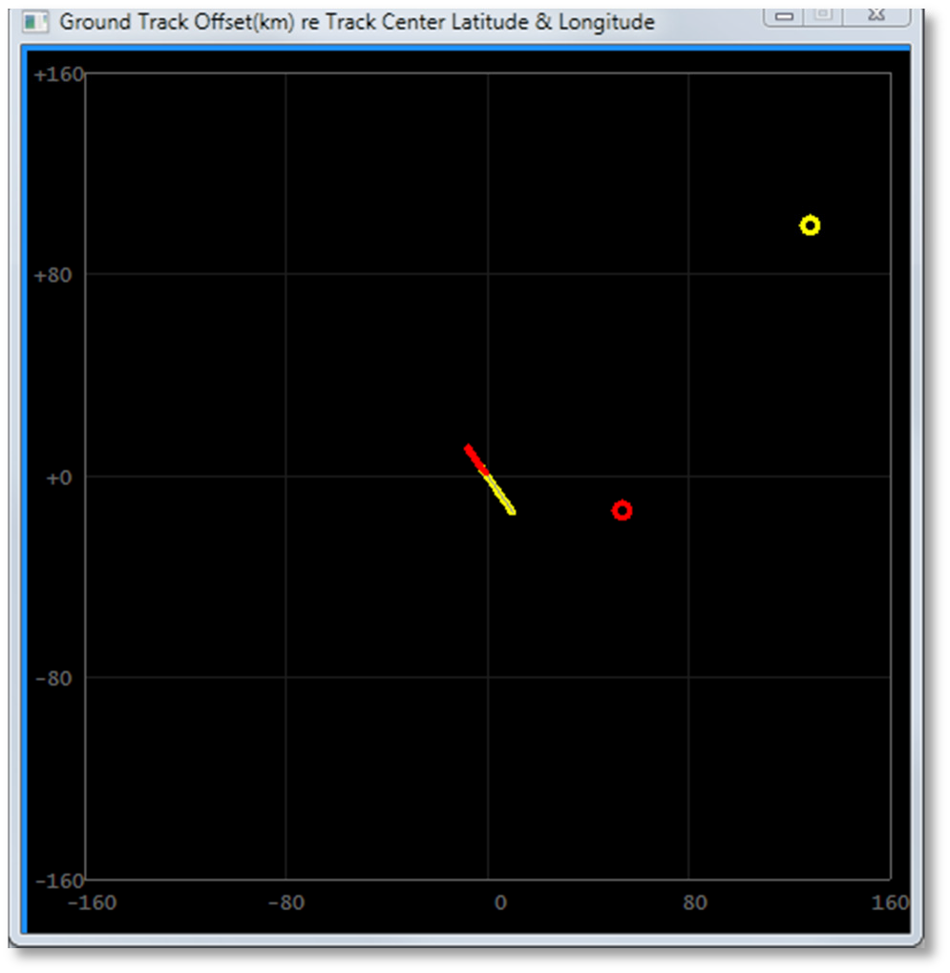
The ideal result shows two overlapping lines that follow the same ground track. There is a possibility that one camera's track of the meteor doesn't actually overlap with another camera. However, the fact that they share the same linear

path over the ground track "may" indicate that it was the same meteor. In those cases, you need to use a bit of care and remember that (a) a meteor with a long ground track probably needs to have a higher intensity at some point than shorter lived meteors; (b) Because there is not overlap, you may have to discard this coincidence.
      - CAMS_nnnnn_MagVsHeight.jpg
(Top-left Magnitude versus Height(km) window)

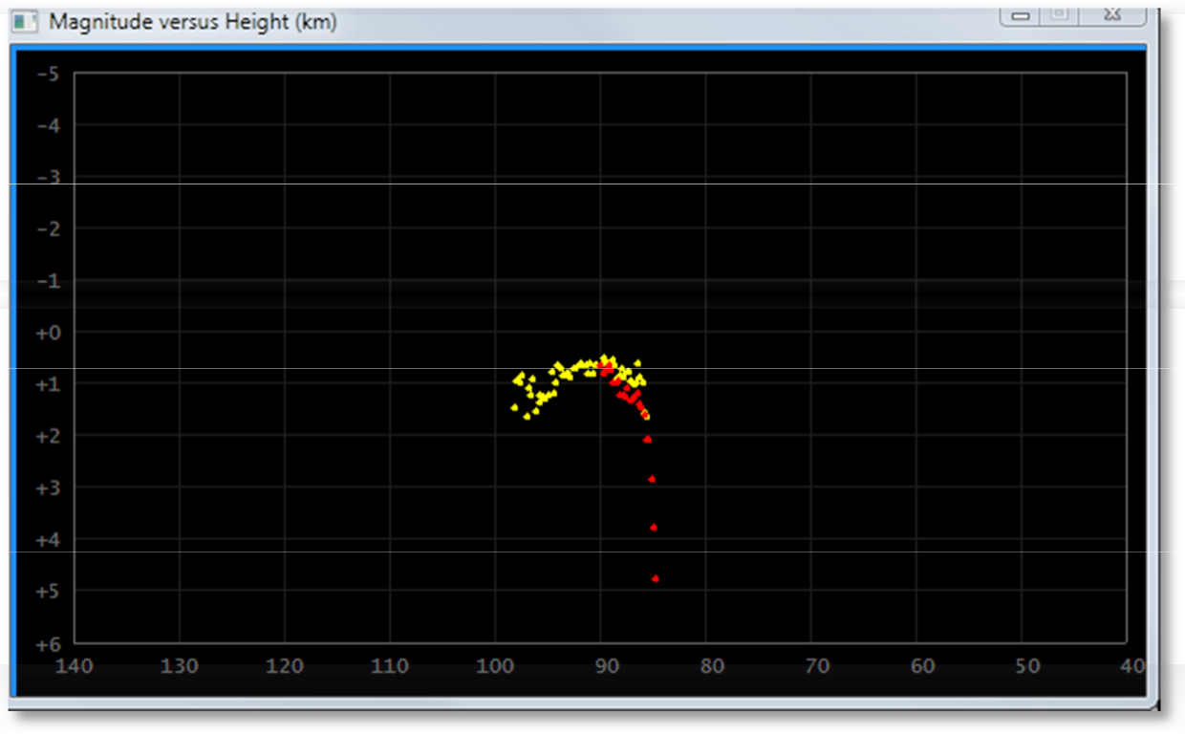

21.6.
21.7.
The magnitude is corrected for distance. Ideally, you will see a rise in magnitude and then a drop in magnitude. The height in km allows you to see where the altitude of where it all occurred.

Task 22 - Manual Coincidence Preparation
To prepare it manually, you'd do something like the following steps:
  - Option 54 has been created to facilitate this procedure.
  - Combine all the detect files for a single date for a specific area (for example, the San Francisco Bay Area CAMS files) into a single FTPdetectinfoCoinc.txt file. You can do this using the following command (notice the placement of the "+" symbols):

copy /y FTPdetectinfo_0201.txt+ftpdetectinfo_0202.txt... FTPdetectinfoCoinc.txt
  - Then you need to patch the header in the file with three values; The Meteor Count, FF Folder, and CAL folder. You can determine the combined meteor count using the following DOS command:

find /i /c ".bin" "path\ftpdetectinfoCoinc.txt"
------------ FTPDETECTINFO.TXT: 139203
It will return the number of detections that we'll call "detection count".
  - Open the file with Notepad. The first 11 lines in the file are called the header. It looks something like this:

Meteor Count = 000009
-----------------------------------------------------
Processed with FTP 1.3 on Mon Dec 19 05:54:33 2011
-----------------------------------------------------
FF folder = C:\CAMS\ArchivedFiles\2011_12_13_07_56_30\
CAL folder = C:\CAMS\Cal\
-----------------------------------------------------
FF file processed CAL file processed
Cam# Meteor# #Segments fps hnr mle bin Pix/fm Rho Phi Per segment: Frame# Col Row RA Dec Azim Elev Inten
  - Your job is to edit the file and replace the Meteor Count (shown in blue as 000009) with the "detection count" that you determined above.
  - You will then also need to change the directory values for "FF folder" and "CAL folder" to match the current drive and path to those directories.
  - Save the detect file and close Notepad.
  - Edit the ConincidenceParameters.txt file and make any changes that might be necessary. Here is one example of a CoincidenceParameters.txt file:

Maximum time for coincidence (sec) Minimum site separation distance (km) Minimum number of frames required Minimum allowed convergence angle (deg) Maximum allowed convergence angle (deg) Maximum co-linearity convergence (deg) Maximum distance from radiant (deg) Minimum height of all meteors (km) Maximum height of all meteors (km)
= 40.0
= 5.0
= 4
= 5.0
= 90.0
= 5.0
= 180.0
= 70.0
= 200.0
Measurement std dev (pixels) = 0.4 Velocity model(0-const,1-lin,2-quad,3-exp) = 3 Maximum radiant cone angle error (deg) = 2.0 Maximum Vinf error re Vinf (percentage) = 10.0 Saturation tau value for zero motion = 5000 Saturation tau value for 30 deg/sec = 9000

In the file CoincidenceParameters.txt, the first line is the time tolerance between cameras to look for coincidence (in time).

Maximum time for coincidence (sec) = 40.0

In example above the clocks could be off by as much as 40 seconds.
Are the cameras well synchronized in time to GPS? The coincidence parameters have a time tolerance offset it will accept between cameras.

Are you 100% sure you are both pointing to the same volume of atmosphere - that is, has there ever been coincidence results between your two cameras in the past. You may not be correctly aligned to see the same meteor.

Hopefully the cameras are all well calibrated for their FOVs.

  - To use the 54. Coincidence.bat script do the following steps.
    - Copy all the submission .zip files to C:\CAMS\Temp.
    - Start AutoCams.bat script and select a date using option 3. (never mind if it can't find any files)
    - From the utility menu, select option "54. Coincidence". It will do a bunch of processing, then launch FTP_Coincidence.exe.
    - The program will run and show you how many detections it is processing. Then it will stop and ask you the "Press CR to end the program". That means press the Enter key.
    - That's it. The result files should be located in the "C:\CAMS\Temp\Coincidence\<date>\gefdat" directory.
22.10.

Task 23 - Archiving for DVD with the Pre-DVD Archive utility menu option.

WARNING: The previous batch script "MakeArchiveDateZip.bat" is obsolete and it has not been tested. Do not use that script anymore.
This section will describe the function of the script that was designed to perform a pre-DVD burn zip of the necessary files needed for shipping back for the scientific archives at NASA.
The CapturedFiles directory takes up the bulk of the space, which mostly consists of thousands of FF*.bin files mostly with no detections in them. All the FF*.bin files with detections in them exist in the ArchivedFiles directory, so there is some reducancy (This is only true if you use AutoCams to capture or if you use the appropriate capture options in interactive mode). By removing the FF*.bin files from the CapturedFiles directory, it will leave only the ArchivedFiles and/or the ConfirmedFiles directories (as well as the Cal and EmailFiles directories). All the FF*.bin files in the ConfirmedFiles directory also have duplicates in the ArchivedFiles directory. Since the collection of the FF*.bin files in the ConfirmedFiles directory is relatively small, we are going to archive both, even though the ConfirmedFiles contains a small subset of duplicates.

The reason for this is to avoid accidental destruction of necessary files during the file management procedures. Also, there are times when there will be an ArchivedFiles directory but not a ConfirmedFiles directory. The ArchivedFiles directory contains the necessary files to recreate any necessary information. If we were to consider deletion delete the ArchivedFiles directory, it will be too easy to mistakenly delete the ArchivedFiles directory before finding out that you don't have a ConfirmedFiles directory. Therefore, we will error on the side of safety and archive the ArchivedFiles directory. In this way, you will be saving to the archive ZIP files all the necessary files to reproduce the submission.
Note: There may be some merit in including the .zip file from the Transmitted directory, however, NASA will already have those and they can choose how they want to archive those on their own. If you want to include those, and maybe we should, I can update this script to include them... later.
You will end up with a zip file for each directory under the SubmissionFiles directory. You can move those .zip files to the DVD burner in 4GB groups (The size of the standard -R DVD format).
IMPORTANT: Always use DVD -R discs. Do not send discs in +R or +-R, or RW format.
The essence of this procedure is to perform the following tasks:
- Strip the source directory tree of any unnecessary CapturedFiles FF*.bin files.

WARNING: Only delete the CapturedFiles after you have verified that the ArchivedFiles has the correct files in it. A script should probably be developed for this validation.
- Copy the remaining files into a ZIP file named after the source directory. If you have multiple cameras, their Submission files will be archived within. This step will include deleting all the Zipped files except those found in the EmailFiles directory. (The Submitted directories will remain in order to be able to run the meteor count scripts to keep a running total).
Here is what we know so far...
  - It is important to follow these rules:
    - Never delete the source files until you have been told that the coincidence has been completed for the set.
    - Only perform these tasks a month at a time. This follows efficient industry accepted archiving methods.
  - Enter AutoCams option "3. Enter Captured Date" to specify a date. Never mind whether it lists any CapturedFiles directories.
From the given choices, enter "S" to pick from the SubmissionFiles directories. The option allows you to enter a date in the regular US-style "mm/dd/yyyy" format. If you will be processing a whole month's data, any date in that month will do.

Once you enter a date or select a CapturedFiles directory from the list, it will attempt to read the associated directories scanning for the number of files, detection files, etc. In many cases it will tell you "File Not Found - No CapturedFiles directories found matching yyyy_mm_dd". It will do the same for the ArchivedFiles directory. Ignore this if it happens.
Eventually, the AutoCams menu will appear.
  - Enter AutoCams option "61. Pre-DVD Archive". It will ask you the following:

Do you want to zip one directory or the entire selected month? [O]ne date
[M]onth [Q]uit
- [O]ne date - will process each directory that has the currently selected date. (It handles the situation where there are multiple directories for the same date due to multiple cameras or multiple capture sessions).
- [M]onth - will use the currently selected date and use the year_month elements of that date to determine which directories belong to the currently selected month to process. The process is designed to iterate through all the dates in the SubmissionFiles directory matching the date range.
The following prompt will appear:

You have the choice of permanently deleting all the FF*.bin files from all the CapturedFiles directories in this collection.

Deleting the FF*.bin files from the CapturedFiles directory makes the archive much smaller, however, it is a non-reversable procedure.

Do you want to permanently delete all the FF*.bin files from all the CapturedFiles directories? [Y/N or Quit]
  - The two choices are:
- Y - Delete all the FF*.bin files from all the CapturedFiles this routine will process.
- N - Keep the FF*.bin files.
Typically, you will want to use the "Y" option because you are running low on space and you don't want to have to re-visit this procedure again.
If you enter the "N" option, you will need to manually manipulate the files before creating the DVDs. The only time you'd want to use the "N" option is when you need to free up some disk space and you haven't heard that the date has been processed for coincidence yet. Until you get the "all-clear" from the local coordinator, you need to try to keep things intact so that you will be able to re-process the files if necessary.

  - For each directory in the selected date range, the procedure will do the following...
- Delete the CaptureFiles\FF*.bin files (if that option was selected)
- Create a zip file of the original directory. The name of the zip file will be the name of the directory with ".zip" at the end.
- The original directory will be renamed to have the "_zipped" suffix.
23.6.
  - When you are done, gather up the .zip files and put them onto a DVD. Once they are on DVD, you may delete the directories matching those that are archived onto DVD that are tagged with the "_zipped" suffix to free up more space.

Task 24 - "AutoCams.Params.ini" file settings
This section will describe the possible settings for the "AutoCams.Params.ini" file. When the scripts read this file, each key/value pair makes a new environment variable in the following format:
bat_SECTION.key=value
If the key name within a section begins with "bat_", the created environment variable matches exactly to the key name. In the following example, the two variables created would be:
bat_CAPTURE.capture_mode=capturetwoanddetect bat_captureexe=FTP_CaptureTwoAndDetect.exe

[CAPTURE]
capture_mode=capturetwoanddetect bat_captureexe=FTP_CaptureTwoAndDetect.exe

Note: The scripts ignore any of the following conditions: Blank lines
Any line that has a space as the first character Any line that has a TAB as the first character Any line that has "//" as the first two characters Any line that has "rem" as the first three characters Any line that has "rem " as the first four characters
    - [AUTOCAMS] section is for parameters that govern the AutoCams functions.
      - bat_vers=1.00a
This is where the AutoCams menu gets its version information when it displays it.

      - autonomouslevel=apply
Governs the level of autonomous operation. This setting indicates the last step that you want it to perform. Possible options are (default is "apply") (Use only one of the following):
autonomouslevel=cal autonomouslevel=apply autonomouslevel=applyconfirmed autonomouslevel=submit autonomouslevel=zip autonomouslevel=ftp

      - completewait=5
Number of seconds to wait after autonomous mode processing. The delay allows a user to allow the unattended autonomous mode to system to delay for a longer period in order to catch and review the console before it kills the window.
      - diskspacewarning.days=14
Number of days to use in calculating whether you are going to run out of disk space with that timeframe.
      - diskspacewarning.hour.per.night = 14
Maximum number of hours per night on the longest night. This value is used in calculating whether you're going to run out of disk space within the number of days specified in diskspacewarning.days.
    - [CAPTURE] section governs parameters used during capture.
There are essentially three modes of capture: Capture single camera, Capture single camera while simultaneously performing detect, Capture two cameras while simultaneously performing detect.
The "CaptureTwoAndDetect" mode has the option of capturing two cameras but disabling detect. Use that mode when you find that excessive number of frames are being dropped during capture and detect but the number of dropped frames is acceptable when disabling simultaneous detection.
The "capture_mode" settings are configured by using multiple variables together, namely:
- capture_mode
- bat_CD_flag and archive_flag
- bat_captureexesrc
- bat_captureexe
- bat_capturebat
- cameralist
      - Use one of these configurations (note, two are commented in the default file):

        - For Single camera with no background detection. Note, you will need to use AutoCams options 44 and 44b to complete the detect process after capture completes.

[CAPTURE]
//===== Single camera, no background detection ===============
//capture_mode=capture
//number.of.cameras=1
//cameralist=998
//archive_flag=-1
//bat_capturebat=CaptureTwoAndDetect.bat
//bat_captureexe=FTP_Capture_998.exe
//bat_captureexesrc=FTP_Capture.exe
//~~~~~~~~~~~~~~~~~~~~~~~~~~~~~~~~~~~~~~~~~~~~~~~~~~~~~~~~~~~~
        - For Single camera WITH background detection. Note, you may need to use AutoCams options 44 and 44b to complete the detect process if capture is interrupted (for example, the computer reboots in the middle of the night).

[CAPTURE]
//===== Single camera with background detection ==============
//capture_mode=captureanddetect
//number.of.cameras=1
//cameralist=213
//archive_flag=-1
//archive_flag=2
//bat_capturebat=CaptureTwoAndDetect.bat
//bat_captureexe=FTP_CaptureAndDetect_998.exe
//bat_captureexesrc=FTP_CaptureAndDetect.exe//~~~~~~~~~~~~~~~~~~~~~~~~~~~~~~~~~~~~~~~~~~~~~~~~~~~~~~~~
~~~~
        - For Dual cameras WITH or WITHOUT background detection. Note, you will need to use AutoCams options 44 and 44b to complete the detect process if capture is interrupted (for example, the computer reboots in the middle of the night). To disable background detection, use a value of -1 for the archive_flag.

[CAPTURE]
//===== Dual camera with/without background detection ======== capture_mode=capturetwoanddetect
number.of.cameras=2 cameralist=998 999 archive_flag=2
// -1 = Don't perform realtime background detection (for slow systems that can dual capture but not detect)
// 0 = Leave FF files in CapturedFiles dir
// 1 = Copy FF files from CapturedFiles to ArchivedFiles dir (takes extra I/O + CPU)
// 2 = (default) Move FF files from CapturedFiles to ArchivedFiles after completion bat_capturebat=CaptureTwoAndDetect.bat
bat_captureexe=FTP_CaptureTwoAndDetect.exe bat_captureexesrc=FTP_CaptureTwoAndDetect.exe
//~~~~~~~~~~~~~~~~~~~~~~~~~~~~~~~~~~~~~~~~~~~~~~~~~~~~~~~~~~~~
        - capture_mode - is a flag used to signal a collection of settings, or a "mode" of operation.
        - number.of.cameras - the number of cameras you will be using

        - cameralist - specifies either one or two camera numbers. The FF*.bin files will be encoded with the camera number matching the camera device used for that 256 frame set.
        - archive_flag - This flag is used by background detection. For performance reasons, there are three modes for background detection. However, the scripts are only compatible with the mode that moves the FF files from CapturedFiles to ArchivedFiles after completion. The other way this flag is used is by using -1 to signal to disable background detection.
        - bat_capturebat - specifies the name of the batch script file that will be chained to from LaunchCapture.bat. I know it sounds strange, but CaptureTwoAndDetect.bat is the latest version of the capture scripts and it has all the logic for the CaptureAndDetect and CaptureTwoAndDetect use-cases. Therefore, use CaptureTwoAndDetect.bat for both of those cases.
        - bat_captureexe - specifies the name of the executable that runs. It is also the name of the executable that is terminated before a new capture session is started. The idea behind this setting was to allow multiple instances of capture to run at the same time. Essentially, a copy of the executable (bearing the camera number) is run instead of the normal executable. This allows you to monitor it using Task Manager. More importantly, if one camera fails and the other continues OK, you can ensure that the failed camera's process is terminated (using process.exe) before the capture for that camera is started again. For dual-camera mode, this is ignored and the bat_captureexe and the bat_captureexesrc values should be the same.
        - bat_captureexesrc - specifies the source name of the executable. The script copies this file to the bat_captureexe file.
      - waitdelay - Either wait or no wait (without quotes). When this setting is set to wait, LaunchCapture will wait until the scheduled Camera ON time. If it is set to no wait, the wait will be ignored and it will move to the capture functions immediately.
    - [CALIBRATION] section is for the calibration scripts.
      - bat_calnstars=50
Minimum number of calstars for "7b. AutoCal" processing. Note: "7c. AutoCal w/ Prompts" still allows you to enter your own values, but it will default to these for the default.
      - bat_caloc=2.50
Minimum number for acceptable "Mean O-C" results. If this value is not achieved, then the script reports a failure and aborts.
      - bat_starcountthreshold=50
Used by ValidateCal.bat for reporting bad calibration files from the Cal directory. (See option "36. Validate Calibration".

      - displaycalstars=false
Not Implemented
If true, during calibration, it will plot the simulated image of the calibration stars as distributed across the FOV. Each will have the x, y residual displayed next to the star.
    - [STAGE] section is for parameters that govern how the "13. Package Working dirs into SubmissionFiles dirs" functions.
      - validatewait=3
Number of seconds to wait after StageFromConfirmed.bat performs the validation and displays the "Total Validation Errors"
    - [COINCIDENCE] section is for the coincidence program parameters.
      - max.height=249
Number of kilometers for the maximum height display
      - min.height=40
Number of kilometers for the minimum height display
    - [DETECT] section is for the coincidence program parameters.
      - maxdetectionthreads=6
Maximum number of detection threads. For systems with fewer than 8 CPUs, you can leave this set to 6. For those with 8 CPUs or more, it may produce diminishing returns to have too many detection threads running at the same time. You should know that the threads start 10 seconds after each other. This is to ensure that subsequent threads don't interfere with previous threads fully operating. An 8 CPU system can be set to 8, but it is probably not necessary. Setting this to 6 allows an 8 CPU system to have free cycles to perform other operations.
    - [SIMULATION] section governs settings used for simulation. I use these settings for daytime testing so it simulates capture, detection, and ftp. Simulation mode provides the ability to store some directories to use as a source in lieu of capturing with a camera, detecting with Capture and Detect or MakeCaseListing.
      - enabled - When set to true, capture and detect is simulated by using the settings in the [SIMULATION] section. Otherwise, simulation is disabled.
      - capture - When set to true, capture and detection are both simulated by using the settings in the [SIMULATION] section.
      - ftp - If true, the FTP simulation is performed instead of a real FTP upload. Otherwise, the real FTP is performed. This setting only applies when simulation is enabled. The reason for this setting was to keep from uploading too many test files to the FTP server.
      - captureddate - Specifies the simulation captured date (simulates AutoCams option 3).

        - CapturedFilesDir - Specifies the directory to which the FF*.bin files are copied from the CapturedFilesSimSource directory in order to simulate capture. (simulates AutoCams option 4)
        - ArchivedFilesDir - Specifies the directory to which the detection files are copied from the ArchivedFilesSimSource directory in order to simulate detection. (simulates AutoCams option 5).
        - SubmittedDir - Specifies the directory used for the Submitted directory.
        - SubmissionFilesDir - Specifies the directory used for the SubmissionFiles directory.
        - CapturedFilesSimSource - Specifies the source directory for simulating capturing to FF*.bin files.
        - ArchivedFilesSimSource - Specifies the source directory for simulating detection.
        - ConfirmedFilesSimSource - Specifies the source directory for simulating confirmed detections.
        - detectfile - Specifies the FTPdetectinfo_*.txt file to be used for this simulation in the ArchivedFiles dir.
    - Here is a look at the file on my dual camera machine...

[AUTOCAMS]
bat_vers=1.00a
//autonomouslevel=cal autonomouslevel=apply
//autonomouslevel=applyconfirmed
//autonomouslevel=submit
//autonomouslevel=zip
//autonomouslevel=ftp completewait=5 diskspacewarning.days=14 diskspacewarning.hours.per.night=14

[CAPTURE]
simulation=false waitdelay=wait
//waitdelay=no wait diskspacewarning=3

//===== Single camera, no background detection ===============
//capture_mode=capture
//number.of.cameras=1
//cameralist=998
//archive_flag=-1
//bat_capturebat=CaptureTwoAndDetect.bat
//bat_captureexe=FTP_Capture_998.exe
//bat_captureexesrc=FTP_Capture.exe
//~~~~~~~~~~~~~~~~~~~~~~~~~~~~~~~~~~~~~~~~~~~~~~~~~~~~~~~~~~~~

//===== Single camera with background detection ============== capture_mode=captureanddetect
cameralist=998 archive_flag=2
bat_capturebat=CaptureTwoAndDetect.bat bat_captureexe=FTP_CaptureAndDetect_998.exe bat_captureexesrc=FTP_CaptureAndDetect.exe
//~~~~~~~~~~~~~~~~~~~~~~~~~~~~~~~~~~~~~~~~~~~~~~~~~~~~~~~~~~~~

//===== Dual camera with/without background detection ======== capture_mode=capturetwoanddetect
number.of.cameras=2 cameralist=998 999 archive_flag=2
// -1 = Don't perform realtime background detection (for slow systems that can dual capture but not detect)
// 0 = Leave FF files in CapturedFiles dir
// 1 = Copy FF files from CapturedFiles to ArchivedFiles dir (takes extra I/O + CPU)
// 2 = (default) Move FF files from CapturedFiles to ArchivedFiles after completion bat_capturebat=CaptureTwoAndDetect.bat
bat_captureexe=FTP_CaptureTwoAndDetect.exe bat_captureexesrc=FTP_CaptureTwoAndDetect.exe
//~~~~~~~~~~~~~~~~~~~~~~~~~~~~~~~~~~~~~~~~~~~~~~~~~~~~~~~~~~~~

[DETECT]
maxdetectionthreads=6

[CALIBRATION]
bat_calnstars=50 bat_caloc=2.50 bat_starcountthreshold=50 displaycalstars=false

[STAGE]
validatewait=3

[COINCIDENCE]
max.height=249 min.height=40

[SIMULATION]
enabled=true capture=true ftp=true
captureddate=2012_08_11 CapturedFilesDir=c:\CAMS\CapturedFiles\2012_08_11_03_44_55 ArchivedFilesDir=c:\CAMS\ArchivedFiles\2012_08_11_08_30_39 SubmittedDir=C:\CAMS\Submitted\2012_08_11_998_03_44_55 SubmissionFilesDir=c:\CAMS\SubmissionFiles\2012_08_11_998_03_44_55 CapturedFilesSimSource=c:\2012_08_11_capture\2012_08_11_03_44_55 ArchivedFilesSimSource=c:\2012_08_11_archive\2012_08_11_08_30_39

detectfile=FTPdetectinfo_09980999_2012_08_11
08_30_39.txt

Task 25 - Multiple Cameras on one computer.
This section will describe how to configure multiple CAMS cameras on a single computer.

Warning: It is important that the computer has enough CPU and BUSS capacity to accommodate the additional requirements of the additional camera. The only proven method is to install it and test that it will be not dropping excessive frames on multiple cameras.
There are two possible configurations to achieve multiple cameras on one computer. The first is to use two different sets of AutoCams configurations on different drives or directories cameras at the same time. Therefore, you will have two separate capture process instances at the same time. In order to avoid confusion between them, the AutoCams scripts rename the executable by including the instance number. There are other problems with achieving multi-camera capture.
Therefore, this method is obsolete and the Capture and Detect programs should be used instead. The capture and detect programs combine the captured FF*.bin files and the FTPdetectinfo*.txt file into the same CapturedFiles and ArchivedFiles directories.
The next section describes the first method of multiple instances of the single-threaded program...
To configure a single computer to run AutoCAMS, you must have a separate AutoCams directory tree for each camera. You can set up multiple directories, like this:
      - C:\CAMS (for your first camera that you've been using a while)
      - C:\cam998\CAMS
      - C:\cam999\CAMS
      - etc.
Doing it this way allows you to create a distinctly named Windows Task Scheduler event for each camera as a separate event. Each scheduled task would be configured to run the LaunchCapture in the corresponding directory and camera on its command line.

Tip: Alternatively, you could configure it to run on separate external hard drives. Each hard drive would be assigned a drive letter, C:\CAMS, D:\CAMS, E:\CAMS, etc. To avoid confusion, it might be a good idea to configure it like this instead:
C:\CAMS,
D:\cam998\CAMS, E:\cam999\CAMS.
That way, you will never have confusion as to which camera is on what drive.
The following instructions will use cameras 998, 999, and 997 as an example.

It is important that you only use camera numbers assigned to you by your local CAMS network coordinator.

To avoid the need to modify all the paths and directory references in the first camera (998) , you will leave the existing camera directory where it has been "C:\CAMS". You will use this directory as the master directory for coping to the other CAMS directories.
  - Considering that you already have a single camera (camera 998) configured on the C:\CAMS
directory, follow these steps:
    - Edit the "C:\CAMS\Cal\CameraSites.txt" file and add entries for the new cameras. Typically, these cameras will be at the same long/lat/alt so the only change from one camera to the next in the same site will be the camera number.
    - In the "C:\CAMS\Cal" directory, copy the "CameraSites-998.txt" file to "CameraSites-999.txt".
    - Edit the new "CameraSites-999.txt" file and change the camera number to match the filename.
    - Create the following three directory:
      - C:\cam999\CAMS\Cal
    - Copy all the files (without the subdirectories) "C:\CAMS" to "C:\cam999\CAMS".
    - Copy all the files from "C:\CAMS\Cal" to "C:\cam999\Cal" .
    - In "C:\cam999\Cal", delete all the files that begin with "CAL998*.txt".
    - In "C:\CAMS999\CAMS" directory, edit the "AutoCams.bat.ini" file and modify as follows:
      - bat_targetlocation=C:\cam999
      - bat_camera=999
      - bat_captureddate=blank
      - bat_capturedfilesdir=blank
      - bat_archivedfilesdir=blank
      - bat_capturedcount=blank
      - bat_archivedcount=blank
      - bat_latestcal=blank
      - bat_submissionfilesdir=blank
      - bat_ftppassword=unchanged
      - bat_ftpsite=ftp.seti.org
      - bat_ftpuser=anonymous
      - ftp_dir=incoming/cams

      - bat_recent_errormsg=blank
    - Add a new Scheduled Task (with a unique name that includes the camera number) for the new camera as follows:
      - If you have Windows Vista or higher, you can export the existing LaunchCapture task, then import it as a new task and edit it to match the new location.
      - If you have Windows XP, you will need to create examine the existing LaunchCapture task and create a new one that matches it except for the camera number and location.
      - Change the Actions tab > Add arguments and change the arguments to:
/k c:\cams914\CAMS\LaunchCapture.bat 999 0.02 C:\cams999 autonomous
      - Change the Start in to:
      - C:\cams999\CAMS
      - Change the new AutoCams.bat.ini to empty out the drive, etc.
      - Make the following subdirs:
        - ArchivedFiles
        - Cal
        - CapturedFiles
        - ConfirmedFiles
        - SubmissionFiles
        - Submitted
        - Temp
        - Transmitted
      - Test it by selecting "Run" from the task window. The LaunchCapture windows will display and most likely go into "delay mode", waiting for the Camera ON time. You can defeat this by entering the following from a command prompt:

for /L %a in (1,1,10) do (process -k wait.exe)
      - After it runs for a few minutes...
        - abort the capture by pressing Ctrl+P in the console window. It should attempt to perform the autonomous operations and fail.

        - Then, locate the created working directories ("C:\cam999\ArchivedFiles\date_time",
..\CapturedFiles\date_time", "..\ConfirmedFiles\date_time").
        - Delete the directories that the test run just created.

Task 26 - Focusing Tips and Tricks.
There are a few tricks that can be employed to aid in focusing these cameras.
Note: As of 2013, the CameraLiveViewer program shows a focusing aid at the bottom.
  - First, be sure that the distance from the back of the lens to the chip is 17.526mm (0.6900 in).
  - Set the focus to just under infinity and attempt to focus on a star or distant object on the far horizon. Make adjustments to the distance using C-CS mount adapters and spacer rings. There should be a 5mm C-CS adapter ring.
  - Turn up the gain to AGC HI during focusing. Don't forget to put it back to the normal setting after focusing.
  - Try to get the focus close using a visual approach.
  - Be careful with daytime focusing techniques if you have an autoiris lens because if the autoiris constricts, it will increase the depth of field and you will not be in focus at night time with a shallower depth of field when the iris is fully open.
  - Hartmann Mask or Batanov Mask focusing
    - Construct a Hartmann Mask or Batanov mask or some other focusing aide to obtain a more objective focus.
    - I don't like either of these because they block so much light and you still can't get a decent focus because they are not good for the last little bit of fine focus adjustments.
  - Diffraction Spike Focusing
    - This is a focusing aide that you can probably only use on very bright stars.
    - Tape some dental floss across the lens to make a cross.
    - Aim the camera at a bright star or planet. On high gain, it should produce 4 diffraction spikes that look like a crosshair for each bright star that is in focus.
    - If the star is out of focus, you will see 8 diffraction spikes (or double vision of the 4 diffraction spikes from a properly focused star).
    - When you get closer to being in focus, the objective determination for best focus is when:
      - The diffraction spikes are the longest
      - The diffraction spikes begin to show some striping

      - The number of stars in the FOV is highest
  - Software assisted focusing:
    - One program that I'm aware of, K3CCDTools, has a focusing aide. It's $35 for the software. It has not been maintained for the last few years, but you may be able to get it to work on your computer. There is a 30 day trial period (it might be 60 days). The problem is, it might not work on Windows 7 (32 bit or 64 bit). You can go to (http://www.pk3.org/Astro/index.htm) and download it to see if it works. There may be some tricks that you have to use to get it to work with Windows 7. It works fine with Windows XP. It has a focusing dialog that should help with the focusing. ImagesPlus and other software that you have may also help to achieve an objective focus instead of relying on subjective methods.
      - Use WDM interface in preview mode, which provides very fast preview. I recommend to use 10fps, which is fast enough while it retains good picture quality for focusing
      - Use Zoom 200% in Video Capture mode for detailed focusing (requires faster computer)
      - Use Brightness Level Meter with unsaturated star for measuring star's peek brightness. I recommend to use Low pass filter to reduce effect of scintillation (seeing variations).
      - Read more in Help - Chapter 3.8 Video Capture – Brightness Level Meter.
      - Use FFT Dialog for surface objects and watch quality graph in the middle part of dialog. The higher the number shown in the graph the better is focus. The focused object must be in the center of the screen.
  - Green Laser focusing:
    - I have not tried this, but someone suggested pointing a green laser at a distant wall and focusing using that. I imagine that this can be done during the daytime.

Task 27 - AutoCams Utilities.
The AutoCams Utility menu has various useful utility scripts. Some of these scripts are merely wrappers around some of the CAMS utility programs while others are pure scripting code that perform other useful functions. Other utility scripts are callable from a command-line and have not been incorporated into the AutoCams menu system while still others are runnable by double-clicking on them.
Tip: Help text is available for most of these scripts by entering "/?" on the command line. AutoCams Main Menu Options:
  - "6. Check Skipped Frames and dropped frames".

    - Outputs a report to the console (per camera) on the session information, camera configuration (fps), total number of FF files, total amount of capture time, Number of frames, avg frame rate, skipped frames and avg skipped frame rate. Also include the First FF File and Last FF File for each camera. This is helpful in knowing if the session ended early.
    - This script is also called by the "70. Thumbnails" option when the CapturedFiles directory is selected.
    - Implemented via "SkippedFrames.bat". Can be invoked standalone.
  - "18. Report on Submission"
    - Currently obsolete. This script used to provide a useful report on the session. Many upgrades have been added and this script no longer functions with the new naming conventions. If you feel that you need this, let us know.
    - Implemented as a subset of "AutoCams.bat". No standalone access outside of AutoCams.
  - "[A]utonomous mode"
    - Restarts the AutoCams.bat using the "autonomous" command line option. When it is run in this way, the menu is bypassed and the [AUTOCAMS].autonomouslevel functions are executed in order until the specified autonomous level is completed. If any errors occur during this autonomous processing, progress halts and the message at the bottom ("Last error msg:") displays the error.
    - Implemented as a subset of "AutoCams.bat". Can be invoked by running AutoCams with the following command line arguments:

  - "[R]eset".
AutoCams.bat "<capturedfilesdir>" "<archivedfilesdir>" <camera> autonomous

    - Resets all the variables except the "target location" and "camera".
    - After using the Reset option, you will need to select another Captured Date (session).
    - This option is useful if something is messed up and you can't run the other options.
    - Internal to AutoCams.bat. Not accessible outside of AutoCams.
  - "FA. Fix Detect Paths Archived".
    - This option patches the "FF Folder" and "CAL Folder" entries in the header of the detect file in the ArchivedFiles directory.
    - Note: You will need this option if you move the files to another hard drive or directory.

    - Implemented in "FixDetectPaths.bat". Can be invoked standalone.
  - "FC. Fix Detect Paths Confirmed".
    - This option patches the "FF Folder" and "CAL Folder" entries in the header of the detect file in the ConfirmedFiles directory.
    - Note: You will need this option if you move the files to another hard drive or directory.
    - Implemented in "FixDetectPaths.bat". Can be invoked standalone.
  - "ClearError. Clear recent error message".
    - Clears the "Last error msg" line in the menu.
    - Internal to AutoCams.bat. Not accessible outside of AutoCams.
  - "ZipLogs. Zip the log files"
    - Copies all the logs pertaining to this session to "C:\Temp\Logs\logs_yyyy_mm_dd_cccc_hh_mm_ss.zip".
    - Then it tells you the name of the zip file.
    - This function is useful if you need to email the log files to someone to help you troubleshoot an issue.
    - Uses "ZipLogs.bat". Can be invoked standalone
27.9.
AutoCams Utility Menu Options:
  - "31. Command Prompt"
    - Launches a new Command Prompt in the CAMS directory.
    - Internal
  - "32. Check for bad FF*.bin files"
    - Checks for bin files that are not 1,228,820 bytes.
    - Implemented in CheckBinFileSize.bat. Invokable standalone.
  - "33. Delete bad FF*.bin files"
    - Careful with this one, in has a tendency to delete good files too if you give it the wrong command line arguments.
    - Implemented in CheckBinFilesize.cleanup.bat. This script is produced when running option 32.
  - "34. Check free disk space"
    - Asks which drive to check and then performs the Check Disk Space function using the [AUTOCAMS].diskspacewarning.days parameters.

    - Displays a warning if disk space will be a problem.
    - Implemented in CheckFreeSpace.bat. Invokable standalone.
  - "35. List all drives"
    - Lists all the drives (using the WMIC command, if you have that enabled on your system). It lists removable drives, flash drives, mapped network drives, etc. It includes the drive letter, volume name, size, and free space for each drive.
    - Implemented in ListDrives.bat. Invokable standalone.
  - "36. Validate Calibration files for "<date>".
    - Lists the main calibration values for each CAL file in the Cal directory that match the current session date.
    - If the calibration values don't fall within the tolerances specified in the AutoCams.Params.ini file in the [CALIBRATION] section, it displays the associated error messages.
    - Implemented in ValidateCal.bat. Invkable standalone for a single date or for all dates.
  - "37. Meteor Count Working dirs"
    - Outputs a report to the console listing the camera, ArchivedFiles meteor count, ConfirmedFiles meteor count, The ArchivedFiles and ConfirmedFiles session date/time, the ratio of Confirmed meteor count to Archived meteor count, and lists the comments associated with the session.
    - Implemented in "MeteorCount.presubmission.bat". Invokable standalone.
    - Note: This script needs some debugging as it has not undergone any checks to see if it works with the new naming conventions.
  - "38a. Meteor Count Submitted dirs"
    - Produces a report similar to "37" but it uses the Submitted directory for the listing.
    - Implemented in "MeteorCount.submitted.bat. Invokable standalone.
  - "38b" Meteor Count SubmissionFiles dirs"
    - Produces a report similar to "37 but it uses the SubmissionFiles directory for the listing.
    - Implemented in the "MeteorCount.submission.bat". Invokable standalone.
  - "39. Display CapturedFiles info"
    - Produces a report of the current session date. It lists the CapturedFiles session directory(s) name, the full path, the first file, Last file, and the count of files.

    - This is useful for figuring out whether a session needs to be processed or if there were issues during capture (early abort).
    - Implemented in GetFFDirectoryListing.bat". Invokable standalone.
  - "40. Display 3 days' CapturedFiles"
    - Similar report as 39, but also includes the day before and the day after the currently selected session.
    - Implemented in GetCaptured.bat. Invokable standalone.
  - "41. Display 3 days' ArchivedFiles"
    - Similar report as 40, but based on ArchivedFiles directory instead of CapturedFiles directory.
    - Implemented in "GetArchived.bat". Invokable standalone.
  - "42. CheckTwilight for "Captured Date"
    - Reports on the date matching the current session date by reading the Twilight.csv.txt file values for that date.
    - Implemented in "CheckTwilight.bat". Invokable standalone. When invoked standalone, if you don't provide any command line arguments, it will use the current system date. You can also specify a date on the command line for any date that appears in the twilight file.
  - "43. Launch Capture Script"
    - Launches the "LaunchCapture.bat" script, which reads the twilight file and then launches the "CaptureTwoAndDetect.bat" script based on the values determined from the twilight file. This is the same script that is launched from the Schedule Task.
    - Implemented in "LaunchCaptured.bat". Invokable standalone and from the Windows Task Scheduler.
  - "44. Multi-tasked Meteor Scan"
    - Performs the MeteorScan function and if possible it launches multiple parallel tasks (depending on how many CPUs). See the AutoCams.Params.ini file [DETECT].maxdetectionthreads value to limit the number of parallel tasks. Note: Setting this value greater than the number of CPUs will not launch more parallel tasks than you have CPUs (as determined by the NUMBER_OF_PROCESSORS system variable).
    - Can be run anytime to re-run the meteor scan routine.
    - Warning: Can take several hours.
    - Implemented in "MakeCaseListing.bat". Invokable standalone.
  - "44b. Merge Multi-tasked Meteor Scan Files"

    - When option "44" us run, it produces a headerless detect file for each CPU. It is then necessary to combine them into a single detect file (matching the new naming convention) complete with an appropriate header.
    - This is now automatically invoked when option "44" is executed.
    - Impemented in MergCaseFiles.bat". Invokable standalone.
  - "45. Single-threaded Meteor Scan"
    - Invokes the FTP_Reprocess.exe program in single-tasking mode. When you have option 44, I don't see a reason that you'd need this except for testing.
    - Note: This program does not produce a detect file that uses the new naming convention.
    - Internal. Invokable via running the FTP_Reprocess.exe program directly.
  - "45b. Post MultiScan Processing"
    - I think this is now obsolete and has been replaced by option "44b".
  - "47. Calculate Day of Week for "<session date>".
    - Lists the day of the week. Also shows the date in various formats and includes the Julian date (JD).
    - Implemented in "DayOfWeek.bat'. Invokable standalone.
  - "48. Save Configuration"
    - Updates the :AutoCams.bat.ini" file. This file is used so that the next time AutoCams is run, it remembers where you left it when you last exited (or saved the config).
    - Internal.
  - "49. Night mode"
    - Toggles night mode, which uses a white on red screen instead of white on black.
    - I'm not sure how useful this is
    - Internal
  - "50. List Dates that need processing"
    - Lists the directories in the CapturedFiles working files directory. Had they been processed, they would have been moved under SubmissionFiles.
    - Internal
  - "51. List Unzipped Nights"
    - Lists the dates/sessions that need to be zipped. Essentially reports of each dir in the submissionFiles dir that does not have a corresponding zip file with the same date_camera file name. The list is derived as follows:

      - Check the SubmissionFiles directory. For each date:
        - Check the Transmitted dir for a matching zip
        - Check the Submitted dir for a matching zip
        - Check the SubmissionFiles dir for any files newer than the newest existing zip file in Transmitted
        - Check the SubmissionFiles dir for any files newer than the newest existing zip in Submitted
    - Internal.
  - "52. List Untransmitted Zips"
    - Lists the dates/sessions zip files in the Submitted directory that haven't been moved to the Transmitted directory (which happens at the end of a successful option "17").
    - Internal.
  - "53. Make Movie from ConfirmedFiles"
    - Makes an AVI out of all the FF files in the ConfirmedFiles directory.
    - Implemented in "MovieFromDetect.bat". Invokable standalone.
  - "54. Coincidence"
    - Runs the Coincidence script to prepare the coincidence run by unzipping the files, launching FTP_Coincidence.exe, and then doing some stuff at the end.
    - Implemented in "Coincidence.bat". Invokable standalone.
  - "55. CameraLiveViewer"
    - Launches the "CameraLiveViewer.exe" program.
    - Implemented via "CameraLiveViewer.exe". There are several live viewer programs, to include "Camera2LiveViewer.exe" and "Camera4LiveViewer.exe". I'm thinking that maybe I should change this command to allow the user to specify which one by entering "55", "55-2", or "55-4".
  - "56. FTP_SingleFFMovie"
    - Makes a movie from the FF file of your choosing. The moving will be an 8.5 second (NTSC, 10.24 seconds PAL) movie.
    - No script. Implemented in "FTP_SingleFFMovie.exe".
  - "57. FTP_CameraMovies"
    - Creates an AVI movie out of all the files in the chosen directory. Careful, this AVI file could get very large.
    - No script. Implemented in "FTP_CameraMovies".

  - "58. FTP_Mosaic"
    - Launches the Mosaic program that helps you build a mosaic of multiple files. The file produced is a large TIF file.
    - More documentation is required for this.

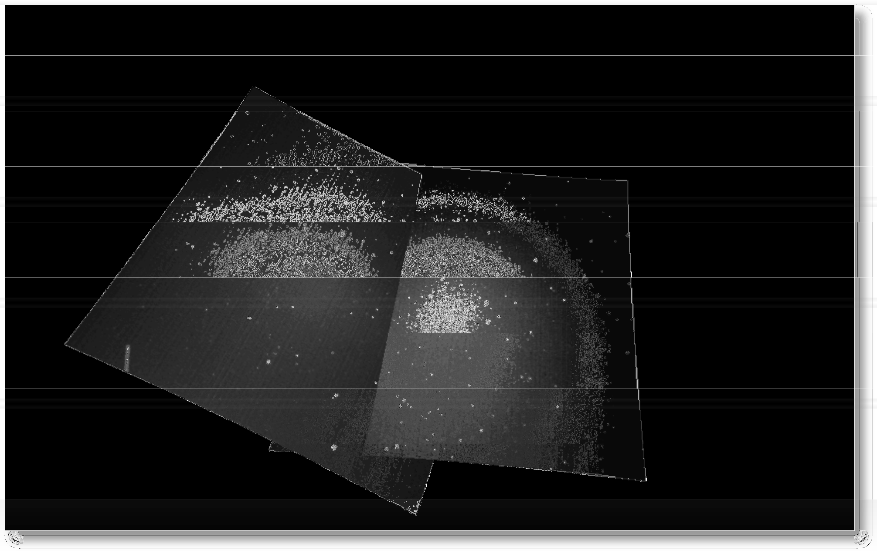
    - Implemented in "FTP_Mosaic.exe".
  - "59. FTP_AdjustFFtimestamp.exe"
    - Adjusts the timestamp on the files in the specified directory.
    - More documentation is needed for this.
    - No script. Implemented in "FTP_AdjustFFtimestamp.exe".
  - "60. FTP_CalSummary"
    - Creates a summary of the specified cal directory.
    - No script. Implemented in "FTP_CalSummary.exe".
    - More documentation is needed for how/when to use this.
  - "61. Pre-DVD Archive"
    - This is documented in another section of this manual.

CAMS-56

© 2013 All rights reserved.

    - Internal.
  - "62. Split dual capture"
    - Splits dual capture into its constituent parts by creating a separate directory tree for each camera (as if it was a separate capture session). The detect file is also split and placed in the appropriate directory.
    - Many changes have allowed dual capture to be handle different from this so this is probably obsolete now.
    - Implemented in "SplitDetect.bat". Invokable standalone.
  - "70. Thumbnails"
    - Produces composite thumbnail "contact sheets" for each camera. The result is one
.bmp file for each camera. Various options are available.
    - See also 70a to produce a kind of Fireball Scan.
    - Implemented in "Thumbnails.bat". Invokable standalone.
  - "70a. Thumbnails FIREBALL CHECK"
    - see above
  - "72. Single File Viewer (first file)"
    - Internal. Calls "SPFF_SingleFileViewer.exe". Invokable standalone.
  - "73. Single File Viewer (Choose starting file)"
    - Internal. Calls "SPFF_SingleFileViewer.exe". Invokable standalone.

AutoCams Hidden Options:
27.1. "3s"
27.1.1. Jumps to the "3. Enter Captured Date" section that lists all the directories under the SubmissionFiles directory and sets the capture session date/time based on the selected SubmissionFiles directory.
27.2. "5a"
27.2.1. Re-finds the detect file without all the other stuff that is done during option "5".
27.3. "?"
    - Dumps all the AutoCams environment variables. Then pauses and allows you to query any individual or group of similarly named variables and their values. It follows the DOS "set" command options. You can change an environment variable's value by using the following syntax:
variable=value Example 1:

bat_vers=999
will show 999 as the CAMS Menu Vers when it refreshes.

Example 2: bat_
will show all the AutoCams variables and values.
    - Be careful when using this option.
    - If you enter [A]bort, it will exit the program by forcing a syntax error. When this happens, the environment variables remain intact outside of the menu program (Under normal conditions, the variables are gone after the menu is dismissed). When you re-run AutoCams, these environment variables may interfere with the normal operation of the next invocation of AutoCams. In that case, you'd use the [R]eset option to clear it all out.
    - Another way to abort is by pressing Ctrl+C, then answer "Y"es. This will terminate the script and the environment variables will be in the same state as they were before running the script.
    - Press [Enter] to continue.
    - Implemented in "indent_pause.bat". Can be invoked standalone or from within other scripts for debugging.
27.4. "v"
    - Displays all the variables.
    - Useful for debugging.
    - Not invokable externally.
  - "cls"
    - Clear the console scroll buffer and clear the screen.
  - "edit"
    - Launches Notepad and opens the AutoCams.bat file asynchronously.
    - Internal
  - "del logs"
    - Deletes all the log files
    - Iternal
  - "notepad <filename>"
    - Launches notepad asynchronously and opens the specified filename. The AutoCams directory is the default directory.
    - Internal

Non menu-based scripts:
  - 7unzip.bat
  - 7za.bat
  - 7zip.bat
  - ApplyCal.bat
  - autocams.setup.bat
  - CaptureTwoAndDetect.bat
  - clear_bat_vars.bat
  - CoincidenceUpload.bat
  - concat.detectfiles.bat
  - CopyFromDetectFiles.bat
  - CreateCalFileList.bat
  - CreateCameraListFile.bat
  - DayOfWeek.bat
  - FTPdailyDownload.bat
  - GetArchivedDir.bat
  - GetCalfileInfo.bat
  - GetCameraList.bat
  - GetDetectFile.bat
  - GetLinesOfCode.bat
  - indent_setup.bat
indent_echo.bat indent_echolog.bat indent_log.bat indent_logexec.bat indent_logexeclog.bat indent_pause.bat indent_pop.bat indent_popecho.bat indent_poplog.bat indent_push.bat indent_pushecho.bat indent_pushlog.bat indent_return.bat
  - KillWait.bat

  - MakeArchiveDateZip.bat
  - MakeCaseListingTrack.bat
  - md5build.bat
md5check.bat md5checkRepeatDirs.bat
  - Move.Archived.bat
  - Move.Submit.bat
  - ParseDir.bat
  - ProessCaptureReturnCode.bat
  - ReadINI.bat
  - ReadParams.bat
  - ReCalibrate.bat
  - RedirectLogs.bat
  - redo.autonomous.bat
  - reprocess_multi.bat
  - rerun_makeCaseListing.bat
  - robocopy.bat
  - show_bat_vars.bat
  - simulationSetup.bat
  - startup_cams.bat
  - StripHeader.bat
  - StripHeaderNASA.bat
  - StripHeaderVBS.bat
  - StripZeros.bat
  - str_math.bat
  - submission.emai..bat
  - synchtime.bat
  - WindowsVers.bat
  - ZipDir_7sa.bat
  - _convertFtpDetectinfo_scanned_to_camera.bat

Supporting Executables:
  - 7za.exe
  - CosmicRayFourChannel.exe
  - md5.exe
  - OrbitCalculator.exe
  - Process.exe
  - ReplaceText.exe
  - robocopy.exe
  - SP_Prescreen.exe
  - vcredist_x86.exe
  - wait.exe
  - WaitFileComplete.exe
  - WaitForFile.exe

End

