Drift Aligning with K3CCDTools using Drift Trend
By Dave Samuels
revised 10/21/2009
revised 07/15/2009
created 05/20/2006

Note: You will not need a guider interface, like GPUSB, to use this technique for drift alignment. You will only need that if you are going to use K3 to perform actual guiding.

This technique is especially useful if you can't see Polaris.

Introduction
You can use K3 to facilitate drift aligning. The biggest problems with drift aligning are:
- You don't know which direction to turn the knob;
- You don't know how much to turn it.
- There is backlash in the knobs
- It takes a long time (mostly because of confusion with (a) and (b)).

K3 can help in these areas. It involves paying close attention to the numbers at the top of the Drift Explorer window. This paper shows how. While this paper may seem quite long, the steps are simple and easily repeatable.

The one's I like are the (..."/min) fields (I'm going to translate that to English as "number of arcsecs per minute of drift). In K3's Drift Explorer window, there are two such trend numbers, one for RA drift in arcseconds per minute and one for DEC drift in arcseconds per minute. The DEC drift trend is what you will use for drift alignment and you can mostly ignore the RA trend values (with regard to drift alignment).

This "trend" feature alone has made K3 worth the $49 I paid for it.

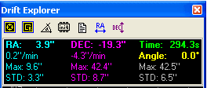
19.3 arcsec drift to the south (negative number means south) after almost 5 minutes (294 seconds), which is about 4.3 arcse/min drift to the south.

Also, the big numbers at the very top (shown here as RA: 3.9", and DEC: -19.3") are the current drift in how far off you are.

For example, after 20 seconds, you might be at -4.50 arcsecs. 20 seconds after that, you could be at 0.00, and 20 seconds after that you could be at +4.50. The trend in this case would read +4.5, since you are now at the one minute mark and you are off by positive 4.50 arcsecs. Anyway, these numbers will bounce around for various reasons, including seeing (atmospheric turbulance), dirty gears, wind, RA movement induced DEC changes, flexure, mirror sag, focuser sag, drawtube sag, camera mount shifting (yes, my EOS mounts are loose at the bayonet and the giggle), and the list goes on. Try to remove as many of these instabilities from your optical path as possible during drift alignment.

Simplify and Stabilize
In the meantime, the best advice is to remove as much of the add-ons to you optical path as possible - anything that could induce drooping or sagging. If you will be autoguiding, this may not be so critical. But use the most stable configuration you can arrange. Once you are done with the drift alignment, you can put all the other stuff back on. This is just a recommendation. You don't want to make polar alignment mount corrections due to flexure.

Supplement added 10/21/2009: One thing that helps is to use a small camera, web cam, DSI, etc. for your drift alignment. Remove your main camera, insert the smaller camera, rebalance, refocus, then perform the drift alignment prescribed herein. Once you're aligned, swap your small camera for the main camera; rebalance, refocus, resynch, etc. For me, this process saves time since I either use a Canon DSLR or my STL-11000 as main cameras. The sampling rate of my main cameras is much too slow.) Also, another observation is that I've used my piggyback DSI camera to perform drift alignment to find later that the focuser droop of my Orion ED80, and Losmandy rings have some flexure that perturbs the drift alignment exercise.

Configure the image "scale"
Before you get started, you need to set your optics in order for K3 to know what an arcsec really is according to the image. The key value for this procedure is the Resolution in arcsec/pixel for the vertical axis (if your camera is situated such that either North or South is up). This is usually called the image "scale".
- From the menu, choose Options > Telescope and CCD Camera...
Here are my settings for the Orion ST80 and Meade DSI-Pro
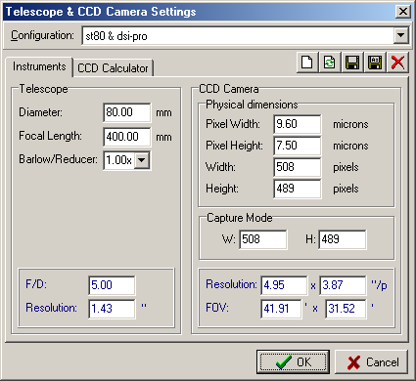

My DSI-IIc would use,
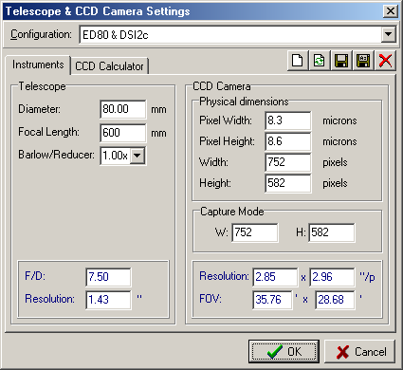

- Now adjust the guiding resolution as follows:
  - Options > Settings > Guiding > Subpixel Guiding
  - Also, adjust the FFT size of the tracking box here.
    - If your focal length is long and the stars won't stay in the tracking box, set the value higher.
    - If your focal length is short and there are multiple stars in the tracking box, make the tracking box smaller.

Initial Exposure
Depending on which star you choose to drift on, the exposure should be adjusted to provide an unsaturated view of the star. Too short of exposure will be too dark and the Drift Explorer will loose track of it and start hunting for it. Also, seeing scintillations will appear as fluctuations in the drift. You want to minimize that as much as possible.

Tip: To help average out (some of) the seeing induced scintillations, you can defocus the star just a little. Of course increasing the exposure will help also.

If you're using a non-video camera like a DSLR, DSI, etc, adjust the exposure using the Digital Camera Control , and the Histogram . If you're using a video camera, such as a Watec, live video freed from a Canon 5D, or any other video camera, you will use the video settings to increase gain and brightness. You will need to learn which settings are best for the camera in use. For example, for my DSI2pro, here are the settings I've been using:
- Options > Settings > Camera > Meade DSI
  - Preview Quality > Fast Preview (lower quality)
- Digital Camera Control
  - Exposure time (s): 1 sec to 3 sec

Each time you change targets, the histogram may not allow you to see it too well. K3 always starts with "Auto" on the Live Histogram setting. Change it to "manual", but unchecking the "Auto" checkbox and then move the red slider until the stars are easy to recognize.

You may optionally add a cross-hair by clicking the toolbar button that looks like this:

Start the Drift Explorer
The alignment procedure is done using the K3 Drift Explorer. Click the button that looks like this:

The Drift Explorer can be used to measure periodic error, perform actual autoguiding, and measure the polar alignment precision in real-time.

The Drift Explorer window appears:
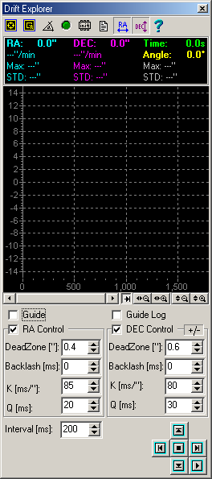

The Drift Explorer window has nine (9) toolbar buttons (from left to right):
- Target
- Reset Target
- Measure Angle
- Connect Interface
- Init Interface
- Log to file
- Swap RA
- Swap DEC
- Help

The tools we will need for drift alignment are really only Target and Measure Angle.

Acquire a Target Star
Press the Target button. A small box cursor will appear as you move over the image. Select the target star by placing the box around the star such that the star is centered in the box. Then click the mouse over that position. The RA/DEC drift values will start to change immediately.

Note: Sometimes, when you want to change targets, you will use the Target button again and then click in the image to select your new target. If you do this too quickly, K3 will throw an exception and present an ugly error dialog. K3 catches this exception/error and allows you to continue, but it isn't all that graceful. To avoid this, click the Target button, and then wait until the cursor changes to a box before clicking.

Determine the Camera Angle
It is important to allow K3 to determine what the camera angle is. K3 does this by watching the drift of a star, in pixels, when all the tracking is off. I prefer and recommend having the camera angle such that North is up.

To determine the camera angle, in the Drift Explorer window follow these steps:
- With the mount tracking in sidereal mode, move the mount using the slow motion controls or hand controller such that the star is about 1 tracking box away from the left side of the image.
- Use the Target button and select the target star.
- Get ready to turn off the tracking (On my AP1200 mount, you press the "8" key to cycle through the tracking modes. Your mount may be different. (If you're using ACP, you can turn off tracking on the ACP main window with a simple checkbox). ASCOM may have a method to toggle tracking on and off too. Whichever method you're going to use, get that ready to turn off, then back on.
- Click the Measure Angle tool .
- Immediately stop the tracking. The tracking box will follow the star across the image until it bumps into the other side, at which time, you will see that the Measure Angle button reverts to the non-pressed state. While the tracking is running, you can stop the angle measurement at any time by pressing the Measure Angle tool again. You can do this once the "Angle" value stops changing too much.
- Take note of the measured angle at the top of the Drift Explorer window.

Drift align the Azimuth Axis
It is a good practice to choose a side that you'll be drifting on to avoid a meridian flip (for GEM mounts) or mirror flop (for SCTs). I usually choose the East side of the sky because (a) That's the side that an AP1200 mount likes to initialize on; (b) Adjustments to the ALT make more sense to me on the East horizon than on the West. If you can't see the Eastern part of the sky, then you will want to use the Western part of the sky and follow the procedures for that.

Meridian and Celestial equator star:
- With the Guide box unchecked...

- Choose a star just to the East of the meridian on the celestial equator (AZ < 180 and DEC +/- 15 deg from 0, where Polaris is 89 degrees North and the celestial equator is 0 degrees North). You want to choose a star that won't drift past the meridian during your procedure, but you also don't want to have pier flip if you're using a GEM. If you're using a fork mount, you can choose stars on the celestial equator on either side of the meridian, but a mirror flop might induce an alignment error. To avoid a meridian flip when slewing to the second star in procedure, you can choose two stars both on the East side of the meridian. Until you get good at this, you might choose a star at least 30 minutes to 1 hour to the East of the meridian. Essentially, I like to choose a star on the East side to avoid a meridian flip - others recommend starting on the West side of the meridian because some scopes can't track past the meridian and choosing a start to the West will avoid this problem in case the meridian drift measurement takes too long. If the telescope isn't orthogonal to the mount, a pier flip messes up the GOTO to the next star.)

You can choose stars above or below the celestial equator by about 10 degrees, 15 degrees is considered the limit.

This map below shows the white graduated arc labeled "Meridian" and the red arc labeled "Celestial Equator". Two blue crosses have been superimposed to show you an ideal spot for the drift run if possible. The big ugly circles indicate the areas that are acceptable for guide star choices. Lastly, you don't really have to choose a star, just point your scope in that direction and take a short exposure and use the best suitable star.

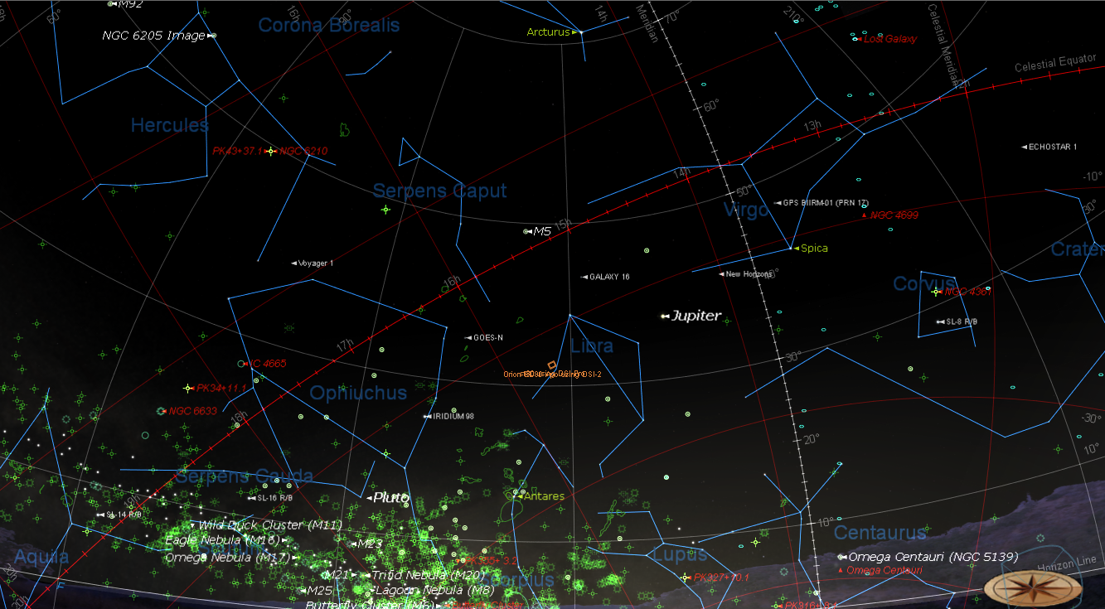

- Slew your scope to the target star or area.
- Take an image and adjust the histogram to suit the field of view.
- In the beginning, when you're making coarse adjustments, it's is a good idea to roughly center the target star.
- Click the Target button (the button on the far left at the top of the Drift Explorer window) and then click the alignment star.

Hint: When doing this, and there is already a guide box around a star, click the Target button, then wait for the existing guide box to go away, then center the cursor on the guide star. This prevents K3 from throwing an exception. The software seems to recover okay if you are too quick with the guidestar target change, but this seems to be the most stable procedure.

- Watch the numbers under DEC. After about 30 secs (The green Time: number at the top-right), you'll get a value for DEC ..."/min. Example -4.50"/min. Remember that number - it will come in handy in the next step (let's call that value DEC_A). Important: Take special notice whether it is a positive or negative number.

The software is actually doing sub-pixel calculations. This allows you to get a trend much quicker this way than, for example, using the visual approach where you wouldn't recognize a misalignment until it was much of the thickness of the star of drift or more. This would also depend on the thickness of the lines in the reticule.

- Now turn your AZ knob on the equatorial mount a little such that the star moves about 3/4 of the FOV away from the center. Remember how far on the screen you moved it (and how many turns it took to move it that far). This will also come in handy in a few moments (let's call this value Distance_A).

Tip: Using the image as a reference as to how far to move allows you to ignore AZ adjustment backlash, for example, you may have a sloppy wedge. Counting turns is for visual observers. Even then, you should not start counting turns until you see the star start to move.

- Roughly recenter the star with the hand controller and then re-Target the star.

- Watch the drift again for the same interval as before (say 30 secs) and remember this value (DEC_B). Did the drift value increase or decrease? If it decreased, you're moving in the right direction. If it increased, you're moving in the wrong direction and you will need to turn the AZ knob in the opposite direction twice the amount to take another measurement.

- Now, using the difference between DEC_A and DEC_B, you can determine a rough multiple of how many turns it will take to get DEC_C to near 0. So let's say DEC_B is -3.50 when it took 1/4 turn to achieve Distance_A. This means that we only moved about 22% of the distance that it needed - let's estimate that as 1/4 of the correction distance (I like to round up here so that I error on the side of overadjusting). That means that we need to move the AZ knob 3 times that amount, or another 3/4 of a turn. This will get you close. If you go slightly too far, it is probably a good thing because you'll immediately see if the ..."/min value changes from positive to negative. When you go too far, you are definitely proving that the right spot is somewhere between this and that last adjustment - you want to find that point.

- Roughly recenter the star with the hand controller and then re-Target the star.

- Remember the DEC_B value as DEC_A and the amount that you just moved to Distance_A the and repeat steps 9 - 11, however you can make some changes to improve the accuracy.
- Each time you repeat step 8, you will probably want to decrease the amount of movement, once you have overshot the point where the trend goes in the opposite direction, thus you have determined how far is too much you can interpolate the difference. I like to put my mouse where I want to move the star before walking over to the mount. That way, I can move the star to the mouse cursor.
- As you get closer, you will want to start drifting for a longer interval until you have drift aligned for a little longer than your maximum exposure time (I like to go for double if I'm going to set up for several days (10 minutes being the maximum). In my backyard, I reach skyfog limit at 60 to 180 secs, so I drift for 5 minutes. At a dark site, I'll drift for as much as 10 minutes and expect my autoguider to take care of the rest.)
- Don't devote too much time on the first iterations at the meridian because you will have to go back to it at least once more for a final tweak. So, get it close, say for about two to three minute drift and then move on to the Eastern star.

Drift align the Altitude Axis
Eastern and Celestial Equator Star:
- The next step is to choose a star on the Eastern celestial equator and follow steps 3 - 13 for the altitude adjustments, only adjusting the ALT knob instead of the AZ knob. You will want this drift to be tested for the maximum drift test duration mentioned in step 13 above.

- Go back to the meridian and tweak it a bit since the ALT adjustments can affect your previous measurements.

You will want this drift to be tested for the maximum drift test duration mentioned in step 13 above.

It doesn't have to be the same star near the meridian each time. In fact, it probably shouldn't be the same star. So choose another star that is close to the meridian.

Results
So, take a look at the results.

These samples were done with an 70mm f/5 scope with a DSI-Pro on an Astro-Physics AP1200GTO mount in 20 mph winds gusting to 30 mph (a testament to the AP1200). The mount was only burdened with the following
- 12" Casady Dovetail saddle
- 14" Losmandy dovetail plate
- Parallax Rings
- Orion ED80 f/7.5 scope with cheesy Orion finder (approx 10 lbs)
- EOS to 2 inch adapter
- Canon 20D, unmodified
- 14" Losmandy dovetail plate
- 5" Losmandy guidescope rings
- Orion Transporter 70mm f/5.0
- Meade DSI-Pro
- 2 USB Cables, an A/C cable for the Canon, and a bulb cable for the Canon.

Basically, this wasn't much weight to introduce flexure issues. And certainly wasn't a burden to the AP1200. Measurements were taken from the guide scope (which is not recommended unless that system is very rigid).

You would typically try to get within 1/2 pixel accuracy. Anything better that, you need to guide.

The scale with the 70mm scope is about 5.66 arcsecs per pixel (5.66"/pixel). With this optical setup, I wouldn't start getting oblong stars due to misalignment drift for over an hour (about 100 minutes). So these results would easily allow 20 minute exposures with no guiding with the 70mm scope, unguided.

Also, the main imaging camera has a smaller scale of about 2.21"/pixel. So, with the Canon 20D attached to the 80mm f/7.5, with 6.42 micron pixel size and 3504 x 2336 pixels (22.5mm x 15.0mm sensor size), it gets about 2.21"/pixel. For a 1/2 pixel maximum allowable drift at 0.05"/min drift trend, I wouldn't get oblong stars due to misalignment drift for at least 22 minutes, unguided.

Remember, seeing is usually not better than 2.5 arcsecs.

With a 12" f/10 scope and the Canon 20D on the ED80, the resolution would be 0.43"/pixel. For a 1/2 pixel maximum allowable drift at 0.05"/min drift trend, I wouldn't get oblong stars due to misalignment drift for just over 4 minutes, unguided.

However, why not turn guiding on and go as long as you want. The guider will correct, not only for misalignment, but also flexure and anything else at this point.

If you're still getting oblong stars, it is either due to periodic error or flexure, or both.

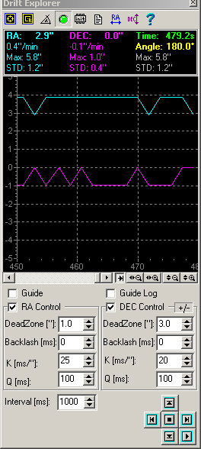
alignMeridianDrift_1.jpg
Slight drift trend in DEC on the first star after 8 minutes of drift measurement (remember, ignore the cyan colored RA lines)

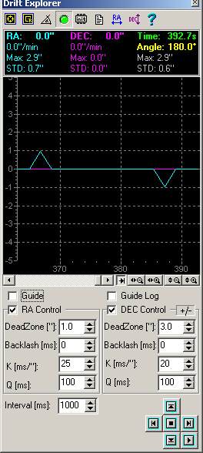
alignEastDrift_2.jpg
Zero drift and zero drift trend after 6.5 minutes of drift measurement on the Eastern star.

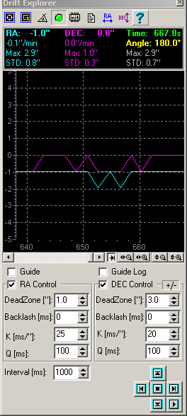
alignEastDrift11min_3.jpg
Zero drift after 11 minutes of drift measurement on the meridian star, second pass. This image might be indicating a slight trend to the south after 11 minutes, but it is probably less than 1/10 arcsec per minute - say 0.05"/min. It is possible I could refine this further but I'm sure that my focuser tube has some sag to it so I will let the guider handle the rest. (Fortunately, or maybe unfortunately, the drift measurement on this run was completely flat until the 640 second mark, which is more than 10.5 minutes. Had I not gone to 10 minutes, I wouldn't have known that it wasn't perfect). If this was a permanent setup, I might be inclined to drift for 6 hours on several different nights.

Addendum 08/09/2006
It came to my attention that you should use your imaging camera, if possible to perform this drift alignment procedure if there is any chance that there is flexure in the guide scope. Essentially, when using this drift alignment procedure, mount the camera on the most solid/stable scope. Otherwise, you will make adjustments that are compensating for the scope mount bending and the RA axis will not be parallel with the earths axis.

Single Star drift alignment:
Following a suggestion from the CCDOps people, who suggest using their Track & Acculumulate for drift alignment facilitation, you could technically perform this same kind of drift alignment with a single star, say, at the zenith, using K3. Just watch the numbers. You need to be less than 60degs DEC to do this from what I understand. I have tried it but I it took longer than the other way and it didn't seem to be accurate enough for other parts of the sky. So I wouldn't recommend depending on it.

Guiding tip
You will need to go to Options > Settings... > Guiding and setup the correct interface and other parameters.
- Pay attention to the Subpixel Guiding option. Check this option to get the best results. Otherwise, guiding corrections will not be issued until the image is off by at least a whole pixel.

