Remote Access Using VPN – Virtual Private Network
Installation, Configuration and Troubleshooting Guide
Version 4.6x

Corporate VPN Requirements
- Must be an active status EMC Employee
- Access approved by your functional manager via ART (wireless users still need to apply via ART for remote access). On-site contractors will require special clearance from Office of Information Security and Risk Management (OISRM) group. External vendors and off-site contractors cannot use this method and must go through OISRM TPA process.
- Have a valid EMC SecurID FOB/ SoftID
- Received “ WELCOME TO EMC’S CORPORATE VPN ” email from IS Helpdesk. This will indicate that your SecurID account has been granted remote access.
- Have an EMC provided PC or your own PC with supported operating system and meets the corporate security standards and requirements
- High-speed Internet access (Wireless users need EMC building AP configured)

Services Offered Through VPN
- Network level access to all EMC resources
- Being in the office local LAN like experience
- All VPN compatible applications will work seamlessly
- Global presence
- Redundant VPN entry options
- Works on all EMC supported operating systems (Windows, Linux and Solaris)

Security Requirements
- After connecting to EMC, you must follow corporate standard policies http://cit.emc.com/cpp/ and Information Security Policy http://itcentral.corp.emc.com/Policies/SecurityPolicy.pdf as applicable.
- Desktop Protector (BlackIce Firewall) and McAfee Anti-virus MUST be running for you to access VPN the facility.
- If you are not an authorized VPN user then you should not install this software. If your EMC employment status has changed with EMC then you must uninstall all VPN related software.
- The software that you downloaded is not for general distribution. Unauthorized distribution of the software may result in your removal from the VPN authorized access list.
- A SecurID fob (with special access) is required for VPN access/authentication and it should not be shared.
- Your own PC must be patched to recommended security level.
- Infected machines/users will be removed form VPN list as soon as detected without prior notice.
- All network activities will be monitored and logged by OISRM after connecting to EMC.

Support Notes
Before you can successfully install and use VPN there is specific information that you need to understand. Please read the following section carefully before going any further:
- There is an offering of two support options as explained during your VPN enroll via ART:
  - Full Support- Assumes that you will be a member of the EMC network domain, regularly log in, run drive mapping scripts. IS could operate remote support software on your machine. Could be EMC issued PC or Home PC that will be recognized by EMC as in the domain with Full Support
  - NO Support- Assumes that you have a Home PC but although you may authenticate with NT/W2K for email and particular Intranet sites, that you machine will not be in the EMC domain; you won’t log in to run scripts and not call IS Support (other than SecurID) You must still run IS virus protection and personal firewall to remain a valid VPN user.
  - Wireless Users – Assumes you are an EMC employee using wireless access. All wireless access now requires the use of VPN.

Installation Instructions
The VPN client software that you have downloaded runs on all Microsoft Windows platforms except Windows 95. The software allows you to access EMC’s corporate network via your broadband connection
The following section details the installation of your VPN software, Desktop Protector (BlackICE) and McAfee. Please download all three software form the http://vpndist.emc.com and follow these directions carefully and call the IS Support Center at x58126 if you encounter any problems.

Before You Begin

Home or Customer Premise Firewall Settings
If you have enabled your home firewall feature or you are behind a customer corporate firewall, you or the customer firewall administrator must allow the following protocols/port though depending on your profile selection (Please read section-4 on Page 7 for VPN Mode info) :
Service Protocol Source Port Dest Port Direction
ISAKMP/IKE (Native and UDP Mode) UDP 500 500 Inbound/Outbound
IPSEC (Native Mode) 50 (ESP) N/A N/A Inbound/Outbound
IPSec over NAT (UDP Mode) UDP 10000 10000 Inbound/Outbound
IPSec over NAT (TCP Mode) TCP >1024 4005 Outbound
Destination host IPs should include the following:
EMC Americas East: 128.221.195.15, 128.221.195.16 and 128.221.195.17
EMC Americas West: 137.69.83.13, 137.69.83.14 and 137.69.83.15
EMC EMEA: 152.62.108.70, 152.62.108.71 and 152.62.108.72
EMC Asia Pac: 57.73.18.114
Note: Refer to your firewall software documentation for more information.

Backup Personal Data
As with the installation of any software it is a good idea to backup all of you critical data before you begin. This software has been thoroughly tested on EMC systems, and chances are that you not experience any problems with your home installation. However, to avoid any possible problems it is better to be safe than sorry.

Installing the VPN and Desktop Protector (BlackICE) Bundled Software
- Double-click DTP3.6_VPN4.6.EXE.
- The EMC VPN Client Setup screen displays information. Click Next.

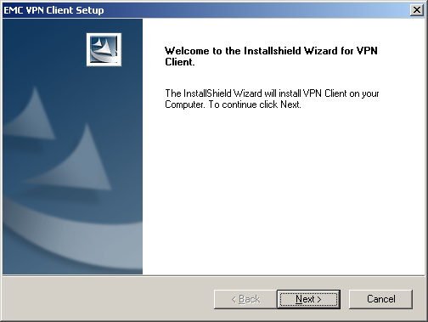
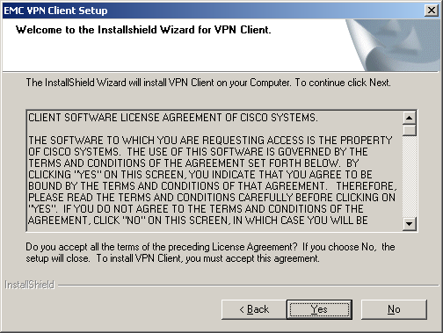
Figure 1: EMC VPN Client Setup dialogs
- Accept defaults and click the Next / Yes buttons through all of the EMC VPN Client Setup screens.

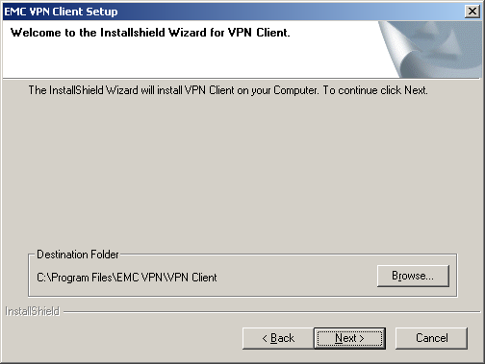

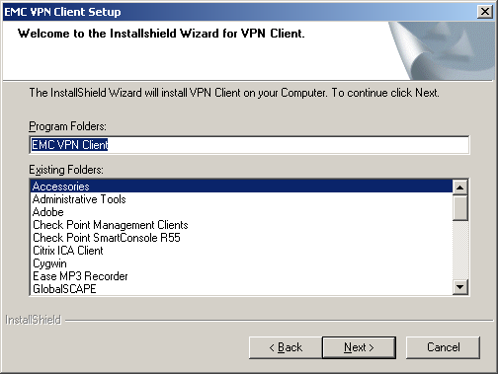
- When the InstallShield Wizard Complete screen displays select “Yes, I want to restart my computer now.” and click the Finish button. The PC reboots.
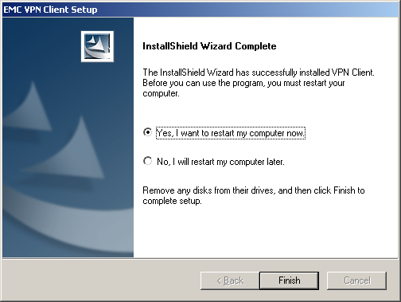

Installing the McAfee Antivirus Software

Double-click on the downloaded mcafee.exe. The McAfee 7.1x dialog displays. Provide answers that fit your environment. If this is on an EMC built PC then it will be running the latest McAfee client already and you can skip this install.

!!You have now installed all of the software that is required to connect to EMC’s corporate network using VPN.

Installing VPN and Desktop Protector (BlackICE) Separately

If you are reinstalling the VPN software only for some reason then you may choose to download the standalone VPN install VPN4.60.EXE and proceed through the screens same as the bundled install.
If for some reason you need to install/re-install the Desktop Protector (BlackICE) software only then download the stand alone install DT_Protector3.6.EXE. The BlackIce Install dialog displays. This is a silent install and does not require a reboot for most systems.

Using VPN to Connect to EMC Network
Now that you have installed and configured VPN you can connect to the EMC network from your home PC using your broadband connection. Once connected, you have the access to the same network resources that you use when you are sitting at your desk in the office.

Logging In
- Select Start  Programs  EMC VPN Client  VPN Dialer. The EMC VPN Dialer dialog displays.
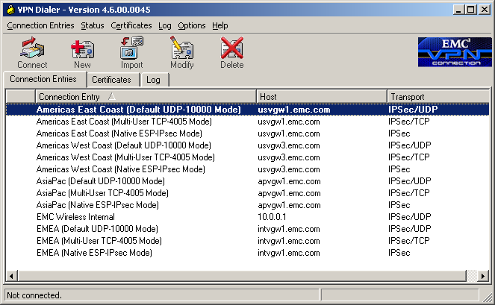
Figure 2: EMC VPN Dialer dialog
- Verify that the Connection Entry field displays as above.
- Identify your country profiles.
We suggest the followings. If you are:
- USA, Canada, Mexico, Central and South American user then try any profiles named “Americas East Coast (Westboro, MA) or West Coast (Mountain View, CA)” whichever is geographically closer to you.
- Europe, Middle East, and Africa user then try any profiles named “EMEA”. This will connect you to our Ireland gateways.
- Asia Pacific user then try any profiles named “AsiaPac”. This will connect you to our gateways in Singapore.
- Wireless users located in EMC buildings should select the “EMC Wireless Internal” profile
- Select the VPN Mode (Transparent Tunneling) that will work for your network/broad band connection.
Please note that the fastest gateway may be the one closest to the EMC resources you are trying to access. Most EMC business applications are located close to Westborough, MA.
Once you have identified your profile, then you can try any three of the tunneling options:
VPN over UDP 10000 Mode (For clients behind a NAT device)
VPN over TCP 4005 Mode (For multiple clients behind a NAT device)
VPN over Native ESP IPsec Mode (For clients with routable IPs)
These options allow secure transmission between the VPN Client and EMC gateway through a router or firewall, which may also be performing Network Address Translation (NAT) or Port Address Translations (PAT). UDP transparent tunneling encapsulates Protocol 50 (ESP) traffic within UDP packets and uses standard IKE (UDP 500). TCP transparent mode encapsulates both Protocol 50 (ESP) and IKE (UDP 500). The most common application for transparent tunneling is behind a home router performing PAT.
Performance Difference Between Different VPN Modes
Encryption overhead between different VPN modes varies and can affect the overall VPN experience of your available bandwidth (DSL, Cable modem, T1, etc). If you have an Internet routable IP then we encourage you to use the Native IPsec mode. However, due to various home and corporate network designs you may not have a choice but to select UDP mode or TCP mode.

Mode | IPsec Encryption Overhead | Encapsulation Protocol Overhead | Overall Performance
UDP 10000 Mode | 10% | 5% | Better
TCP 4005 Mode | 10% | 9% | Average
Native ESP IPsec Mode | 10% | 0 | Best
After selecting your profile, click the Connect button. The User Authentication dialog displays.
- In the Username field enter your NT Username (excluding domain prefix.)
- In the Passcode field enter your PIN (the code you specified when you activated your SecurID FOB) followed by the passcode that displays on your SecurID FOB
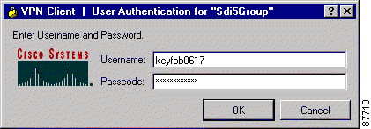
4444123456 (PIN + display)
Figure 3: User Authentication dialog
- Click OK. The Connecting to usvgw1.emc.com dialog displays. Your display may differ slightly.
- You are now connected to the EMC corporate network. Click OK on the “Banner” message.
- Log on to the network if applicable.

Logging Out
When you are finished using EMC network resources you must log off as follows:
To Log Out:
- Right-click the EMC VPN Dialer icon lower right corner of your screen.
- Click Disconnect.

Advanced Configuration Instructions
In some special cases you may need to adjust the default settings to fit your environment. Please find the topic of your interest and follow the instructions.
Select Start  Programs  EMC VPN Client. The EMC VPN Dialer displays.
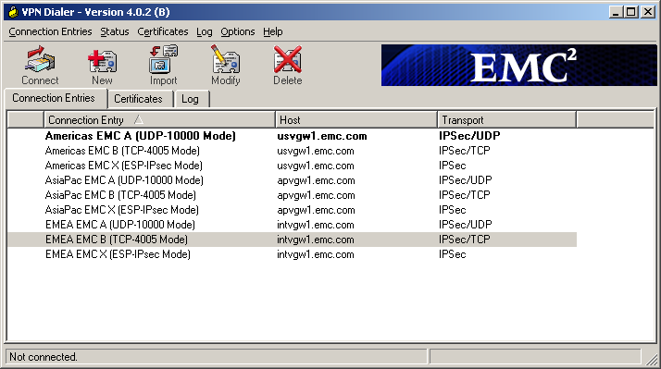
- Setting your country profile as default and set to Simple Mode for one click connection
Highlight your working profile and right click and select “Set As default Connection Entry”. This will highlight your profile at all times.
Select <Options> and set “Simple Mode” and the following screen will appear without displaying all the other unwanted profiles.
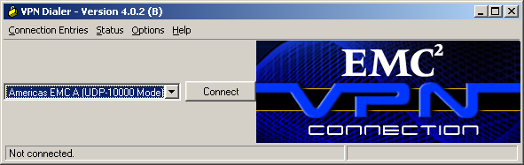

- Enabling Local LAN Access.
By default you will NOT have access to your local environment after connecting to EMC (no split tunnel policy). The Allow Local LAN Access parameter gives you access to the resources on your local LAN (printer, fax, shared files, other systems) when you are connected to EMC. However, this is restricted to a specific network 192.168.1.0/255.255.255.0. When this parameter is enabled and your local LAN is 192.168.1.x, you can access local resources while connected.
To enable this feature, high light a profile and select → connection entries → Transport and check Allow Local LAN Access;
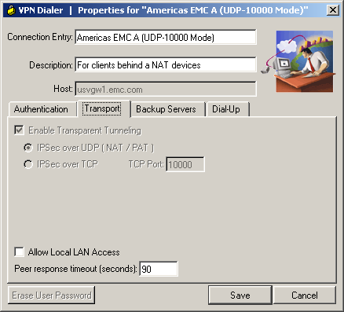

If the local LAN you are using is not secure, you should disable this feature. For example, you would disable this feature when you are using a local LAN in a hotel or airport.

Starting a VPN Connection Before Logging on to a Windows NT Platform
On a Windows NT platform, you can connect to the private network before you log on to your system. This feature is called start before logon and its purpose is primarily to let you log in to the domain and run login scripts.
Your administrator may have set this up for you. Once you establish a VPN connection, your credentials are sent to a domain controller for logging on to your system.
When you have established a successful VPN connection, the VPN Client window closes, and your logon window displays. If the connection is not successful, the VPN Client window continues to display. Your administrator might have set up a banner that lets you know when you have a successful connection.
To activate start before logon, follow these steps:

Step 1 Open the VPN Client Options menu and choose Windows Logon Properties.
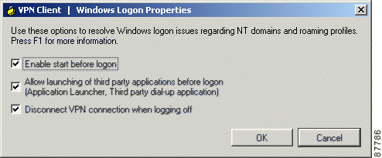

Step 2 Click Enable start before logon and then click OK .

Stateful Firewall (Always On)
Please DO NOT turn on this feature (check mark will appear if turned on) as it will conflict with BlackICE. This is CISCO’s built in firewall protection that EMC is NOT using. You must install the EMC provided BlackICE personal firewall and running it all times. The BlackICE client is a stateful firewall that provides protection for the VPN Client PC from Internet attacks and worms whether your are connected to EMC or not.

Troubleshooting Self Guide
This guide is intended to help resolve some common issues. Please find the symptom/question that is applicable to your problem and follow the suggested solution. Please call the EMC IS Global Helpdesk for issues that you cannot resolve.

Mapping Drives Issues
If you are not logging into the EMC domain then you will not get the shared drive mappings. In this case you need to manually connect to a resource.
Right click on “ My network Places” and select “ Map Network Drive”
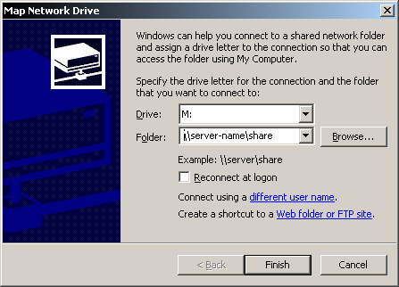
If you are logged in locally with cached credential or different userID then select “different user name” and enter your domain\NTuserID and supply password when prompted
Please DO NOT check the “ Reconnect at Logon” as it would create password lockout issues when you change your EMC domain password.

Outlook Prompts for Password During a Middle of Session
Normally this would happen when your domain password has reached minimum failed attempt limit and got locked out. Check for old drive mappings that may be using your previous NT password thus causing the lockout. Id you see a custom drive mapping then delete and re-map the drive with your newly established NT password.

VPN Client Cannot Launch Microsoft Connection Manager
The VPN Client does not see a dialup connection made with Microsoft Connection Manager because of incompatibilities between the requirements of the two applications (CSCdx85663).

The 4.6 VPN Client Is Not Supported on Windows 95
The VPN Client for Windows, Release 4.0 and higher, requires the use of the Windows 98 or later operating system. We recommend updating your operating system to a newer version of Windows (CSCea06231).

BlackICE Service Startup Failure on Windows XP SP2 on a Dell D610 laptop

The BlackIce Service may fail to startup on Windows XP Service Pack 2 Machines due to the new "NX" or "DEP" bit on new generation hardware interacts badly with BlackIce after Windows XP SP 2 is applied. This new bit prevents the execution "Unauthorized" programs as a security measure. Its intended purpose is to prevent malicious programs such as viruses and worms from running on machines. The current version of BlackIce does not properly respect this bit and is shutdown by the OS as soon as it starts up on an OS which supports the NX bit.
A fix for this problem has been created by the IT Client Services TAG Group and is located at:
\\corpustechweb\software\Patches_Fixes\XPSP2NX run the bootfix.exe file. It will execute silently and repair the problem.

Cannot Connect from Windows 2003 SP1 on a Dell D610

Hold down the F2 function key during boot to access BIOS settings, use down-arrow to scroll to the "Security" settings and select "CPU XD Support". In the right pane press the enter key to modify the setting, then arrow over to select "OFF". Press the enter key to set it, then press Esc and save and exit.

VPN Client Not Supported on Windows NT Servers
The VPN Client is not supported on any Windows NT server version (including Windows 2000 and Windows XP/.NET/2003 servers). Only Windows NT 4.0 Workstation and Windows 2000 Workstation are supported platforms.

Windows 98 Might Hang on Shutdown
On some Windows 98 PCs with the VPN Client installed, if you restart the PC, it may stop responding (that is, "hang") on the screen that says "Windows is shutting down".
Wait a minute. If the PC is still not responding, press the reset button. When the PC reboots, it should not run through ScanDisk, indicating the shutdown was successful in closing all open files. This problem may occur on some PCs and not on others, and we are looking for a solution. Windows 98 shutdown has numerous issues, as can be seen the following Microsoft Knowledge Base Article:

America Online (AOL) Interoperability Issues

AOL Versions 5.0 and 6.0
The VPN Client supports AOL Version 5.0. AOL Version 6.0 is also supported, with one limitation: when connected, browsing in the network neighborhood is not available.

AOL Version 7.0
AOL Version 7.0 uses a proprietary heartbeat polling of connected clients. This requires the use of split tunneling to support the polling mechanism. Without split tunneling, AOL disconnects after a period of time between 5 and 30 minutes.

AOL 7 Disconnects after VPN Authentication
When making a dialup connection with AOL 7.0 Revision 4114.537 (for Windows 95, 98, ME, Windows 2000 and XP), then attempting to connect with the VPN Client, AOL might disconnect while the user is being authenticated. This is an AOL issue, not a VPN Client problem (CSCdy45351).

VPN Client Fails to Connect over Some AOL Dialup Connections
The Cisco VPN Client connecting over an AOL dialup connection fails to complete the connection, particularly when using AOL 7.0 and 8.0
The AOL dialup process uses a fallback method which, if your initial attempt to connect fails, resorts to a different connection type for the second attempt. This second attempt can sometimes cause AOL to communicate over two PPP adapters (visible in ipconfig /all output). When this happens, the VPN Client cannot connect. This is a known issue, and AOL is investigating the problem.
The workaround is to try to reconnect the dialup connection to try to avoid getting two PPP adapters (CSCea29056).

Aladdin Runtime Environment (RTE) Issue with Windows NT and Windows 2000
Using versions of the Aladdin Runtime Environment (RTE) on Windows NT and Windows 2000 can cause the following behavior. The login prompt that is posted by the Aladdin etoken when connecting the VPN Client can get hidden in the background. If this happens, the VPN connection can timeout and fail with the following event:
"System Error: Connection Manager failed to respond."
A side effect of this is that the VPN Client's service and dialer might become out of synch, and the PC might need to be restarted (CSCdv47999). To avoid this issue, use the Aladdin Runtime Environment (RTE) version 2.65 or later.

Windows 2000 (only) Requires Adding Client for MS Networks for Dialup Connections
For the Cisco VPN Client running on a Windows 2000 system, you cannot access Microsoft resources unless you add the Client for Microsoft Networks for the Dial-up adapter.

WINS Information Might Not Be Removed from Windows Servers If Not Disconnected Before Shutdown
If the VPN Concentrator is configured to send WINS server addresses down to the VPN Client and the PC is shut down or restarted without first disconnecting the VPN Client, the WINS servers are not removed from the network properties. This might cause local PC registration and name resolution problems while not connected with VPN.
To work around this problem, do one of the following:
•Be sure to disconnect the VPN Client before shutting down. If you are having problems, check your network properties and remove the WINS entries if they are not correct for your network.
•Alternatively, enable "Disconnect VPN connection when logging off". Go to Options > Windows Logon Properties, check Disconnect VPN connection when logging off (CSCdv65165).

DNS
For DNS resolution, if the DOMAIN NAME is not configured on the network interface, you need to enter the fully qualified domain name of the host that needs to be resolved.

Network Interfaces
•The VPN Client does not support Point-to-Point Protocol over ATM (PPPoA).
•The VPN Client cannot establish tunnels over Token Ring. However, it does not conflict with an installed Token Ring interface.
•DELL Docking Station users running the VPN Client on Windows NT may experience bluescreen failures if the latest version of Softex Docking Services has not been installed. The Softex Docking Service utilities are available directly from the DELL Support Web site, http://search.dell.com/index.asp. Select the checkbox for the File Library and search for the term "Softex Docking Services".

Microsoft Outlook Error Occurs on Connection or Disconnect
The following Microsoft Outlook error might occur when the VPN Client connects or disconnects:
"Either there is no default mail client, or the current mail client cannot fulfill the messaging request. Run Microsoft Outlook and set it as the default mail client."
This message does not affect operation of the VPN Client. The issue occurs when Microsoft Outlook is installed but not configured for email, although it is the default mail client. It is caused by a Registry Key that is set when the user installs Outlook.
To eliminate this message, do one of the following:
•Right-click the Outlook icon, go to Properties, and configure it to use Microsoft Exchange or Internet Mail as the default mail client.
•Use Internet Explorer to configure the system to have no default mail client.
•Configure Outlook as the default mail client

Adjusting the Maximum Transmission Unit (MTU) Value - Windows Only
VPN Encapsulation adds to the overall message length. To avoid refragmentation of packets, the VPN Client must reduce the MTU settings. The default MTU adjusted value is 1300 for all adapters. If the default adjustments are not sufficient, you may experience problems sending and receiving data. To avoid fragmented packets, you can change the MTU size, usually to a lower value than the default. To change the MTU size, use the VPN Client SetMTU utility. If you are using PPPoE, you may also have to set the MTU in other locations. Refer to the following table for the specific procedures for each type of connection.
The MTU is the largest number of bytes a frame can carry, not counting the frame's header and trailer. A frame is a single unit of transportation on the Data Link Layer. It consists of header data, plus data that was passed down from the Network Layer, plus (sometimes) trailer data. An Ethernet frame has an MTU of 1500 bytes, but the actual size of the frame can be up to 1526 bytes (22-byte header, 4-byte CRC trailer).

Recognizing a Potential MTU Problem
If you can connect with the Cisco VPN Client but cannot send or receive data, this is likely an MTU problem. Common failure indications include the following:
•You can receive data, such as mail, but not send it.
•You can send small messages (about 10 lines), but larger ones time out.
•You cannot send attachments in email.

Setting the MTU Value
If you are not experiencing a problem, do not change the MTU value. Usually, an MTU value of 1300 works. If it doesn't, the end user must decrease the value until the Cisco VPN Client passes data. Decrement the MaxFrameSize value by 50 or 100 until it works.

Asante FR3004 Cable/DSL Routers Require Asante Firmware Version 2.15 or Later
Versions of the Asante firmware caused a problem with rekeying and keepalives when a VPN Client had an all-or-nothing connection to a VPN Concentrator through an Asante FR3004 Cable/DSL router. Version 2.15 (or later) of the Asante firmware resolves these issues. For more information about Asante cable/DSL routers, see the following Web sites:
• http://www.asante.com/products/routers/index.html
• http://www.practicallynetworked.com/pg/router_guide_index.asp

Using Nexland Cable/DSL Routers for Multiple Client Connections
All Nexland Pro routers support passing multiple IPSec sessions through to Cisco VPN 3000 Series Concentrators. To enable this function, the Nexland user must select IPSec Type 2SPI-C on the Nexland options page.
The discontinued Nexland ISB2LAN product correctly handles a single connection, but problems can occur when attempting to make multiple client connections to the same Secure Gateway from behind an ISB2LAN Nexland Cable/DSL router. Nexland has fixed this problem in the Nexland Pro series of routers (CSCdt10266).

VPN Dialer Application Can Load During OS Shutdown or Restart
When using the VPN Client's Start Before Logon feature (Windows NT, Windows 2000, or Windows XP) in "fallback" mode, the VPN dialer application loads during a shutdown or restart of the operating system. This will not cause any problems and can be ignored (CSCdu02071).

ZoneAlarm Plus Versions 3.1.274 and Earlier Are Incompatible with VPN Client
The following known incompatibility exists between the Cisco VPN Client and Zone Labs ZoneAlarm Plus version 3.1.274 and earlier. If you are using such a version of ZoneAlarm Plus, please visit http://www.zonelabs.com or contact your Zone Labs representative for an update.
On a PC with ZoneAlarm Plus version 3.1.274 (or earlier) and the VPN Client, the following errors occur when the PC boots:
On Windows 2000:
ZAPLUS.exe has generated errors and will be closed by Windows. You will need to restart the program.
An error log is being generated.
The Application Log states:
The application, ZAPLUS.EXE, generated an application error. The error occurred on 7/23/2002... The exception was c0000005 at address 00401881 (<nosymbols>).
Similar errors occur on other Windows operating systems.
The result of this error is that the ZoneAlarm GUI does not run, and therefore a user can not change any settings in ZoneAlarm Plus or allow new programs to access the Internet.(CSCdy16607).

ZoneLabs Automatically Adds Loopback and VPN 3000 Concentrator Addresses to Trusted Zone for Windows NT PCs
The Loopback address and the VPN 3000 Concentrator's address are automatically added to the ZoneLabs "Trusted Zone" on Windows NT-based systems.
If a Windows NT based-PC has ZoneAlarm, ZoneAlarm Pro, or Zone Labs Integrity Agent, and the VPN Client Release 4.0 installed on it, the loopback address (127.0.0.1) is automatically added to Zone Labs "Trusted Zone" when the Client service is started. Additionally, the VPN 3000 Concentrator's address is automatically added to the "Trusted Zone" when a connection is made (CSCea61272).

Upgrading Zone-Alarm Pro to Version 3.7.098 Causes Error When VPN Client Is Already Installed on the PC
Upgrading ZoneAlarm Pro version 3.5.xxx to ZoneAlarm Pro version 3.7.098 when the VPN Client is installed on the PC might cause the following error to appear:
"The procedure entry point DbgProcessReset could not be located in the dynamic link library VSUTIL.dll."
Click OK, and the installation continues (CSCea25991). See ZoneLabs' bug number 10182.

DHCP Route Renewal in Windows 2000 and Windows XP
In a Windows 2000 or Windows XP environment, if the public network matches the private network (for example, a public IP address of 192.168.1.5, with a subnet mask of 255.255.0.0, and an identical private IP address) and the public network's route metric is 1, then traffic might not be tunneled to the private network (CSCdz88896). The same problem can occur if you are using a virtual adapter and the public metric is smaller than the virtual adapter metric.
In Windows 2000 and Windows XP, you can increase the metric of the public network by doing the following steps:

Step 1 Select Start > Settings > Control Panel > Network and Dial-up Connections.
Step 2 Select the public interface and click properties for the public interface.
Step 3 Select Internet Protocol (TCP/IP) and get the properties for the Internet Protocol (TCP/IP).
Step 4 Click Advanced, and set the interface metric to 2 or greater.

Data Meant for Private Network Stays Local if VPN Client's Local Network Is on Same IP Subnet as Remote Private Network
This problem occurs only with the VPN Client, Release 4.6 and only with Virtual Adapter (Windows 2000 and Windows XP), when the VPN Client's local network is on the same IP subnet as the remote private network. When a VPN connection is up, data meant for the private network stays local. For example: 192.168.1.0/255.255.255.0
The VPN Client, Release 4.6, with Virtual Adapter attempts to modify local route metrics to allow data to pass over the VPN tunnel. In some cases, it is impossible for the VPN Client to make this modification (CSCdz38680).
To work around this problem, make the change manually, using the following procedure:

Step 1 Run > Control Panel > Network and Dialup Connections.
Step 2 Right-click on the adapter in question and select Properties.
Step 3 From the Adapter Properties dialog, select TCP/IP from the list and click Properties.
Step 4 Click Advanced and increase the number in the "Interface metric" box by 1 (it is usually 1, so making it 2 works).
Step 5 Click OK to exit out of all dialogs.
Step 6 The VPN connection should now work.

VPN Client Supports Sygate Personal Firewall V. 5.0, Build 1175
The supported version of Sygate Personal Firewall is version 5.0, build 1175. Earlier versions might cause the following Blue screen to occur on a Windows NT-based system that has made many connects/disconnects with the VPN Client (CSCdy62426):
Stop: 000000d1 (BAD0B0B8, 00000002, 00000000, BFF12392)
Driver_IRQL_Not_Less_Or_Equal
***Address BFF12392 base at BFF10000, Datestamp 3CCDEC2C - Teefer.sys

No Limit to Size of Log File
When logging is enabled on the VPN Client, all of the log files are placed in the Program Files\Cisco Systems\VPN Client\logs directory and are date and time stamped. There is no limit to the size of the log when logging is enabled. The file will continue to grow in size until logging is disabled or the VPN Client program is closed. The log is still available for viewing until the VPN Client program is re-launched, at which time the display on the log tab and log window are cleared (CSCdy87504). The log file remains on the system and a new log file is created when the VPN Client, with logging enabled, is launched.

Downgrading VPN Client from Release 4.6 Causes Start Before Logon Failure
Start Before Logon fails if the VPN Client is downgraded from Release 4.6 to 3.6. The reason for this is that the file csgina.dll is upgraded when the VPN Client version 4.6 is installed. If the VPN Client is downgraded to version 3.6, the csgina.dll file for version 4.6 is not replaced, and this breaks ability in the VPN Client version 3.6 to Start Before Logon (CSCea03685).
Follow this procedure to drop back to the VPN Client version 3.6 from version 4.6.

Step 1 Uninstall the VPN Client version 4.6.
Step 2 After rebooting, search for csgina.dll. This file is found in the System32 directory.
Step 3 Rename csgina.dll to something like csgina.old.
Step 4 Install the VPN Client version 3.6.

Linksys Wireless AP Cable/DSL Router Version 1.44 or Higher Firmware Requirement
To use the VPN Client behind a Linsksys Wireless AP Cable/DSL router model BEFW11S4, the Linksys router must be running version 1.44 or higher firmware. The VPN Client cannot connect when located behind a Linsksys Wireless AP Cable/DSL router model BEFW11S4 running version 1.42.7 firmware. The VPN Client may see the prompt for username/password, then it disappears (CSCdz52156).

Use Zone Labs Integrity Server 2.1.052.0 or Higher with VPN Client 4.0
Versions of the Zone Labs Integrity Server earlier than 2.1.052.0 exhibit the following problem. If two or more VPN Clients (running on Windows 2000 or XP) are connected to a VPN 3000 Series Concentrator and receive firewall policy from a ZoneLabs Integrity Server, the Integrity Server registers only one connection.
On the Integrity Flex (client agent), under "Policies", the "Integrity Server" column flashes "Connected" then "Disconnected" over and over. Also, the VPN Client log includes the following event: "The firewall, configured for Client/Server, returned a status of lost connection to server." Zone Labs Integrity Server version 2.1.052.0 fixes this issue (CSCea66549).

Restart VPN Client Service If You Install VPN Client Before Zone Alarm
The Firewall Enhancement, "Prevent VPN Traffic Blocking", automatically adds the Loopback address (127.0.0.1) and the address of the VPN 3000 Concentrator to the ZoneAlarm or ZoneAlarmPro trusted zone.
An exception to this, however, occurs if the VPN Client is installed before Zone Alarm. Then the VPN Client's service must be restarted by rebooting the PC or stopping and restarting the service through the Control Panel (on Windows NT-based PCs) (CSCea16012).

InstallShield Error Might occur during VPN Client Installation
The following error message might occur during VPN Client installation:
IKernel.exe - Application Error
The instruction at "0x771c741a" referenced memory at "0x00163648". The memory could not be "read".
This error is caused by an InstallShield component, possibly because of a run-once stale remnant. To recover, you must reboot.
The InstallShield Knowledge base article q108020 addresses this problem. To view this article go to the following URL (CSCea43117):
http://support.installshield.com/kb/view.asp?articleid=q108020

VPN Client cTCP Connection Fails If Checkpoint Client Is Installed
When the Checkpoint VPN-1 Securemote client is installed with the 4.6 VPN Client, and the VPN Client attempts to connect using cTCP, the 4.6 VPN Client cannot make the connection. Connections do work with UDP, NAT-T, and non-NAT connections.
To make a connection with cTCP when the Checkpoint VPN-1 Securemote is installed, you must disable the Check Point SecuRemote driver in the Connections Properties. To do this, you must be administrator. Follow these steps:

Step 1 Click Start > Settings > Control Panel >Network and Dial-up Connections.
Step 2 Select the Local Area Connection you use.
Step 3 Click on File > Properties.
Step 4 Uncheck Check Point SecuRemote, and click OK.

